Press release

Liebherr to supply first complex 3D printed component for Airbus’ A350 fleet

**⸺**

**Liebherr-Aerospace Lindenberg GmbH has reached a new important milestone: Airbus has selected the OEM to supply the lower cargo door actuator and valve for the A350. The complex valve will be produced by Liebherr using 3D printing technology (additive layer manufacturing).**

Lindenberg (Germany), July 2022 – Liebherr-Aerospace Lindenberg, Liebherr’s center of competence for flight control systems, landing gears, gears, gearboxes as well as electronics, is collaborating intensively with Airbus in the development of additive layer manufactured components.

At the beginning of 2019, Liebherr-Aerospace started the serial production of 3D printed parts. The company had successfully certified and delivered a printed proximity sensor bracket for the A350 nose landing gear. This bracket was the first-ever introduced Airbus system part to be qualified for titanium additive layer manufacturing. Now, Airbus and Liebherr are launching a more complex component - the valve of the lower cargo door actuator system - for the same aircraft.

Liebherr-Aerospace is on board of all Airbus commercial aircraft programs, and this contract is another demonstration of the trust between the two companies and their mutual commitment to introduce cutting edge innovation.

**About Liebherr-Aerospace & Transportation**

Liebherr-Aerospace & Transportation SAS, Toulouse (France), is one of eleven divisional control companies within the Liebherr Group and coordinates all activities in the aerospace and transportation systems sectors.

Liebherr-Aerospace is a leading supplier of systems for the aviation industry and has more than six decades of experience in this field. The range of aviation equipment produced by Liebherr for the civil and defense sectors includes flight control and actuation systems, gears and gearboxes, landing gear and air management systems as well as electronics. These systems are deployed in wide-bodied aircraft, single aisle and regional aircraft, business jets, defense aircraft, defense transporters, defense training aircraft and civil and defense helicopters.

Liebherr’s aerospace and transportation systems division employs around 6,000 people. It has four aviation equipment production plants at Lindenberg (Germany), Toulouse (France), Guaratinguetá (Brazil) and Nizhny Novgorod (Russia). These production sites offer a worldwide service with additional customer service centers in – among others - Saline (Michigan/USA), Seattle (Washington/USA), Montreal (Canada), Hamburg (Germany), Dubai (UAE), Bangalore (India), Singapore and Shanghai (People’s Republic of China).

**About the Liebherr Group**

The Liebherr Group is a family-run technology company with a highly diversified product portfolio. The company is one of the largest construction equipment manufacturers in the world. It also provides high-quality and user-oriented products and services in a wide range of other areas. The Liebherr Group includes over 140 companies across all continents. In 2021, it employed around 49,000 staff and achieved combined revenues of over 11.6 billion euros. Liebherr was founded in Kirchdorf an der Iller in Southern Germany in 1949. Since then, the employees have been pursuing the goal of achieving continuous technological innovation, and bringing industry-leading solutions to its customers.

**Image**

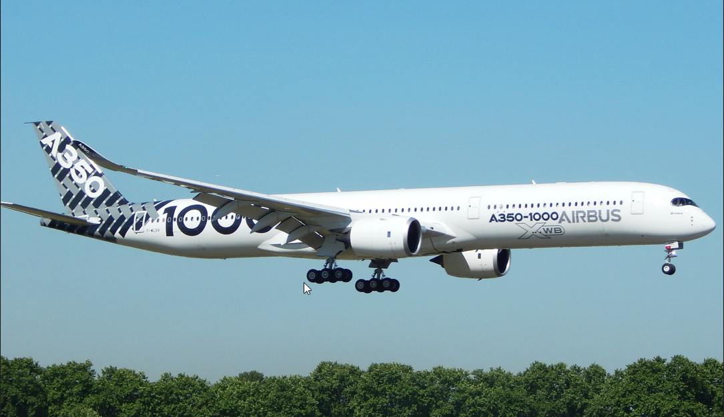  
 liebherr-a350-1000-xwb-airshow.jpg

Liebherr-Aerospace is on board all Airbus commercial aircraft programs, incl. the A350.

**Contact person**

Ute Braam  
Corporate Communications  
Phone: +49 8381 / 46 - 4403  
E-mail: ute.braam@liebherr.com

**Published by**

Liebherr-Aerospace & Transportation SAS   
Toulouse / France  
www.liebherr.com