Press release

Herkules strengthens crane fleet with Liebherr-LG 1750 lattice boom mobile crane

⸺⸺

* New Liebherr-LG 1750 lattice boom mobile crane for Herkules S.A.
* LG 1750: combines the flexibility of a crawler crane with the mobility of a mobile crane
* Mobility, capacity and Liebherr service are key selling points

The Polish crane and heavy transport company Herkules S.A. has taken delivery of a new LG 1750. The lattice boom mobile crane offers the flexibility of a 750-tonne crawler crane combined with the high mobility of a mobile crane. Herkules is extending the performance range of its crane capacities upwardswith the LG 1750. The choice of this Liebherr lattice boom mobile crane was made based on the fulfilment of market requirements and the trust placed in Liebherr. Another important point for Herkules is the high availability of Liebherr service in Poland.

Ehingen (Donau) (Germany), 26 July 2022 – With the acquisition of an LG 1750, the Polish crane company Herkules S.A. has expanded its crane range upwards in the heavy-duty sector. Consideration of what was available on the crane market and the requirements of the company's customers led to the decision in favour of the Liebherr lattice boom mobile crane. For Herkules, it is also particularly important that Liebherr is present in Poland with good service availability: "Our confidence in Liebherr products, their high availability and reliable service led us to choose a Liebherr crane," explains Pawel Maciejak, Director of the Crawler Cranes and Wind Energy Division at Herkules.

Symbiosis of two worlds

The LG 1750 lattice boom mobile crane has the flexibility of a 750-tonne crawler crane combined with the mobility of a high speed mobile crane. That means it combines the benefits of these two crane types in a single concept. This makes it the largest and strongest lattice boom mobile crane in the world and unrivalled in the market. "The high mobility and carrying capacity were decisive factors for the purchase of the new LG 1750," states Maciejak. Having the chassis of an all-terrain crane, the bottom part of the 8-axle crane is self-driving to any application site. Compared to a crawler crane, this reduces transport vehicles, thereby saving times and costs. Its vehicle width of less than three metres is a great advantage. This chassis combined with a strong lattice boom of a crawler crane makes the crane particularly powerful. The components can also be transported economically thanks to the transport weight of less than 45 tonnes.

That makes the compact lattice boom mobile crane ideal for fast erection work for wind power, industrial construction or infrastructure work. There is a large selection of boom configurations for the LG 1750 which have been specially enhanced for deployment in the wind industry. The latest generation of wind turbines with hub heights of up to 170 metres can be erected using the SX system. At Herkules, too, the main area of application for the new 8-axle is in the wind segment.

The Polish crane and heavy transport company Herkules S.A. offers the rental of lifting and transport services. Herkules' wide-ranging fleet has around 300 tower, mobile and lattice boom cranes in various load classes. With almost 200 employees, the company therefore operates from its headquarters and several branches, mainly in Poland. The core areas are in general construction, energy and telecommunications. In addition to renting mobile and crawler cranes as well as tower cranes, Herkules carries out construction, assembly and electrical work, undertakes road transport for oversized goods and is involved in the installation and assembly of wind turbines.

About Liebherr-Werk Ehingen GmbH

Liebherr-Werk Ehingen GmbH is a leading manufacturer of mobile and crawler cranes. Its range of mobile cranes extends from 2-axle 35 tonne cranes to heavy duty cranes with a lifting capacity of 1200 tonnes and a 9-axle chassis. Its lattice boom cranes on mobile or crawler crane chassis deliver lifting capacities of up to 3000 tonnes. With universal boom systems and extensive additional equipment, they can be seen in action on construction sites throughout the world. The Ehingen site has a workforce of 3,800. Extensive, global service guarantees the high availability of Liebherr mobile and crawler cranes. In 2021, the Liebherr plant in Ehingen recorded a turnover of 2.33 billion euros.

About the Liebherr Group

The Liebherr Group is a family-run technology company with a highly diversified product portfolio. The company is one of the largest construction equipment manufacturers in the world. It also provides high-quality and user-oriented products and services in a wide range of other areas. The Liebherr Group includes over 140 companies across all continents. In 2021, it employed more than 49,000 staff and achieved combined revenues of over 11.6 billion euros. Liebherr was founded in Kirchdorf an der Iller in Southern Germany in 1949. Since then, the employees have been pursuing the goal of achieving continuous technological innovation, and bringing industry-leading solutions to its customers.

Image

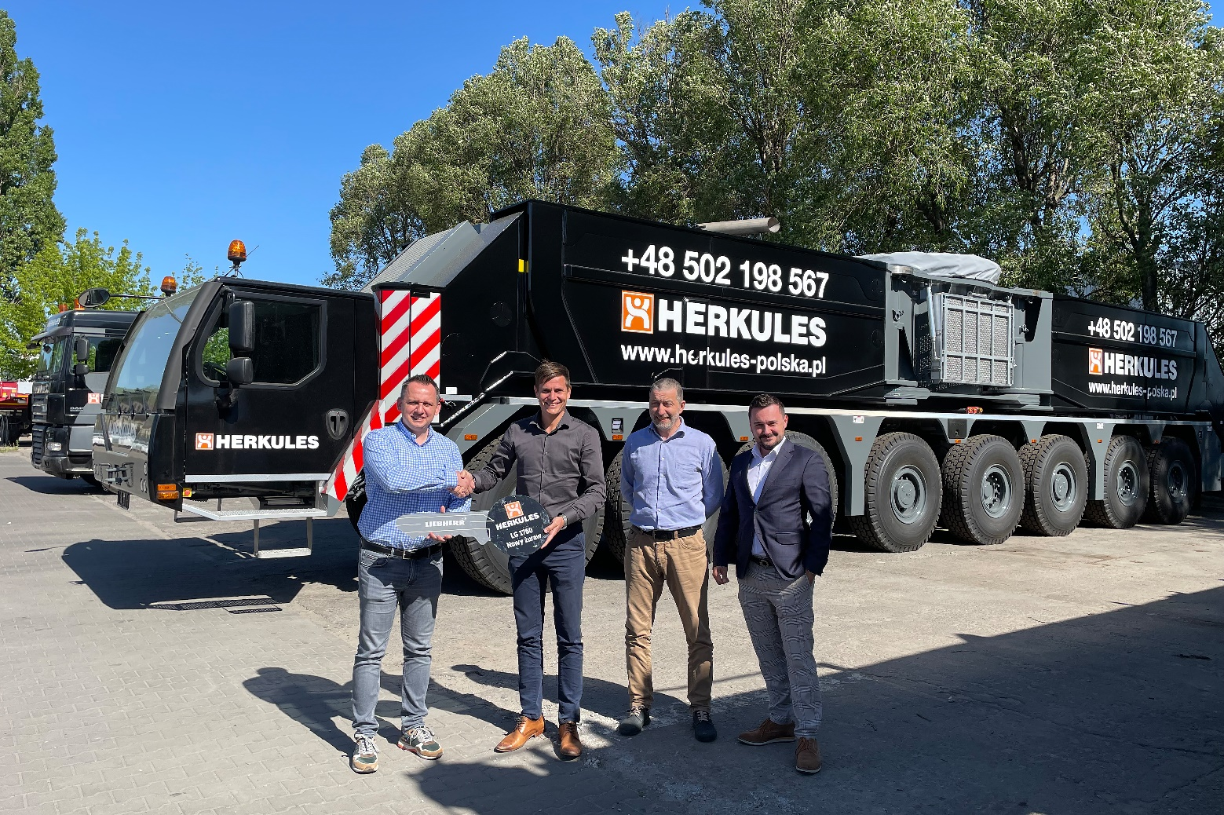

liebherr-lg-1750-handover-herkules.jpg  
Handover of the LG 1750 lattice boom mobile crane to Herkules (from left to right): Mateusz Rychlewski (Herkules), Florian Flöss (Liebherr Ehingen), Pawel Maciejak (Herkules) and Artur Heiduk (Liebherr Poland).

Contact

Wolfgang Beringer  
Marketing and Communication  
Phone: +49 7391/502 - 3663  
Email: wolfgang.beringer@liebherr.com

Published by

Liebherr-Werk Ehingen GmbH  
Ehingen (Donau), Germany  
[www.liebherr.com](http://www.liebherr.com)