Press release

170 metre office tower – Liebherr cranes involved in construction of “To‑Lyon”

⸺

EC-H and EC-B series cranes in Lyon, France, working on the development of a modern urban district

Liebherr provides the perfect concept for anchoring the cranes to advance the site timetable

Crane operators and service technicians travel to their workplace comfortably in the LiUP elevator

A 170 metre building, little space and heavy hoists – four Liebherr tower cranes finished in aircraft warning paintwork are helping to redevelop the Part-Dieu district in Lyon, France. High lifting capacity and a perfect concept for anchoring the cranes were the main focal points for this job for customer Vinci Construction France. Liebherr developed bespoke solutions to meet these demands.

Lyon (France), 28 July 2022 – The cranes used for the project, which is located right next to Lyon central station, are the 420 EC-H 16, 280 EC-H 12, 280 EC-H 16 and 250 EC-B 12. The most striking building in the redevelopment of Part-Dieu is the “To‑Lyon”, a skyscraper with a height of 170 metres. On completion, the building will have a total floor area of 80,000 square metres for offices, businesses and a hotel. New buildings, more space for nature and networked mobility – these are just some of the measures that the district will use to make itself more attractive to residents and visitors.

Precision tailoring of tower and jib to the site conditions

The hook height and jib length of the top-slewing cranes were selected so that the machines can slew over each other without causing problems for each other despite the small amount of space available. This is exactly what the cranes in the ECB and EC‑H series were developed for because the jib length and tower heights can be tailored flexibly to the situation on a site. The jibs on the four cranes working at the site are between 30 and 65 metres in length. Their hook heights are between 47 and 194 metres.

The 420 EC-H 16 will reach a final hook height 194 metres. A stable tower system and a sophisticated concept for guying to the building are what make this enormous hook height possible for the erection of the “To-Lyon”. This is because the guying systems have different lengths as the construction work progresses. Initially longer struts will be used, and then shorter ones. The reason for this is that the crane had to be anchored at a time when the final concrete façade was not finished. This enabled the crane to be erected without jeopardising the whole site timetable.

Precise positioning of concrete and steel

The cranes are mainly being used to help install steel elements and for concreting work. Some of the loads being hoisted way more than twelve tonnes. The Micromove assistance system can be a real benefit for these hoists. Micromove enables crane operators to position heavy loads with fingertip precision and is just one of several assistance systems which are available. Litronic, Liebherr’s smart assistant, is designed to support crane operators in their work and also increase handling capacity, reliability and safety.

Using LiUP to get up to the required height at the touch of a button

All the cranes on the French site feature the LiUP crane operator elevator. Liebherr’s LiUP crane operator elevator is designed to transport two people or a payload of 200 kilogrammes. The crane operator gets to his workplace quickly and safely at the touch of a button. It also means that erection engineers no longer have to face an energy-sapping, time-consuming climb. The LiUP elevator is tailored to Liebherr tower systems and only requires one-time installation. The rails can be left in the tower system during the erection and dismantling processes.

The site is now so far advanced that the 250 EC-B 12 has been dismantled. The 420 EC-H 16 helped to carry out this work. Thanks to its easy-erection design, the EC-B crane was dismantled within a single day. LiConnect quick-release connections and the compact head with the slewing platform, cabin and switchgear cabinet ensure that the cranes can be dismantled and erected quickly and safely. Smooth dismantling was helpful in this particular project because the remaining cranes were able to restart their work quickly. The “To‑Lyon” is scheduled to be completed in spring 2023.

About the Liebherr Tower Cranes Division

More than seven decades of experience make Liebherr an renowned specialist for hoisting technology on all kinds of construction sites. The Liebherr Tower Cranes portfolio includes an extensive range of high quality tower cranes suitable for use all over the world. They include fast-erecting, top-slewing, luffing jib and special cranes as well as mobile construction cranes. Alongside its products, Liebherr Tower Cranes has an extensive range of other services to round off its portfolio – Tower Crane Solutions, the Tower Crane Centre and Tower Crane Customer Service.

About the Liebherr Group

The Liebherr Group is a family-run technology company with a highly diversified product portfolio. The company is one of the largest construction equipment manufacturers in the world. It also provides high-quality and user-oriented products and services in a wide range of other areas. The Liebherr Group includes over 140 companies across all continents. In 2021, it employed more than 49,000 staff and achieved combined revenues of over 11.6 billion euros. Liebherr was founded in Kirchdorf an der Iller in Southern Germany in 1949. Since then, the employees have been pursuing the goal of achieving continuous technological innovation, and bringing industry-leading solutions to its customers.

Images

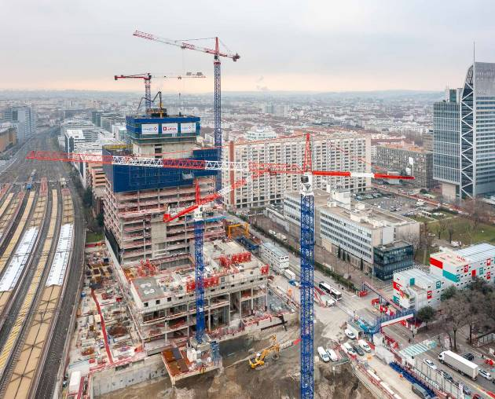

liebherr-lyon-ec-b-ec-h-01.jpg  
At times, four Liebherr cranes were operating simultaneously on the site to complete various buildings, including the “To-Lyon” tower.

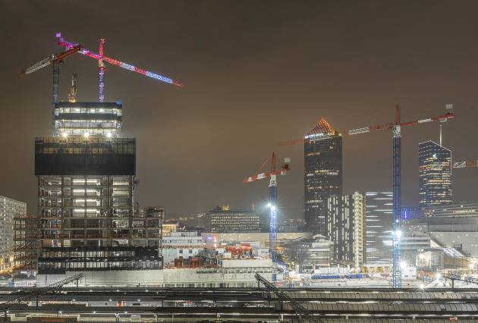

liebherr-lyon-ec-b-ec-h-02.jpg  
All the cranes feature the LiUP crane operator elevator and are finished in aircraft warning paintwork.

liebherr-lyon-ec-b-ec-h-03.jpg  
The 420 EC-H 16 has now dismantled the 250 EC-B 12 within a very short time so that the site can progress even further.

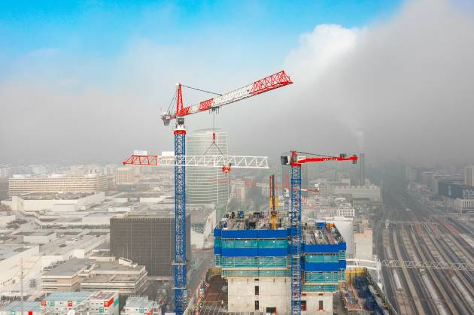

Contact

Daniel Haefele  
Global Communication  
Phone: +49 7351 / 41 - 2330  
Email: daniel.haefele@liebherr.com

Published by

Liebherr-Werk Biberach GmbH  
Biberach / Germany  
www.liebherr.com