Press release

Two new Liebherr mobile cranes for Poloniato

⸺⸺

* Partnership with Liebherr since 1998
* Two new Liebherr 5-axle cranes: LTM 1110-5.1 and LTM 1150-5.3 for Poloniato S.r.l.
* Worldwide high mobility, long boom and good Liebherr service were decisive for the purchase of the two cranes

Italian crane company Poloniato S.r.l. is closing the gap between the 100- to 160-tonne cranes in its fleet with the acquisition of two new Liebherr mobile cranes. The two 5-axle LTM 1110-5.1 and LTM 1150-5.3 impress with their high mobility, long booms and innovative technology. Thanks to the powerful Liebherr cranes and good service, a partnership has grown between Poloniato S.r.l. and Liebherr that has already lasted over 23 years.

Ehingen (Donau) (Germany), 29. July 2022 – Italian crane company Poloniato S.r.l. has taken delivery of two new Liebherr mobile cranes, an LTM 1110-5.1 and an LTM 1150-5.3. The cranes complement Poloniato's fleet in the range between 100 and 160 tonnes lifting capacity.

LTM 1110-5.1: high mobility worldwide and long telescopic boom

"We chose the LTM 1110-5.1 because of some of its fundamental features: the ability to take 13.4 tonnes of counterweight on board, the 60-metre telescopic boom and the VarioBase® Plus support system," explains Michele Poloniato, owner of Poloniato S.r.l. With its 60-metre telescopic boom, the LTM 1110-5.1 offers one of the longest booms in this class of crane and this combined with powerful lifting capacities. Various extensions with folding tips or lattice pieces are possible for the telescopic boom. The 5-axle model also features a variety of different driving conditions – thereby ensuring major advantages for road travel worldwide. The innovative VarioBase® Plus gives the crane's support even more power and safety. The rear supports have a double-stage design and achieve a support width of 8.3 metres, 1.3 metres wider than the front supports. This increases the load-bearing forces over the rear supports even more. Poloniato S.r.l. plans to use the LTM 1110-5.1 mainly for erecting and dismantling tower cranes.

LTM 1150-5.3: high load capacities in steep position and large radius

"Size and performance are in excellent proportion in the LTM 1150-5.3. It offers a 66-metre telescopic boom. What is also special is the possibility to drive on public roads with nine tonnes of counterweight," Michele Poloniato explains the decision for the LTM 1150-5.3. The single-engine strategy with mechanical drive of the superstructure eliminates weight there, which is used for the longer boom and more lifting capacity. This allows the 5-axle crane to do many jobs without extra counterweight transport. This makes it quickly ready for use on the construction site and saves costs. Its 66-metre telescopic boom lifts loads weighing over nine tonnes when fully extended. That makes it perfect for erecting tower cranes. This is also the main area of application for the mobile crane at Poloniato. The crane will also be used in the assembly of prefabricated elements made of reinforced concrete for industrial buildings. The Liebherr-150-tonne crane can achieve hoisting heights of up to 92 metres and radii up to 72 metres using lattice extensions.

Good technical support and fast spare parts service

Liebherr's service also contributed to the decision to buy. "The fast service and excellent support from Liebherr-Italia technicians, the rapid delivery of spare parts and an efficient workshop in Monfalcone have allowed the long-standing relationship with Liebherr to grow," explains Michele Poloniato.

Over 23 years of cooperation with Liebherr

"Our Liebherr mobile cranes are certainly among the best in the world in terms of performance, value and image," Poloniato enthuses. The cooperation between Poloniato and Liebherr has existed for over 23 years. "We have been working with Liebherr since 1998 and during this time we have purchased a total of 11 new and used cranes," says Poloniato. More than half of the Italian company's mobile cranes come from Liebherr.

The Italian crane company Poloniato S.r.l. was founded in 1973. The 30 employees work with the machines in Poloniato's fleet on up to 200 construction sites a year. The Italian crane company is particularly well positioned with machines in the medium load range. The areas of application range from the assembly of construction and hall cranes, to cable car masts and air conditioning systems, to moving loads.

About Liebherr-Werk Ehingen GmbH

Liebherr-Werk Ehingen GmbH is a leading manufacturer of mobile and crawler cranes. Its range of mobile cranes extends from 2-axle 35 tonne cranes to heavy duty cranes with a lifting capacity of 1200 tonnes and a 9-axle chassis. Its lattice boom cranes on mobile or crawler crane chassis deliver lifting capacities of up to 3000 tonnes. With universal boom systems and extensive additional equipment, they can be seen in action on construction sites throughout the world. The Ehingen site has a workforce of 3,800. Extensive, global service guarantees the high availability of Liebherr mobile and crawler cranes. In 2021, the Liebherr plant in Ehingen recorded a turnover of 2.33 billion euros.

About the Liebherr Group

The Liebherr Group is a family-run technology company with a highly diversified product portfolio. The company is one of the largest construction equipment manufacturers in the world. It also provides high-quality and user-oriented products and services in a wide range of other areas. The Liebherr Group includes over 140 companies across all continents. In 2021, it employed more than 49,000 staff and achieved combined revenues of over 11.6 billion euros. Liebherr was founded in Kirchdorf an der Iller in Southern Germany in 1949. Since then, the employees have been pursuing the goal of achieving continuous technological innovation, and bringing industry-leading solutions to its customers.

Image

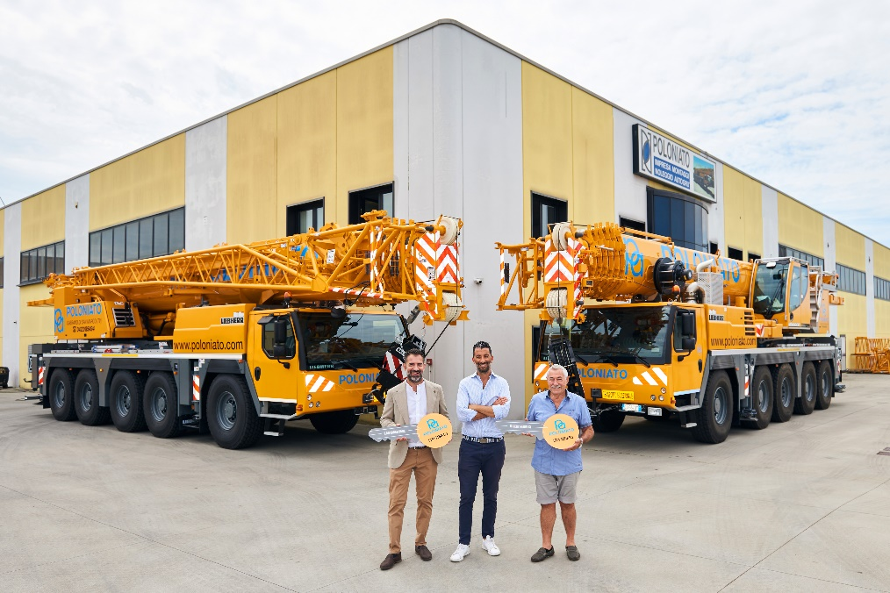

liebherr-ltm1110-5-1-ltm1150-5.3-handover-poloniato.jpg  
Handover of the LTM 1110-5.1 und LTM 1150-5.3 crane to Poloniato S.r.l. (from left to right): Michele Poloniato (Poloniato S.r.l.), Davide Calore (Liebherr-Italia S.p.a.) and Angelo Poloniato (Poloniato S.r.l.).

Contact

Wolfgang Beringer  
Marketing and Communication  
Phone: +49 7391/502 - 3663  
Email: wolfgang.beringer@liebherr.com

Published by

Liebherr-Werk Ehingen GmbH  
Ehingen (Donau), Germany  
[www.liebherr.com](http://www.liebherr.com)