Press release

Morrow Equipment purchases 27 Liebherr tower cranes

⸺

Purchased 27 tower cranes to add to growing fleet

Exclusive distributor of Liebherr manufactured tower cranes in US, Mexico, and Canada

Committed to continued growth with Liebherr

With a primary focus on tower cranes within the construction industry, Morrow Equipment Company, LLC purchased multiple cranes to add to their already established fleet, providing further growth opportunities for the company in North America.

Newport News, VA (USA), Liebherr USA, Co., July 8, 2022 – Based out of Salem, OR, Morrow Equipment Company, LLC (Morrow) recently purchased 27 tower cranes to add to their fleet at Liebherr USA, Co’s first Customer Day in May of 2022. Morrow has been using Liebherr products for over 40 years and serves as an exclusive distributor with a strong network of locations and over 320 employees across the US, Canada, and Mexico.

Morrow’s established fleet is already equipped with over 560 cranes. Their most recent acquisition at Customer Day included multiple 340 EC-B flat top, 470 EC-B flat top, 357 Luffing HCL, and 125 K fast erecting cranes to be used for lifting materials such as concrete, steel, and lumber at various project sites. Each of these cranes are designed to suit the modern world, allowing multiple cranes to work optimally in tight spaces on industrial, commercial, and residential construction sites.

Flexibility and versatility

Liebherr cranes are designed for lifting and precise positioning of heavy loads. Each crane enables easy handling, high hook heights, and efficient operation.

The [EC-B series](https://www.liebherr.com/en/usa/products/construction-machines/tower-cranes/top-slewing-cranes/flat-top-ec-b/ec-b-series/ec-b-series.html) flat-top cranes are characterized by simple assembly, powerful handling drives, and flexible usage. The 470 EC-B 20 is the latest member of the "tough ones" family, and provides a lifting capacity of up to 20 tons (22 USt).

Liebherr’s [HC-L series](https://www.liebherr.com/en/usa/products/construction-machines/tower-cranes/top-slewing-cranes/luffing-hc-l/luffing-hc-l.html) cranes are generally used in the construction of skyscrapers. A major advantage of the luffing jib crane is that several cranes can be easily erected in a small space. These cranes also offer the horizontal load path function, allowing crane operators to concentrate on positioning loads without the need to manually readjust the height of the load when the system is activated.

The Liebherr [125 K](https://www.liebherr.com/en/usa/products/construction-machines/tower-cranes/fast-erecting-cranes/k-cranes/details/253430.html) combines the performance of a top-slewing crane with all the benefits and mobility of a fast-erecting crane. It is currently the largest fast-erecting crane on the market, and it was specifically developed for civil engineering needs such as housing developments as well as commercial and industrial building construction.

A trusted partnership

Having 50 years of experience, Morrow is an established leader in lift equipment specializing in tower crane leasing and sales, as well as support services including engineering, parts distribution and servicing.

“As part of our continued commitment to provide the best quality equipment available in the North American tower crane market, along with our long-term growth strategy, we are pleased to have worked with Liebherr to put this order together,“ noted Peter Juhren, President and COO of Morrow. “Liebherr has been a great partner for over four decades, and we continue to reinforce that relationship. We share the same passion for the best equipment, backed by Morrow’s local network of service locations, technicians, and over $23 million dollars in spare parts stocked locally. Our customers have to come to expect the same quality and service wherever their project may be.”

About Morrow Equipment

Since 1968, Morrow has focused exclusively on the tower crane and construction hoist industry. As an exclusive distributor of Liebherr-manufactured tower cranes and as a representative of Alimak Scando hoists, Morrow has developed a unique expertise and knowledge of the tower crane product line. Morrow’s technical knowledge and foundational support, combined with the high-quality products, has made them one of the most successful in the lift equipment industry.

About Liebherr USA, Co.

[Liebherr USA, Co](https://www.liebherr.com/en/usa/start/start-page.html). based in Newport News, VA provides sales and service on behalf of ten different Liebherr product segments: earthmoving, material handling, mining, mobile and crawler cranes, tower cranes, concrete technology, deep foundation machines, maritime cranes; components, and refrigeration and freezing.

About the Liebherr Group

The [Liebherr Group](https://www.liebherr.com/en/usa/about-liebherr/about-liebherr.html) is a family-run technology company with a highly diversified product portfolio. The company is one of the largest construction equipment manufacturers in the world. It also provides high-quality and user-oriented products and services in a wide range of other areas. The Liebherr Group includes over 140 companies across all continents. In 2021, it employed more than 49,000 staff and achieved combined revenues of over 11.6 billion euros. Liebherr was founded in Kirchdorf an der Iller in Southern Germany in 1949. Since then, the employees have been pursuing the goal of achieving continuous technological innovation, and bringing industry-leading solutions to its customers.

Images

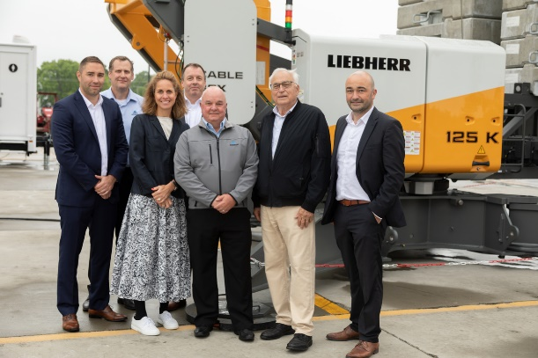

Tower_Crane_Handover_LUS_CustomerDay_007.jpg

The Morrow team and Liebherr tower crane team pose in front of a 125 K fast erecting crane at the first Liebherr USA, Co. Customer Day in Newport News, VA. From left to right: Andrew Stalter, Michael Heacock Morrow, Stéfanie Wohlfarth, Stefan Brandt, Peter Juhren Morrow, Willi Liebherr, Marco Guariglia

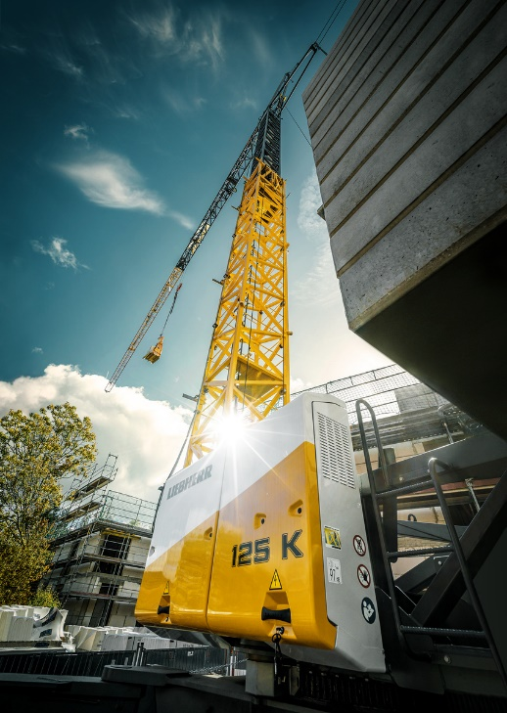

125K_SOS-Kinderdorf_Gemuenden_D_2019-Print_angesetzt_web.jpg  
Close up shot of the 125 K fast erecting crane.

Contact

Ana Cabiedes   
General Manager, Marketing, Liebherr USA, Co.  
Phone: +1 757-240-4250   
E-Mail: ana.cabiedes@liebherr.com

Daniel Haefele  
Global Communication, Tower Cranes  
Phone: +49 7351/41 - 2330  
E-Mail: daniel.haefele@liebherr.com

Published by

Liebherr USA, Co.  
Newport News / USA  
www.liebherr.com