Press release

Liebherr HS 8100.1 duty cycle crawler crane utilized on Florida coast

⸺

Duty cycle crawler crane provided dredging services in Florida

Machine in operation 10-12 hours per day throughout duration of project

Reliability and production were major factors in choosing Liebherr

Brance Diversified, Inc. (BDI), a dredge and marine construction company, utilized their new 100 USt (110 t) Liebherr HS 8100.1 duty cycle crawler crane for a clamshell operation on St. John’s River in Jacksonville, FL. BDI actively work on projects perserving Florida’s waterways and wetlands, relying on Liebherr’s crawler crane to efficiently work on these large scale operations.

Newport News, VA (USA), Liebherr USA, Co., Crawler Cranes and Deep Foundation Machines, January 13 2023 – Brance Diversified, Inc. (BDI) spent approximately two months dredging 50,000 cubic yards off of a barge in Jacksonville, FL. BDI chose to use their [Liebherr HS 8100.1](https://www.liebherr.com/en/usa/products/construction-machines/earthmoving/duty-cycle-crawler-cranes/details/hs8100hd.html#!/content=table_module_technical_data) duty cycle crawler crane to complete this job due to its reliability, excellent clamshell barge charts and efficient production.

“We chose the HS 8100.1 because of its powerful 523 hp engine, 61,800 lbs. line pull winches, low noise emission and low fuel consumption” said BDI’s President, Lance Young. The hydraulic crawler crane has a Liebherr diesel engine which complies with Tier 4 regulations supporting BDI’s mission of being an environmentally safe company.

BDI’s machine includes Liebherr’s GrabMatic® System which assists operators in clamshell projects. It visually aids the operator with optimized grab closing including level cutting and shows the machine’s inclination up to 40 on the operator’s monitor, as well as records cycles and turnover. “These systems increase safety, minimize rope wear and significantly increase turnover/production, allowing our customers to dredge larger projects faster and more efficiently” notes Wolfgang Herzog, Liebherr USA, Co. Crawler Cranes and Deep Foundation Machines, VP Sales South East & Caribbean.

BDI also added a lighting package for dusk/night work as the crawler crane operated for 10-12 hours a day throughout various light conditions handling materials such as sand and silt. “Reliability and production definitely meet and exceed our expectations,” said Young.

**About Liebherr USA, Co.**

[Liebherr USA, Co](https://www.liebherr.com/en/usa/start/start-page.html). based in Newport News, VA provides sales and service on behalf of ten different Liebherr product segments: earthmoving, material handling, mining, mobile and crawler cranes, tower cranes, concrete technology, deep foundation machines, maritime cranes; components, and refrigeration and freezing.

**About the Liebherr Group**

The [Liebherr Group](https://www.liebherr.com/en/usa/about-liebherr/about-liebherr.html) is a family-run technology company with a highly diversified product portfolio. The company is one of the largest construction equipment manufacturers in the world. It also provides high-quality and user-oriented products and services in a wide range of other areas. The Liebherr Group includes over 140 companies across all continents. In 2021, it employed more than 49,000 staff and achieved combined revenues of over 11.6 billion euros. Liebherr was founded in Kirchdorf an der Iller in Southern Germany in 1949. Since then, the employees have been pursuing the goal of achieving continuous technological innovation, and bringing industry-leading solutions to its customers.

Images

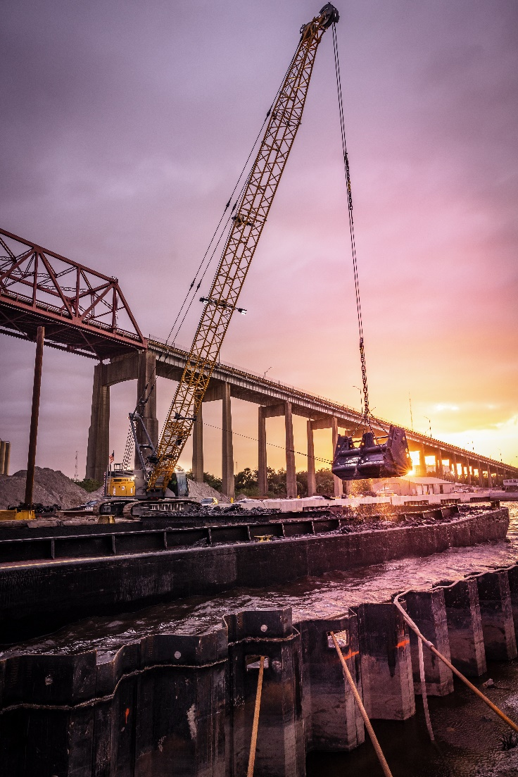

liebherr-HS-8100.1-Jacksonville-portrait.jpg  
Brance Diversified, Inc. utilizes the Liebherr HS 8100.1 for dredging work off the coast of Florida.

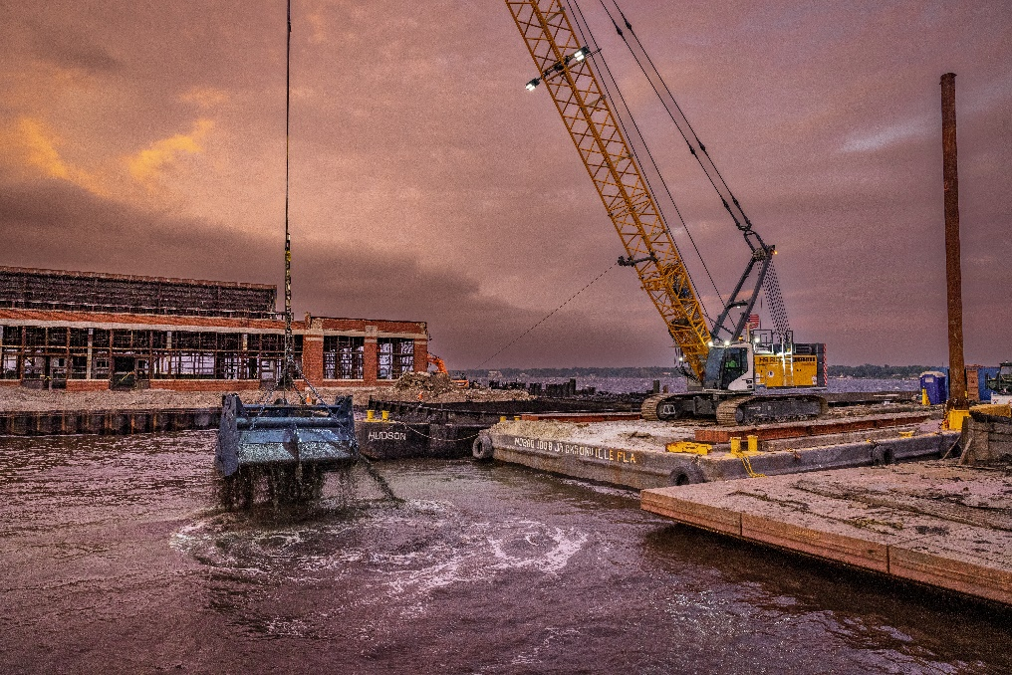

liebherr-HS-8100.1-Jacksonville-landscape.jpg  
Brance Diversified, Inc. purchased both the dredging and lighting packages to equip their crawler crane.

Contact

Ana Cabiedes   
Head of Marketing

Liebherr USA, Co  
E-Mail: ana.cabiedes@liebherr.com

Published by

Liebherr USA, Co.   
Newport News / USA  
www.liebherr.com