Press release

"On your site": Liebherr at Conexpo 2023

⸺

Liebherr showcases over 30 exhibits from seven product segments and various solutions from its high-quality portfolio

Efficiency, digitalization & service as well as product responsibility: how Liebherr aims to meet individual customer needs on every construction site

Liebherr construction machines on the outdoor grounds at booth #F9253, Liebherr components at booth #S80821 in the South Hall

Liebherr exhibits at Conexpo 2023 from March 14-18 offer visitors the unique opportunity to discover the latest developments from the areas of construction machines, cranes, material handling technology and components. "On your site," is the motto at this year’s Conexpo. It represents Liebherr’s promise to be at the customers’ side around the world at all times – whether it is directly on the construction site with high-quality machines or through individual advice, global services and comprehensive solutions.

Biberach a.d. Riss (Germany), 9 February 2023 – The Liebherr booths at Conexpo 2023 offer space for more than 30 exhibits on a total exhibition area of almost 60,500 ft² (~ 5,600 m²) (Festival Grounds, booth F9253). The area was enlarged by approximately 7.200 ft² (~ 670 m²) due to the addition of a demo area, where Liebherr will show its machines in action for the first time at Conexpo. Numerous new products and developments from the areas of construction machines, cranes and material handling technology are on display. In addition, Liebherr presents the latest innovations from its components product segment in the South Hall (booth S80821).

Higher efficiency through maximum performance, economy and flexibility

The TA 230 Litronic from the new generation of articulated dump trucks, has been redeveloped from scratch not only featuring a new design. The machine was unveiled to the U.S. market during Liebherr USA, Co’s Customer Day event in May of 2022 and it is now introduced to the rest of the North American market at Conexpo 2023. The TA 230 Litronic showcases performance, efficiency and utmost comfort.

With the two material handling machines, the LH 30 M Industry Litronic and the LH 60 M Industry Litronic, Liebherr will present two models specifically designed for scrap handling. The handling of scrap steel and other metals is one of the toughest applications in industrial material handling which requires high-performance and economical material handlers.

Likewise, Liebherr's Generation 8 crawler excavators have proven as top performers since their market launch in the USA at Conexpo 2020: The machines with proven technology have fully established themselves on the US market. The R 924 and R 945A feature higher engine power, a larger counterweight in conjunction with higher bucket capacities and increased digging and pulling forces – special characteristics of the Generation 8 crawler excavators compared to their predecessors.

The concrete technology product segment is launching US sales of an exhibit that combines the most efficient technologies in a compact machine. The new 36 XXT truck mounted concrete pump comes equipped with the advantages of a new five-part folding boom with the Powerbloc drive unit and the semi-closed oil circuit. The 36 XXT is a versatile machine including multiple comfort and safety enhancing factors, such as ergonomic access steps and simplified accessibility. An extremely compact assembly with no boom overhang at the rear ensures high maneuverability in confined spaces. A major highlight of the new 36 XXT is Liebherr's newly developed “Powerbloc” pump drive unit that is characterized by the fact that all hydraulic switching and measuring elements are fully integrated.

In response to market needs, Liebherr´s mobile and crawler cranes will present the new LR 1400 SX which extends its range of crawler cranes. For Conexpo, the LR 1400 SX is fitted with a 134,514 ft (41 m) main boom and a 144,357 ft (44 m) luffing jib. With the compact transport weight of 50,706 USt (46 t), the complete crane can be transported easily between jobsites. Whether expanding the infrastructure with bridges or tunnels, constructing stadiums or factories with steel or precast concrete elements, working in the energy sector or lifting work on high buildings – this versatile and highly efficient machine is useful in the most diverse work applications.

Also from the area of cranes, Liebherr will show "The master of all roads": a mobile crane that takes the combination of mobility, economy and performance to a new level. The LTM 1100-5.3 offers a powerful 203 ft (62 m) telescopic boom and carries up to 37,250 lbs (16.9 t) of ballast with a 26,450 lbs (12 t) axle load on public roads. The new crane also provides economical mobility worldwide as it can travel with an axle load of only 19,840 lbs (9 t).

Flexibility and economical worldwide transport also characterize the LRT 1130-2.1: As the most powerful 2-axle rough-terrain crane with longest telescopic boom on the market, this crane is especially adapted to the needs of the US-market. The LRT 1130-2.1 has a maximum lifting capacity of 140 USt (130 t) and extends Liebherr’s range of rough-terrain cranes at the top end of this segment.

For the first time at a trade show in North America the product segment tower cranes will present the 470 EC-B, its largest flat-top crane in steel rope design. The top-slewing crane excels with a maximum lifting capacity of 35,270 lbs (16 t) or 44,090 lbs (20 t). From transport through assembly to operation on site: this Liebherr crane meets all the demands of a modern fleet.

This also applies to the 125 K from the K crane series: the fast-erecting crane offers maximum lifting capacity with minimum space requirements. With a radius of 180 ft (55 m) and a hook height of up to approx. 217 ft (66 m), the Liebherr 125 K is currently the largest fast-erecting crane on the market. A well-thought-out assembly system and low logistical costs make the Liebherr fast-erecting cranes particularly useful for shorter projects.

Individual digital solutions and services: improved reliability for customers

From the deep foundation machines segment, visitors will be able to experience the LRB 23 piling and drilling rig and the LB 30 unplugged drilling rig at the trade show. These two machines are characterized by maximum reliability and safety thanks to digital assistance systems: Ground Pressure Visualization, for example, calculates the machine's current ground pressure in real time and compares it with the specified safety limits. The Kelly Visualization makes locking the telescopic rails of the Kelly bar much easier. The drilling assistant enables automated drilling during the concreting process. Automatic obstacle recognition and remote control are used to recognize attachments as well as simplify the loading process during transport and assembly. All of these systems, partially available for crawler cranes, contribute to time savings and higher machine availability as well as a significant increase in safety during operation.

As a holistic solutions provider, Liebherr Tower Cranes is presenting its new digital service portfolio for the first time in North America at Conexpo. Liebherr supports customers with its ”Plan and Analyze“ concept for comprehensive planning and spot-on analysis. The dimension "Plan" covers the digital planning of construction sites, including the digital design and selection of crane models based on crane information models. These then form the basis for a precisely fitting crane selection that best meets the requirements of the respective construction site. Liebherr's digital Site Monitoring enables efficient "Analyzing" processes as: relevant crane data can be easily recorded, displayed and analyzed. This information also gives site managers and construction planners a reliable overview of efficiency and construction progress.

The product range of Liebherr attachments is specifically designed and customized for the respective application and optimally configured for the machine size. During Conexpo, a range of Liebherr´s attachments will be demonstrated for example on the R 914 Compact Litronic excavator. Liebherr will demonstrate, amongst others, its fully automatic quick coupling system Solidlink during live shows in a dedicated demo area. Solidlink, formerly known as LIKFUIX, is a hydraulic quick coupler combined with an automatic hydraulic coupling system developed by Liebherr. Here, Liebherr will demonstrate how Solidlink allows both mechanical and hydraulic attachments to be changed quickly, efficiently and safely from the operator's cab. Application possibilities and utilization of the machines can be increased by up to 90 % with this solution.

For the first time in North America, Liebherr is presenting its new medium-sized wheel loaders, which are equipped with a wide range of digital assistance systems. With a significant increase in performance compared to the previous models, the new machines are prepared for demanding applications in various industries such as mining, recycling or the timber industry. The portfolio of intelligent assistance systems for maximum reliability and safety includes, for example, active person detection with brake assist or the revised Skyview 360° camera system for an optimal all round view even in poor visibility conditions. Moreover, Liebherr shows several large wheel loaders of the XPower® series at the booth. Thanks to their power-split driveline, these wheel loaders are known for their tremendous fuel efficiency.

From the field of digitalization, the components product segment will also be presenting, amongst others, its digital bearing clearance monitoring (BCM) for slewing bearings. The integrated wear measurement system enables optimum remote monitoring of the slewing bearings in various applications, such as mining and material handling or maritime applications. The BCM system can be used to measure bearing wear in axial and radial directions, as well as tilting clearance. These diagnostics ensure flexibility in measurement, reduced downtime and lower costs in maintenance.

Safe and environmentally compatible products for the long term

As a globally active family-run company, Liebherr bears a great responsibility towards society and the environment. That is why Liebherr is working, among other things, on the continuous improvement of work safety. It has always been important for Liebherr that customers can rely on our machines at all times and can work safely with them.

This includes, for example, comprehensive work on modern assistance systems for earthmoving machines and cranes, which relieve the machine operator and thus make a significant contribution to work safety on the construction site. Under the slogan "Safety first", the mobile and crawler crane segment will be demonstrating the latest safety equipment and assistance systems that set new standards, using its LRT 1130-2.1 on display as an example. One of the highlights is the VarioBase® variable outrigger base developed by Liebherr, which is used as standard on all Liebherr-LRT-cranes and makes an important contribution to increasing safety. With VarioBase®, each individual crane jib can be extended to any length. Crane operation is controlled by a load moment limiter, which calculates the maximum lifting capacities precisely for the current situation.

In order to also meet our claim to environmental compatibility Liebherr is working to continually reduce the ecological footprint of its products throughout their entire life cycle, from development to disposal. Today, the Liebherr Group already offers its customers numerous ecologically optimized products, some of which operate with zero local emissions. The basis for this is, among other things, our technology neutral work on alternative drives.

At Conexpo, for example, visitors are able to experience the LB 30 unplugged from the deep foundation machines product segment. For battery operation and thus local zero emission, the charging cable only has to be unplugged and reconnected to the construction power supply for unrestricted operation. The battery is designed for an operating time of 4 hours in Kelly mode. Whether in battery or socket operation, the drilling performance remains unchanged.

In addition, Liebherr Components will present a prototype of its hydrogen engine, the H964, for the first time in the USA. It employs a direct hydrogen injection also developed by Liebherr. This technology is particularly well suited for dynamic heavy-duty applications, since it offers high power density. Durable against dust, dirt and vibrations, as well as other harsh environmental conditions, the direct injection is comparable to the diesel engine in terms of performance and durability.

Also from Liebherr Components, open circuit hydraulic pumps along with the successful high-speed DMVA double motor, featuring high power density and flexibility in control, expand Liebherr's axial piston portfolio for robust applications.

About the Liebherr Group

The Liebherr Group is a family-run technology company with a highly diversified product portfolio. The company is one of the largest construction equipment manufacturers in the world. It also provides high-quality and user-oriented products and services in a wide range of other areas. The Liebherr Group includes over 140 companies across all continents. In 2021, it employed more than 49,000 staff and achieved combined revenues of over 11.6 billion euros. Liebherr was founded in Kirchdorf an der Iller in Southern Germany in 1949. Since then, the employees have been pursuing the goal of achieving continuous technological innovation, and bringing industry-leading solutions to its customers.

Image

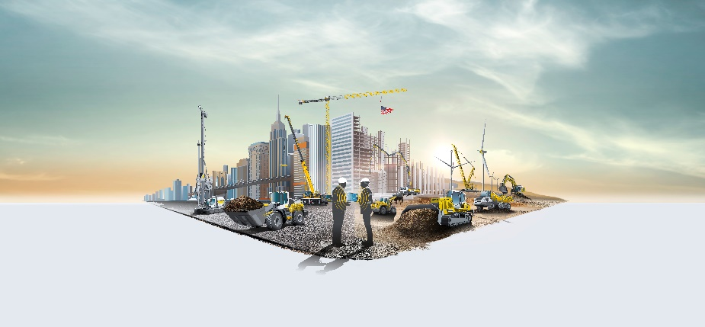

liebherr-conexpo-2023.jpg  
Using the motto "On your site", Liebherr presents customized solutions for the construction site of the future at Conexpo in Las Vegas, NV (United States).

Contact

Philipp Hirth  
Head of Public Relations  
Phone: +49 7351 4144-45  
Email: [philipp.hirth@liebherr.com](mailto:philipp.hirth@liebherr.com)

Ana Cabiedes   
Head of Marketing, Liebherr USA, Co  
Phone: +1 757 240-4250

Email: ana.cabiedes@liebherr.com

Published by

Liebherr-International Deutschland GmbH  
Hans-Liebherr-Strasse 45  
88400 Biberach an der Riss / Germany  
www.liebherr.com