Press release

Doyle Shipping Group order hybrid RTG

⸺

Doyle Shipping Group in Dublin order hybrid RTG

Sustainable solution delivers reduced emissions and costs

Killarney (Ireland), April 2023 – Liebherr Container Cranes is proud to announce the sale of a new hybrid rubber Tyre gantry crane (RTG) to Doyle Shipping Group (DSG), at Dublin Port. The new RTG has a span of 25.9 meters, which is seven containers plus a truck lane wide, and a lift height of 21 meters, which is one over six containers high and a safe working load of 41 tonnes.

Dan O’Shea, Area Sales Manager for Europe with Liebherr Container Cranes commented. "We are delighted to continue our long-standing relationship with DSG and to provide them with the latest technology in container handling. Liebherr have worked with Doyle’s Shipping Group at Dublin Port since 1999 when they received the first of six Liebherr Harbour Mobile (LHM) cranes. Subsequent years saw the addition of five more LHMs and in 2007, they received the first three of their Liebherr RTGs, with the newest machine bringing to 12 the number of RTGs at the terminal. In addition, we have supplied a ship to shore container crane in 2015. DSG are thoroughly familiar with the benefits of Liebherr equipment, and we are proud to continue our long-standing partnership with this new hybrid RTG.”

Mr O’Shea continued "Commitment to sustainability is not just an option but is a responsibility for both Liebherr Container Cranes and Doyle Shipping Group. As two leading companies in the supply chain, we understand the vital importance of operating in a way that minimises our environmental impact, while maximising social and economic benefits. Liebherr's Gold Medal in sustainability from EcoVadis is a clear demonstration of our unwavering dedication to transparency and certainty in sustainable supply chains. For our customers, choosing sustainable equipment is a vital first step towards a sustainable economy, where every stage of the supply chain works in harmony to deliver truly sustainable products to consumers. Our commitment to sustainability is not just a choice, but an obligation that we embrace with pride."

The LES 200 is a state-of-the-art capacitor system that effectively captures and preserves the energy produced during hoist lowering and braking, which would otherwise go to waste. The captured energy is redeployed during peak demand to reduce the overall energy consumption and emissions of the RTG. The system not only benefits the environment but also ensures cost savings by reducing running and maintenance expenses.

The solution is available on both new machines and as a retrofittable solution via Liebherr Transform.

About Liebherr Container Cranes

Liebherr Container Cranes Ltd. Is one of the world’s leading manufacturers of ship to shore container cranes, rail mounted gantry cranes and rubber tyre gantry cranes. From a base in Killarney, Ireland, Liebherr Container Cranes Ltd designs, builds and exports container cranes worldwide. Founded in 1958 as the first Liebherr factory outside of Germany, today, container cranes manufactured by Liebherr in Ireland are renowned for their quality, longevity and productivity.

About the Liebherr Group

The Liebherr Group is a family-run technology company with a highly diversified product portfolio. The company is one of the largest construction equipment manufacturers in the world. It also provides high-quality and user-oriented products and services in a wide range of other areas. The Liebherr Group includes over 140 companies across all continents. In 2021, it employed more than 49,000 staff and achieved combined revenues of over 11.6 billion euros. Liebherr was founded in Kirchdorf an der Iller in Southern Germany in 1949. Since then, the employees have been pursuing the goal of achieving continuous technological innovation, and bringing industry-leading solutions to its customers.

Images

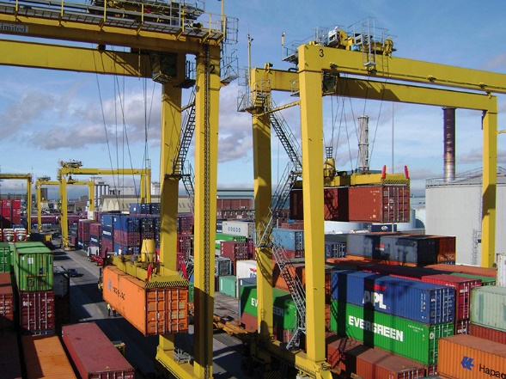  
Liebherr-RTG  
Liebherr RTGs at DSG in Dublin Port

Contact

Trevor O’Donoghue  
Marketing Manager  
Telephone: +353 (0) 64 668 0459   
email: trevor.odonoghue@liebherr.com

Published by

Liebherr Container Cranes Ltd.  
Killarney / Ireland  
www.liebherr.com