Press release

Liebherr to explore new technologies for hydrogen-powered aircraft

**⸺**

**Liebherr-Aerospace is supporting Airbus in its ambition to develop the world’s first hydrogen-powered commercial aircraft by 2035. The OEM develops an air supply system for the fuel cell dedicated to the propulsion of Airbus demonstrator aircraft.**

Toulouse (France) April 2023 – Liebherr-Aerospace is developing an air supply system for the fuel cell dedicated to the propulsion of Airbus hydrogen-powered demonstrator aircraft.

After the first study phase, the OEM has already designed and delivered a functional air supply system demonstrator with a power of 1 MW, which is presently installed in Airbus’ testing facilities.

During the second study phase, currently in progress, Liebherr-Aerospace aims to design and qualify a safety-of-flight air supply demonstrator, which is able to withstand the integration constraints in an operational environment close to the propulsion system. This demonstrator will support a flight test campaign to demonstrate the performance of a fuel cell propulsion system under operational conditions by the middle of the decade.

“We are very pleased to support Airbus in this ambitious project. As Liebherr’s center of excellence for air management systems, we are continuously investing in Research and Development to offer innovative technological breakthrough solutions to our customers. Our systems and components are on board the Airbus aircraft family and we are proud to say that we will also participate in this emblematic program that will contribute to transform aviation towards a sustainable future,” commented Dr. Nathalie Duquesne, Managing Director at Liebherr-Aerospace Toulouse SAS.

**About Liebherr-Aerospace & Transportation**

Liebherr-Aerospace & Transportation SAS, Toulouse (France), is one of eleven divisional control companies within the Liebherr Group and coordinates all activities in the aerospace and transportation systems sectors.

Liebherr-Aerospace is a leading supplier of systems for the aviation industry and has more than six decades of experience in this field. The range of aviation equipment produced by Liebherr for the civil and defense sectors includes flight control and actuation systems, gears and gearboxes, landing gear and air management systems as well as electronics. These systems are deployed in wide-bodied aircraft, single aisle and regional aircraft, business jets, defense aircraft, defense transporters, defense training aircraft and civil and defense helicopters.

Liebherr’s aerospace and transportation systems division employs around 6,000 people. It has three aviation equipment production plants at Lindenberg (Germany), Toulouse (France) and Guaratinguetá (Brazil). These production sites offer a worldwide service with additional customer service centers in Saline (Michigan/USA), Seattle (Washington/USA), Montreal (Canada), Hamburg (Germany), Dubai (UAE), Bangalore (India), Singapore and Shanghai (People’s Republic of China).

**About the Liebherr Group**

The Liebherr Group is a family-run technology company with a highly diversified product portfolio. The company is one of the largest construction equipment manufacturers in the world. It also provides high-quality and user-oriented products and services in a wide range of other areas. The Liebherr Group includes over 140 companies across all continents. In 2022, it employed around 51,000 staff and achieved combined revenues of over 12.5 billion euros. Liebherr was founded in Kirchdorf an der Iller in Southern Germany in 1949. Since then, the employees have been pursuing the goal of achieving continuous technological innovation, and bringing industry-leading solutions to its customers.

**Image**

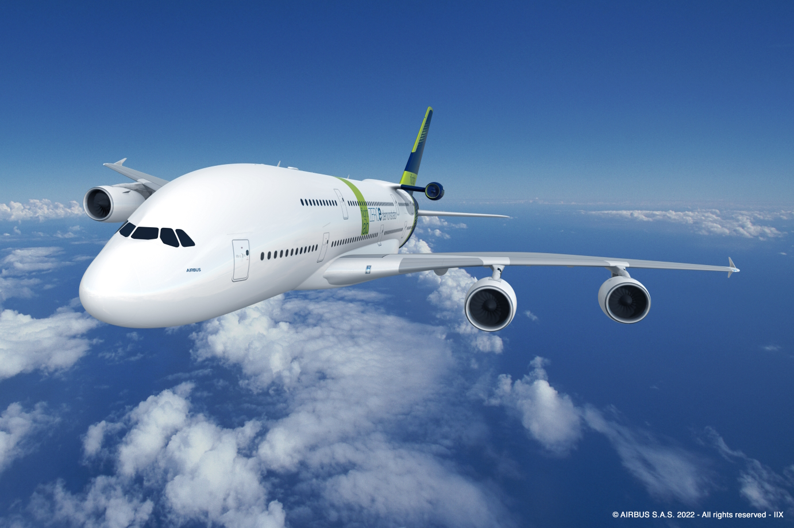

A380 - an ideal flight test platform for the ZEROe demonstrator.jpg

The A380 – an ideal flight test platform for the ZEROe demonstrator - © Airbus S.A.S. 2022

**Contact person**

Ute Braam  
Corporate Communications  
Phone: +49 8381 / 46 - 4403  
E-mail: [ute.braam@liebherr.com](mailto:ute.braam@liebherr.com)

**Published by**

Liebherr-Aerospace & Transportation SAS   
Toulouse / France  
www.liebherr.com