Press release

LTM 1300-6.3 – A powerhouse over the rear

⸺

LTM 1300-6.3 confidently assists LTM 1650-8.1 in lifting huge combustion boilers

Floßdorf masters challenge with clever operational concept

The 300-tonner impresses with its load capacities over the rear supports – thanks to VarioBase®Plus

Dietmar Floßdorf GmbH & Co. KG was one of the first three crane companies in Germany to put the new Liebherr LTM 1300-6.3 mobile crane into service. For a few weeks now, the company based in Bad Neuenahr-Ahrweiler in Rhineland-Palatinate has been sending its newcomer on assignments. The 6-axle crane has now replaced an LTM 1300-6.2 in the fleet at Floßdorf. On just its second job, the new machine was able to demonstrate its strengths during a tandem lift of massive combustion boilers.

Ehingen (Donau) (Germany), 13 April 2023 – "The telescopic section, which is really long at 90 metres, and the super lifting capacity when working over the rear make this new mobile crane very appealing for us," says Marco Floßdorf, explaining his company's decision to buy the LTM 1300-6.3. In February, the young company officer and scion of the family business was present when the mobile crane was handed over at the Liebherr factory in Ehingen. "The new crane will certainly be used on all kinds of jobs at our company and, if necessary, will be a capable assistant to our LTM 1650-8.1."

One of the first jobs on which the modern 300-tonne mobile crane was deployed involved two tandem lifts that were executed with Floßdorf's most powerful mobile crane. Two enormous steel boilers, the heaviest weighing almost 100 tonnes, had to be installed in a new power plant at a paper factory in Düren. Some very cramped conditions and a pipe bridge running between the pre-assembly site and the installation site made the job a bit of a challenge. Originally, the customer planned to use a crawler crane. However, a well thought-out concept designed by Thorsten Mahlberg from Floßdorf's technical field service, which instead involved operating mobile cranes on both sides of the pipe bridge, convinced the client. Mahlberg positioned the LTM 1650-8.1 – equipped with Y-guying and 155 tonnes of ballast – directly in front of the power plant construction site. The LTM 1300-6.3 was used on the other side of the pipes to guide the mighty steam boilers into a vertical position while they were being turned.

Taking on a load via the rear support

The VarioBase®Plus trapezoidal support on the LTM 1300-6.3, one of this mobile crane's many innovative features, provided more than sufficient stability while the two Liebherr machines lifted the huge steel elements from their pre-assembly site. The new crane had to cope with a maximum load of 48.2 tonnes at a radius of 14.3 metres before the large crane gradually took over the load and moved the boilers into a vertical position. Lifting them into the prefabricated steel structure for the future power plant was then the sole responsibility of the LTM 1650-8.1 and its two experienced drivers, Martin Pohl and Martin Holzem.

Both men's expertise really became apparent as the heavy steel blocks were carefully inserted into the new building. During this demanding manoeuvre, there was only about a hand's breadth of space between them and the steel construction on the side of the boilers, which were around twenty metres high. These first had to be precisely positioned and then held in place for hours until the enormous load was released following welding work on the structure.

Jibs of other LTM cranes are compatible

Floßdorf did not purchase any jibs for its new LTM 1300-6.3. "If the long telescopic boom is ever insufficient, we can use the fixed or hydraulically adjustable jibs from our other Liebherr cranes," said Michael Sadrinna, pointing out the advantageous compatibility of the Liebherr machines. As an active and progressive company – its portfolio includes heavy transport, rental and working platforms – Floßdorf owns a modern fleet of cranes made exclusively by Liebherr. Therefore, there is no shortage of equipment in stock for its LTM units.

Indeed, the 90-metre boom of its newly acquired mobile crane will probably suffice for the vast majority of the company's future assignments. Thorsten Mahlberg, Floßdorf's project manager, already has his eye on the new 300-tonne crane for the planned dismantling of a 70-metre-high chimney. "We could hang a demolition grapple from the hook block on the LTM 1300-6.3, which could then nibble away at the chimney from above. Of course, with its long telescopic boom the crane would be perfect for that."

About Liebherr-Werk Ehingen GmbH

Liebherr-Werk Ehingen GmbH is a leading manufacturer of mobile and crawler cranes. Its range of mobile cranes extends from 2-axle 35 tonne cranes to heavy duty cranes with a lifting capacity of 1200 tonnes and a 9-axle chassis. Its lattice boom cranes on mobile or crawler crane chassis deliver lifting capacities of up to 3000 tonnes. With universal boom systems and extensive additional equipment, they can be seen in action on construction sites throughout the world. The Ehingen site has a workforce of 3,800. Extensive, global service guarantees the high availability of Liebherr mobile and crawler cranes. In 2021, the Liebherr plant in Ehingen recorded a turnover of 2.33 billion euros.

About the Liebherr Group

The Liebherr Group is a family-run technology company with a highly diversified product portfolio. The company is one of the largest construction equipment manufacturers in the world. It also provides high-quality and user-oriented products and services in a wide range of other areas. The Liebherr Group includes over 140 companies across all continents. In 2021, it employed more than 49,000 staff and achieved combined revenues of over 11.6 billion euros. Liebherr was founded in Kirchdorf an der Iller in Southern Germany in 1949. Since then, the employees have been pursuing the goal of achieving continuous technological innovation, and bringing industry-leading solutions to its customers.

**Images**

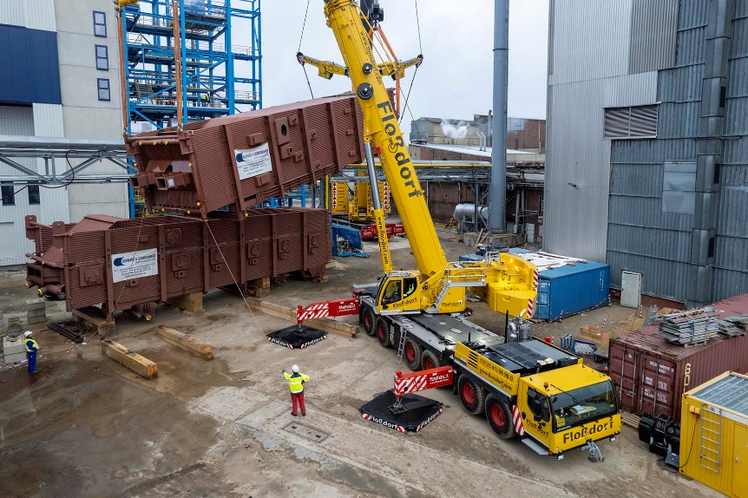

liebherr-ltm1300-6.3-flossdorf-01.jpg   
Power over the rear:like something out of a textbook, the LTM 1300-6.3 operated by Dietmar Floßdorf GmbH & Co. KG uses the strong rear VarioBase®Plus supports to lift an almost 100-tonne boiler at the new power plant together with the LTM 1650-8.1.

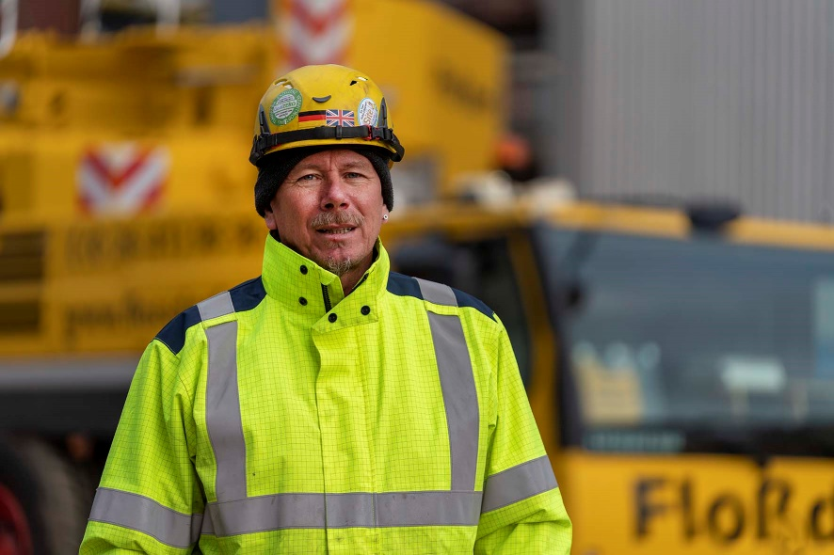

liebherr-ltm1300-6.3-flossdorf-02.jpg   
"It's really good to work with." Crane driver Michael Sadrinna in front of his new work equipment. In addition to VarioBase®Plus, VarioBallast® and the 90-metre telescopic boom, he finds the lighting system and the mast camera particularly useful.

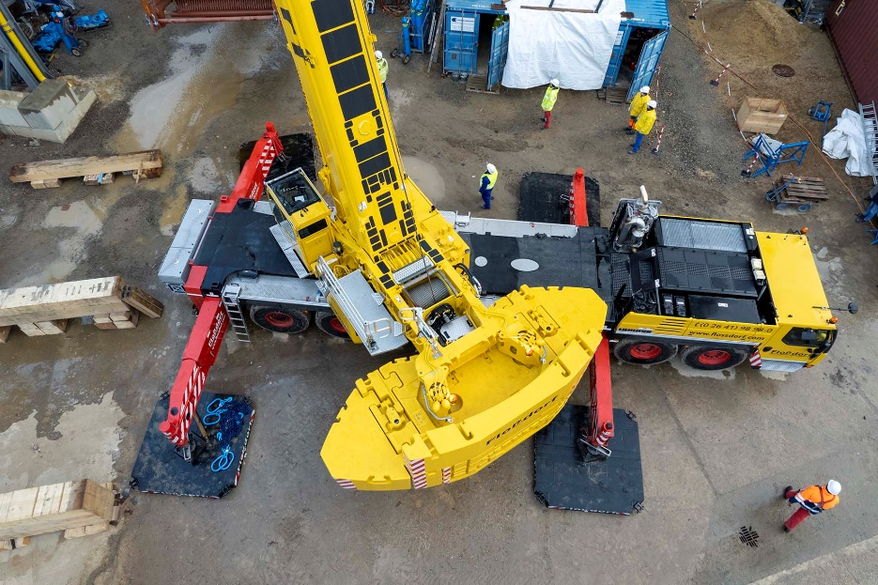

liebherr-ltm1300-6.3-flossdorf-03.jpg   
Less is more: the ability to set the ballast to a radius of almost six metres means the LTM 1300-6.3 can manage with eight tonnes less ballast than the LTM 1300-6.2. And in some cases, with significantly higher lifting capacities.

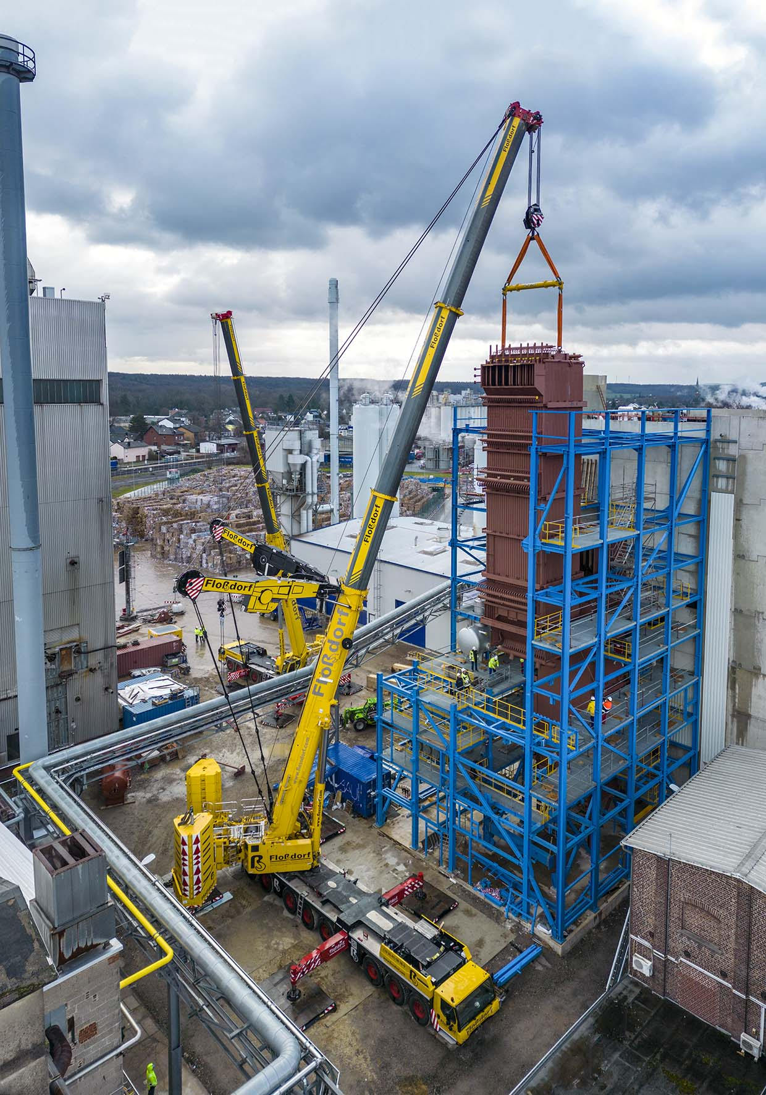

liebherr-ltm1650-8.1-flossdorf.jpg   
Centimetre precision – the heavy steam boiler soon reaches its destination. Here, on the hook of the LTM 1650-8.1, the last component is brought into the future power plant at the paper mill – with little room between the load and the steel structure. In the background you can see the LTM 1300-6.3.

**Contact**

Wolfgang Beringer  
Marketing and Communication  
Phone: +49 7391/502 - 3663  
Email: wolfgang.beringer@liebherr.com

**Published by**

Liebherr-Werk Ehingen GmbH  
Ehingen (Donau), Germany  
[www.liebherr.com](http://www.liebherr.com)