Press release

Liebherr-Werk Bischofshofen GmbH launches state-of-the-art logistics centre

⸺

New building includes automated warehouse as well as logistics and office space

Increased logistics capacity for growing wheel loader production figures

Investment, job creation in logistics and new vocational training

After just two years construction work, a new logistics centre was put into service in April in Bischofshofen, Austria . Since it was founded in 1960, Liebherr-Werk Bischofshofen GmbH has been writing success stories: over the decades, its factory has developed into a centre of expertise for the Liebherr Group’s wheel loaders and has distinguished itself through technical innovations, continually increasing production figures and wide-ranging job opportunities. To stay successful, Liebherr continually invests in the future of the site.

Bischofshofen (Austria), 18 April 2023 – The investment of around € 26 million includes a state-of-the-art automated warehouse with space for over 12,000 pallets and over 33,500 small load carriers, generous logistics and office space and a photovoltaic rooftop installation to generate electricity. “This year, we will produce another record number of wheel loaders. Our unit numbers have more or less doubled in the last six years. The new logistics centre is an essential part of the infrastructure necessary to meet the continually rising global demand for Liebherr wheel loaders in the future”, explains Peter Schachinger, Director of Production and Operations at Liebherr Werk Bischofshofen.

With the new logistics centre, Liebherr is also creating an exciting work environment for skilled jobs in logistics. Innovations such as modern operating materials, ergonomic lifting devices and automated material flows reduce physical strain for staff. They optimise working conditions for employees and also make it easier for workers from other industries to enter the profession. “I am particularly pleased that we could add another apprenticeship to our wide range of options: to become an operation logistics specialist”, Schachinger adds.

New logistics centre: more efficient processes and more jobs

The automated warehouse, which is designed as a fully automatic high-bay warehouse, is the heart of the new logistics centre. Its massive storage capacity and the automation of complex storage processes help make optimal usage of the limited factory space. For example, the material flow from receipt of goods to the station at which the tugger trains are prepared for delivery to the assembly line can extend over multiple storeys in the new building complex. A practical and special feature is the innovative storage technology which automatically moves the goods onto trolleys after order picking. This removes the need for complicated manual intermediate steps, for example using a pallet truck, before the new tugger trains deliver the prepared material to the assembly lines.

“These innovations in our intralogistics help us to handle the increasing material flows and make our processes even more efficient. The growth in automation will not put any jobs at risk, but will in fact create additional attractive jobs”, says Schachinger. The fields of work are diverse, from logistics planning, warehouse and goods administration to in-house transportation and plant technology. Information on professional opportunities in the different company departments and various qualifications required for them can be found at [www.liebherr.com/karriere](http://www.liebherr.com/karriere).

About Liebherr-Werk Bischofshofen GmbH

Liebherr-Werk Bischofshofen GmbH develops, produces and sells wheel loaders from the Liebherr Group. The plant in Salzburger Land (Austria) has grown steadily over the decades thanks to sustainable innovations, creative solutions and high quality standards. The wheel loader range is constantly being expanded and includes models in different product groups: compact loaders, stereo loaders, and mid-sized and large wheel loaders with impressive, innovative drive designs.

About the Liebherr Group

The Liebherr Group is a family-run technology company with a highly diversified product portfolio. The company is one of the largest construction equipment manufacturers in the world. It also provides high-quality and user-oriented products and services in a wide range of other areas. The Liebherr Group includes over 140 companies across all continents. In 2022, it employed more than 50,000 staff and achieved combined revenues of over 12.5 billion euros. Liebherr was founded in Kirchdorf an der Iller in Southern Germany in 1949. Since then, the employees have been pursuing the goal of achieving continuous technological innovation, and bringing industry-leading solutions to its customers.

Images

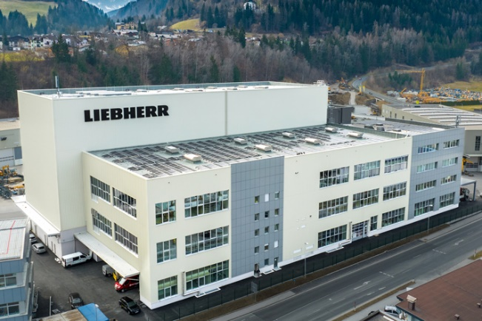

liebherr-werk-bischofshofen-gmbh-neues-logistikzentrum.jpg  
Liebherr-Werk Bischofshofen GmbH’s new logistics centre includes an automated warehouse as well as logistics and office space.

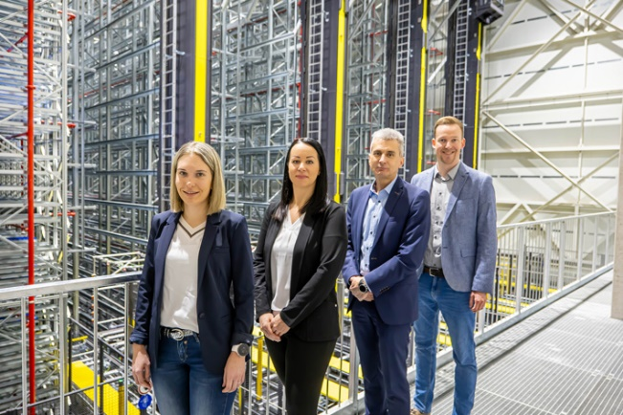

liebherr-werk-bischofshofen-gmbh-neues-logistikzentrum-gruppenfoto.jpg  
Employees of Liebherr-Werk Bischofshofen GmbH in front of the new automated warehouse. The group from left to right: Alexandra Bernhofer (HR generalist), Nadja Leitinger (trainee officer for Intralogistics), Peter Schachinger (Director of Production and Operations), Alexander Berner (Head of Human Resources and Welfare).

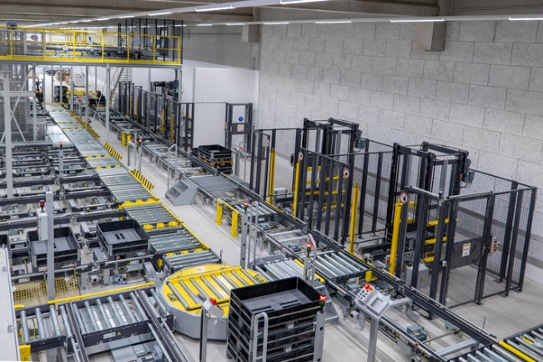

liebherr-werk-bischofshofen-gmbh-neues-logistikzentrum-lagertechnik.jpg  
To manage increasing material flows, Liebherr has invested in innovative storage and conveyance technology in the new logistics centre.

Contact

Martin Koller  
Marketing and Public Relations  
Phone: +43 50809 11475  
E-mail: [martin.koller.lbh@liebherr.com](mailto:martin.koller.lbh@liebherr.com)

Published by

Liebherr-Werk Bischofshofen GmbH  
Bischofshofen/Austria  
[www.liebherr.com](http://www.liebherr.com)