Press release

Liebherr presents the LR 1700-1.0W, the most powerful narrow track crawler crane on the market

⸺⸺

* The LR 1700-1.0W is the successor to the LR 1600/2-W
* Unrivalled load capacities and lifting heights
* Crawler travel gear with a particularly powerful and low-wear drive train

Liebherr has unveiled the successor to its successful 600-tonne LR 1600/2-W narrow track crawler crane. With more power and greater lifting height, the LR 1700-1.0W offers the best prerequisites for efficient assembly of modern wind turbines in wind farms. To meet the challenging demands for driving and steering, Liebherr has equipped the crane's new narrow track travel gear with components from its next larger crane class. The new 700-tonner is now the benchmark for narrow track cranes worldwide.

Ehingen (Donau) (Germany), 18 April – Narrow track crawler cranes are optimised for use on wind farms: they can travel from one turbine to the next along the existing routes and be deployed very quickly. Liebherr developed the first narrow track lattice boom crawler crane 20 years ago, the LR 1400/2-W. However, in the intervening years wind turbine towers have become taller and wind power components heavier. For this reason, Liebherr launched the significantly more powerful LR 1600/2-W back in 2010, of which around 50 units are currently in operation worldwide. However, assembly of the latest generation of wind turbines now requires cranes with an even higher lifting capacity.

The LR 1700-1.0W is the successor to the successful LR 1600/2-W

Just as the LR 1700-1.0 replaced the LR 1600/2 in Liebherr's line-up almost two years ago, the narrow track version of the 600-tonner is now also being replaced by the new 700-tonne LR 1700-1.0W. The company's successful crane concept has thus been continued: Liebherr has designed a narrow crawler travel gear and a new centre section with star support for the existing slewing platform. The boom systems from the standard crane can be adopted to a large extent. At 5.9 metres, the crawler travel gear is only 10 cm wider than its predecessor. When driving, the supports are folded forwards and backwards.

The biggest differences to the predecessor model, the LR 1600/2-W, are the new crane's significantly higher lifting capacities and greater lifting heights. The basis for this is a more powerful basic machine as well as the 3.5-metre-wide H-lattice type sections in the lower area of the main boom, which increase the lateral stability of the entire system. Comparing the longest wind-turbine boom with the derrick system on the predecessor model (156-metre main boom plus 12-metre lattice type fixed jib) with the new crane with the same boom length results in a 64 per cent increase in lifting capacity (from 73 to 120 tonnes). In addition, the new LR 1700-1.0W can be built up higher: with derrick system plus 15 meters, without derrick system plus 6 meters. The new crane thus meets the more challenging requirements of working on modern wind turbines with hub heights reaching 170 metres. Liebherr also offers the LR 1700-1.0W with a luffing jib. This option was not available for its predecessor.

State-of-the-art crawler crane technology

The V-frame and VarioTray have more than proven their worth on the LR 1700-1.0, LR 1800-1.0 and LR 11000 crawler cranes. Therefore, the narrow-gauge variant of the LR 1700-1.0 also receives these innovative systems. The "VarioTray" is a small counterweight frame that can be unbolted quickly and easily as required. This eliminates the need for tiresome stacking and unstacking of counterweight plates. The V-Frame ballasting system is a hydraulically adjustable folding frame that allows the ballast radius of the 700-tonne crawler crane to be adjusted continuously between 13 and 21 metres. A rigid ballasting system is thus no longer required for large radii. These innovations offer great advantages, especially for wind turbine assembly.

The new narrow track crane also gets the LR 1700-1.0's modern lattice type fixed jib, which can lift up to 170 tonnes and is designed for both single and parallel operation. Limited rope length is no longer an issue because two winches can work simultaneously over the jib. A particularly wide hook block prevents twisting. To save weight, the whip line is integrated on the head section.

Powerful drive train

Since crawler cranes – and especially narrow track models – have to cope with longer distances and inclines on wind farms, Liebherr's designers have placed a special focus on maximising the performance of the new LR 1700-1.0W's drive train. It therefore includes components designed for the crawler cranes in the next higher load class. The powerful drive of the new Liebherr narrow track crane raises driving and steering to a higher level while reducing wear. The 4-way drive for the travel gear is standard equipment, as are the two-metre wide crawler pads.

About Liebherr-Werk Ehingen GmbH

Liebherr-Werk Ehingen GmbH is a leading manufacturer of mobile and crawler cranes. Its range of mobile cranes extends from 2-axle 35 tonne cranes to heavy duty cranes with a lifting capacity of 1200 tonnes and a 9-axle chassis. Its lattice boom cranes on mobile or crawler crane chassis deliver lifting capacities of up to 3000 tonnes. With universal boom systems and extensive additional equipment, they can be seen in action on construction sites throughout the world. The Ehingen site has a workforce of 4,300. Extensive, global service guarantees the high availability of Liebherr mobile and crawler cranes. In 2022, the Liebherr plant in Ehingen recorded a turnover of 2.37 billion euros.

About the Liebherr Group

The Liebherr Group is a family-run technology company with a highly diversified product portfolio. The company is one of the largest construction equipment manufacturers in the world. It also provides high-quality and user-oriented products and services in a wide range of other areas. The Liebherr Group includes over 140 companies across all continents. In 2022, it employed more than 50,000 staff and achieved combined revenues of over 12.5 billion euros. Liebherr was founded in Kirchdorf an der Iller in Southern Germany in 1949. Since then, the employees have been pursuing the goal of achieving continuous technological innovation, and bringing industry-leading solutions to its customers.

Image

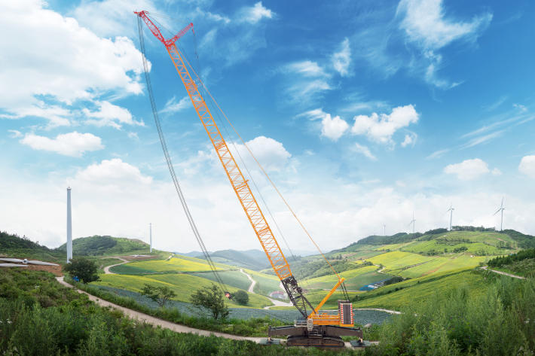  
  
liebherr-lr1700-1-0W.jpg  
The LR 1700-1.0W is the new benchmark for narrow track cranes worldwide.

Contact

Wolfgang Beringer  
Marketing and Communication  
Phone: +49 7391/502 - 3663  
Email: wolfgang.beringer@liebherr.com

Published by

Liebherr-Werk Ehingen GmbH  
Ehingen (Donau), Germany  
[www.liebherr.com](http://www.liebherr.com)