Press information

Fast-erecting crane from Liebherr works on former castle in historic old town

⸺

81 K.1 impresses with compact transport dimensions and strong overall package

Automatic centralized lubrication system for optimal ball slewing ring maintenance

Small slewing radius for space-saving positioning directly at the building

Narrow streets and closely lined buildings lend historic old towns a very special charm. But when construction work needs carrying out, this can quickly turn into a challenge. Narrow access routes and limited space require exactly the right crane for the job. This has definitely been the case for the renovation of the former Geyerswörth Castle building in Bamberg (Germany), where a Liebherr 81 K.1 fast-erecting crane is in use.

Bamberg (Germany), 19 April 2023 – When it came to selecting a crane for the project, contracting authority Bamberg City Council placed great importance on the machine being able to cover all the renovation work required. The highest point on site is a 36-metre-high tower. Plus, the crane needed to be as compact as possible for transport and operation given the tight access routes and limited available space on site. Bamberg City Council took its specifications to the crane specialists at BKL Süd. The solution: an 81 K.1 from Liebherr.

**Flexible hook heights and jib lengths**

The bottom-slewing crane can be flexibly adapted to local construction site conditions with eleven carefully graduated hook heights and five different jib lengths. This makes hook heights between 17 and 40 metres and jib lengths between 31 and 48 metres possible. The crane was configured with a hook height of just under 39 metres and a reach of 48 metres for the historic building's renovation. As a result, the machine can reach all parts of the construction site with ease. The 81 K.1 offers a maximum lifting capacity of six tonnes and a jib head load capacity of 1,350 kilograms with a 48-metre jib.

Despite its considerable hook heights, the fast-erecting crane is extremely compact in transport, measuring just 16 metres in length and 2.5 metres in width. Thanks to these dimensions, the machine is easy to manoeuvre and can be delivered to site without the need for a special permit. The crane’s agility also proved useful when approaching the site due to the narrow access routes available. As the 81 K.1 is delivered as a compact, complete unit, it can be assembled straight away once on site and without the need for extra resources. Given the nature of the ground near the river, the crane was positioned on a three-metre-thick, 9 x 9-metre concrete foundation.

**Partner for a variety of lifts**

The crane has been involved in various different tasks for the historic building's comprehensive renovation since August 2019, including the repair of roof trusses and rooftops, interior demolition and remodelling work, as well as the renovation of ceilings and façades. The aim is to restore the building to its former glory and to meet statutory standards regarding fire protection and accessibility. Geyerswörth Castle as it stands today was completed in 1588/89, making it a prominent feature of Bamberg’s historic city centre for near to five hundred years. The building is also home to the Renaissance Hall, one of the city's most prestigious historic venues.

The crane is expected to be on site for another one to two years. In cases like this, when a machine is in use for so long, an automatic centralised lubrication system is an ideal add-on. It lubricates the ball slewing ring at set intervals and simple handling ensures that the crane has a long service life. Another advantage of the 81 K.1 is its small slewing radius of 2.75 metres. This allowed the fast-erecting crane to be positioned directly at the former castle building, enabling other site vehicles to pass through the narrow inner courtyard without any problems and making optimal use of the crane’s reach. Intelligent assistance systems in combination with precision drives ensure safe and accurate crane operation.

Well thought-out solution concept

“The crane meets the customer's renovation work requirements perfectly and is the most cost-effective crane solution for this project,” says Martin Fischer from BKL Süd, based in Forstinning. BKL Baukran Logistik GmbH specialises in the sale and rental of cranes along with related services. Its crane fleet includes over 500 construction cranes ranging from 22 to 90 metres in radius, more than 100 mobile cranes from 30 to 700 tonnes, and 15 mobile construction cranes with a radius of up to 65 metres. Liebherr’s K series fast-erecting cranes, from the 34 K through to the 125 K, also form an integral part of the fleet.

About the Liebherr Tower Cranes Division

More than seven decades of experience have made Liebherr a recognised specialist for lifting technology on all types of construction sites. The range of Liebherr Tower Cranes encompasses an extensive selection of high-quality tower cranes that are used worldwide. This includes fast-erecting, top-slewing, luffing jib and special-purpose cranes as well as mobile construction cranes. In addition to these products, Liebherr also offers a wide range of services that complete the company’s portfolio: Tower Crane Solutions, the Tower Crane Center and Tower Crane Customer Service.

About the Liebherr Group

The Liebherr Group is a family-run technology company with a highly diversified product portfolio. The company is one of the world's largest manufacturers of construction machinery. It also offers high-quality, user-oriented products and services in multiple other areas. Today, the group consists of more than 140 companies across all continents. In 2021, it employed more than 49,000 people and achieved combined revenues of over 11.6 billion euros. Liebherr was founded in 1949, in Kirchdorf an der Iller in southern Germany. Ever since then, the company’s employees have been committed to satisfying customers with advanced solutions and to helping drive technological progress.

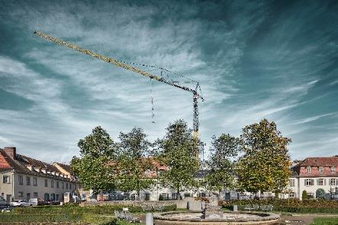Images

liebherr-81K1-bkl-bamberg-01.jpg  
With a hook height of almost 39 metres, Liebherr’s 81 K.1 is the right solution for the renovation of the former Geyerswörth Castle building.

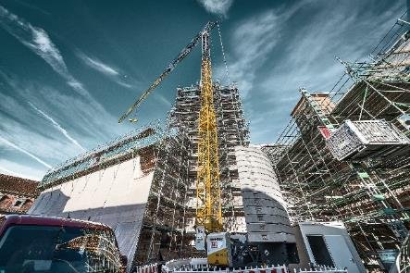

liebherr-81K1-bkl-bamberg-02.jpg  
Thanks to its vertical tower and small slewing radius, it was possible to position the Liebherr 81 K.1 directly at the building.

Contact

Daniel Haefele  
Global Communication  
Phone: +49 7351 / 41 - 2330  
Email: daniel.haefele@liebherr.com

Published by

Liebherr-Werk Biberach GmbH  
Biberach / Germany  
www.liebherr.com