Press release

Liebherr to supply three automated dual trolley ship to shore container cranes to HHLA

⸺

Ireland, June 2023 – Liebherr Container Cranes, a leading European manufacturer of innovative port equipment, is pleased to announce the sale of three large dual trolley ship to shore container cranes (STS) to Hamburger Hafen und Logistik AG (HHLA) for use at their container terminal Altenwerder (CTA) in the Port of Hamburg. The terminal has consistently been at the forefront of the industry, constantly adopting innovative solutions and cutting-edge technology, making it a pioneer in its field. The advanced cranes mark a significant milestone in Liebherr's longstanding partnership with HHLA. Following the successful delivery of two STS cranes in 2015 and three in 2017 to HHLA’s Container Terminal Tollerort, the newly acquired dual trolley cranes are the first step in a new strategic alliance, marking the beginning of a closer collaboration between the two companies. Together, HHLA and Liebherr will drive forward innovative and sustainable change in the logistics industry. The cranes have a safe working load of 75 t twin lift at an outreach of 61 m, lift height of 53 m, back reach of 24.5 and a span of 35 m.

Automation and remote control for optimised operations

The cabinless cranes will operate entirely through automation and remote control. Liebherr's automation technology enables autonomous operation for most of the cycle but facilitates remote control via the Liebherr Remote Operator Station (ROS), for pick and place on the vessel, providing operators the same level of control as an on-board operator, but in a comfortable office-based environment.

With two trolleys operating on a single crane, dual trolley STS cranes offer exceptional operational flexibility and increased efficiency. The primary trolley handles container transfers between the ship and the landside, while the secondary portal trolley can simultaneously handle transfers from the crane to the automated guided vehicles. This parallel operation decouples the landside and seaside operations, reducing wait times and significantly improving vessel turnaround times. This enhances operational safety, maximises productivity, and optimises operations at the container terminal.

Sustainable European based manufacturing and service

With its rich European heritage, Liebherr is uniquely positioned to cater to the specific needs of HHLA. Liebherr Hamburg, dedicated to servicing maritime cranes, is based in the Port of Hamburg. Its team of technicians, large parts warehouse, and proximity to HHLA’s terminals ensures seamless support and unparalleled service for HHLA's crane fleet, cementing the strong partnership between the two companies.

The strategic collaboration between Liebherr and HHLA represents a shared vision for the future of port operations. By systematically reducing greenhouse gas emissions across its operations, HHLA's CTA terminal is the world's first certified climate-neutral container handling facility. This certification reflects HHLA’s proactive approach towards achieving environmental sustainability goals, in alignment with global efforts to mitigate climate change. With a shared environmental vision, Liebherr Container Cranes, has achieved a gold medal in sustainability from EcoVadis. This award illustrates Liebherr's dedication to sustainable practices and positions them as the preferred choice for terminals where sustainability is a core value.

Liebherr's dual trolley ship-to-shore container cranes are not only at the forefront of technological innovation but also prioritise energy efficiency. They are designed to minimise energy consumption and optimise operational efficiency. Energy regeneration and capture is a key feature of the cranes and is carried out at both the primary and portal trolley hoist drives, enhancing the power consumption of the crane. The use of advanced automation algorithms further reduces energy consumption per container moved, contributing to a more sustainable and environmentally friendly operation.

"We are delighted to deepen our partnership with HHLA through the sale of these innovative dual trolley ship-to-shore container cranes," said Gerry Bunyan, Managing Director - Sales at Liebherr Container Cranes. "The combination of advanced automation, remote control capabilities, and industry-leading energy saving features, makes these cranes a perfect fit for HHLA's sustainability requirements. Together, we are shaping the future of port handling. This is the second order we have received for our dual trolley cranes, following an earlier order for Eurogate’s CTW terminal. This continued demand demonstrates the industry's appetite for European manufacturing and design, backed up by a local service.”

“From day one Container Terminal Altenwerder has set itself apart as an industry pioneer, leading the integration of the newest technology to optimize its operations sustainably. It is with great pleasure that we announce our enhanced collaboration with Liebherr, as we continue to leverage the latest advancements in technology and automation. The state-of-the-art cranes will empower CTA to meet the demands of the future while optimizing operations and enhance our overall performance, ultimately benefiting our customers”, said Patrick Krawutschke, Managing Director of Container Terminal Altenwerder.

By choosing Liebherr Container Cranes, HHLA secures a trusted partner with a proven track record in delivering energy-efficient and sustainable solutions. The technological advancements, combined with Liebherr's commitment to environmental responsibility, position Liebherr Container Cranes as the preferred choice for terminals like CTA seeking to optimize their operations while minimizing their carbon footprint.

About Liebherr Container Cranes

Liebherr Container Cranes Ltd. Is one of the world’s leading manufacturers of ship to shore container cranes, rail mounted gantry cranes and rubber tyre gantry cranes. From a base in Killarney, Ireland, Liebherr Container Cranes Ltd designs, builds and exports container cranes worldwide. Founded in 1958 as the first Liebherr factory outside of Germany, today, container cranes manufactured by Liebherr in Ireland are renowned for their quality, longevity, and productivity.

About the Liebherr Group

The Liebherr Group is a family-run technology company with a highly diversified product portfolio. The company is one of the largest construction equipment manufacturers in the world. It also provides high-quality and user-oriented products and services in a wide range of other areas. The Liebherr Group includes over 140 companies across all continents. In 2022, it employed more than 50,000 staff and achieved combined revenues of over 12.5 billion euros. Liebherr was founded in Kirchdorf an der Iller in Southern Germany in 1949. Since then, the employees have been pursuing the goal of achieving continuous technological innovation, and bringing industry-leading solutions to its customers.

About HHLA

Hamburger Hafen und Logistik AG (HHLA) is one of Europe’s leading logistics companies. With a tight network of seaport terminals in Hamburg, Odessa, Tallinn and Trieste, excellent hinterland connections and well-connected intermodal hubs in Central and Eastern Europe, HHLA represents a logistics and digital hub along the transport flows of the future. Its business model is based on innovative technologies and is committed to sustainability. www.hhla.de/en

Images

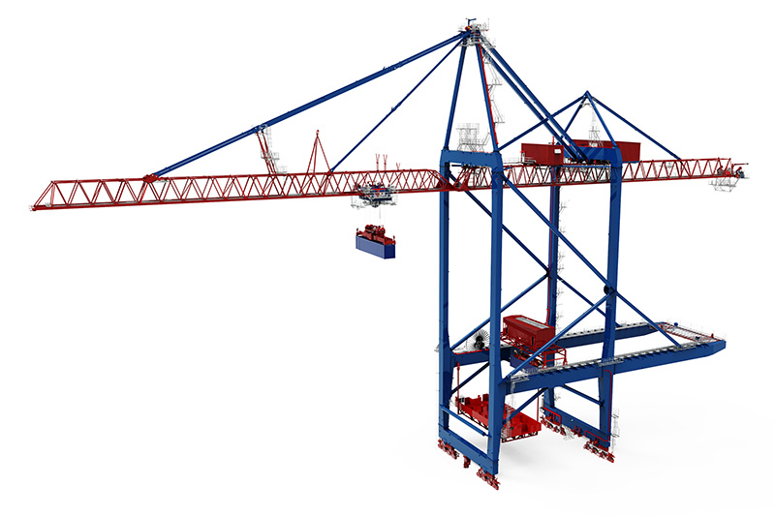

liebherr-dual-trolley-hhla.jpg  
The new Liebherr STS cranes for HHLA’s CTA terminal at the Port of Hamburg

Contact

Trevor O’Donoghue  
Marketing Manager  
Phone: +353 64 668 0459  
trevor.odonoghue@liebherr.com

Published by

Liebherr Container Cranes Ltd.   
Killarney, Ireland  
www.liebherr.com