Press release

Liebherr Container Cranes delivers semi-automated ship to shore container crane to Patrick Terminals - Brisbane Autostrad

⸺

Crane features landside automation, an automated arced cycle and manual control for pick and place on the vessel

The STS is supplied with a Liebherr Remote Operator Station for manual control and for exception handling

A newly released video showcases the cranes automation capabilities

Killarney (Ireland), June 2023 – Liebherr Container Cranes Ltd., is excited to unveil a video highlighting the advanced automation capabilities of its new cabinless ship-to-shore container crane. This cutting-edge crane has recently entered service at Patrick Terminals - Brisbane AutoStrad in Australia, where it is already hard at work handling container vessels and automated landside operations. The crane features extensive automation and utilises Liebherr’s Remote Operator Station (ROS) for pick and place over the vessel and for exception handling. The ROS allows the same level of crane control as an on-board operator but from the comfort of an office-based environment.

This semi-automated crane is the first of its kind for Patrick Terminals, and one of the first cabinless Liebherr ship to shore container cranes to enter service globally, underscoring Liebherr's commitment to driving technological progress in the port equipment industry. Liebherr has previously delivered fully automated and cabinless rail-mounted gantry (RMG) cranes. In addition, Liebherr has many automated ship-to-shore (STS) and rubber-tired gantry (RTG) cranes on order, with several scheduled to be operational in the coming months, reinforcing Liebherr's position as a pioneer in providing safe and secure automated solutions.

We are thrilled to unveil the automation capabilities of our Liebherr ship-to-shore crane at Patrick Terminals - Brisbane AutoStrad," said Declan O’Sullivan, General Manager Sales at Liebherr Container Cranes Ltd. "This achievement signifies our dedication to working hand in hand with our clients to push the boundaries of port automation and providing cutting-edge solutions that transform operations. Through this video, we aim to showcase the power of automation in enhancing port efficiency, safety, and profitability.”

Michael Jovicic, CEO, Patrick Terminals said, “The introduction of the new semi-automated Liebherr ship-to-shore crane with a remote-control operator's station marks a significant milestone in the Patrick Terminals crane fleet. We are proud to have collaborated with Liebherr Container Cranes on this ground-breaking project, delivering a crane that aligns with our unwavering commitment to safety and efficiency. This innovative addition enhances our operations and underscores our dedication to embracing technology.”

Patrick Terminals - Brisbane Autostrad has two Liebherr ship to shore container cranes, the first unit was supplied in 2015 and has recently undergone a lift height and outreach extension using the innovative and patented Liebherr transform technology. The new crane features an outreach of 54 m, a backreach of 48 m, a lift height over rail of 40 m and a span of 25.3 m.

Watch the video on <https://www.youtube.com/watch?v=GZQPxl9zssk>

About Liebherr Container Cranes

Liebherr Container Cranes Ltd. Is one of the world’s leading manufacturers of ship to shore container cranes, rail mounted gantry cranes and rubber tyre gantry cranes. From a base in Killarney, Ireland, Liebherr Container Cranes Ltd designs, builds and exports container cranes worldwide. Founded in 1958 as the first Liebherr factory outside of Germany, today, container cranes manufactured by Liebherr in Ireland are renowned for their quality, longevity, and productivity.

About the Liebherr Group

The Liebherr Group is a family-run technology company with a highly diversified product portfolio. The company is one of the largest construction equipment manufacturers in the world. It also provides high-quality and user-oriented products and services in a wide range of other areas. The Liebherr Group includes over 140 companies across all continents. In 2022, it employed more than 50,000 staff and achieved combined revenues of over 12.5 billion euros. Liebherr was founded in Kirchdorf an der Iller in Southern Germany in 1949. Since then, the employees have been pursuing the goal of achieving continuous technological innovation, and bringing industry-leading solutions to its customers.

Images & Video

Watch the video on <https://www.youtube.com/watch?v=GZQPxl9zssk>

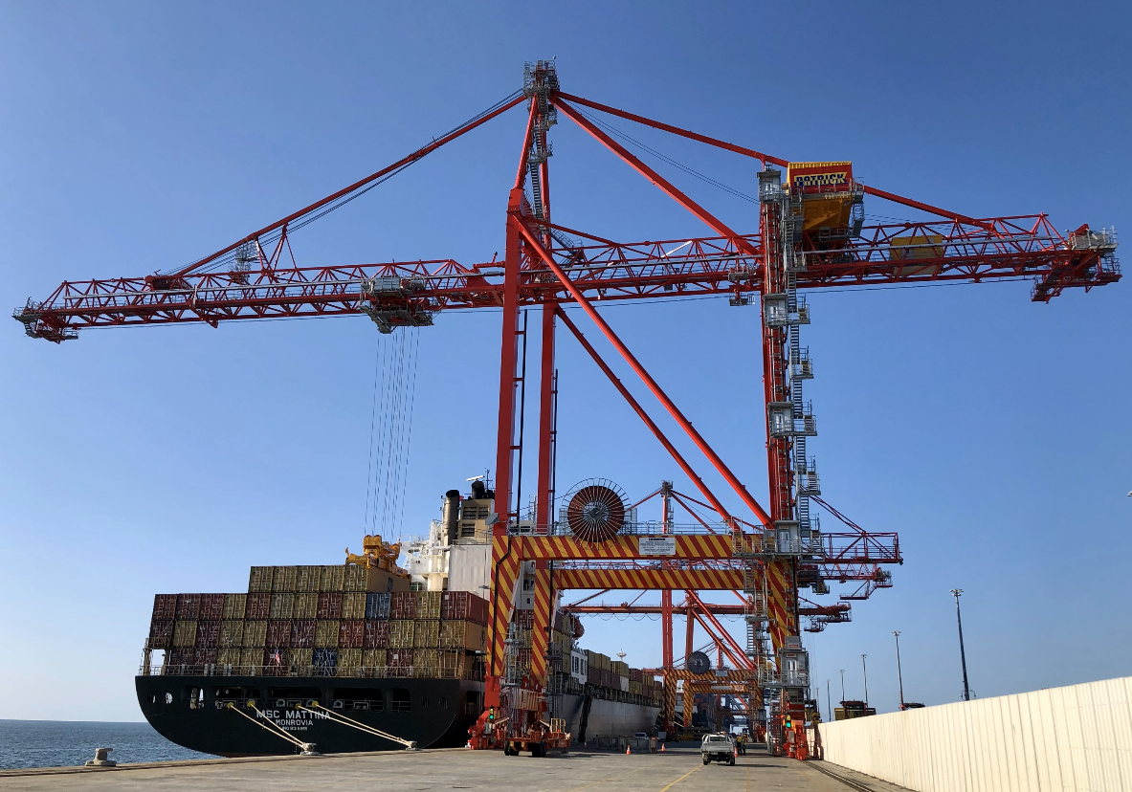

liebherr-STS-Patick-Terminals-Brisbane-Autostrad.jpg  
The new semi-automated, cabinless, Liebherr STS at Patrick Terminals – Brisbane Autostrad

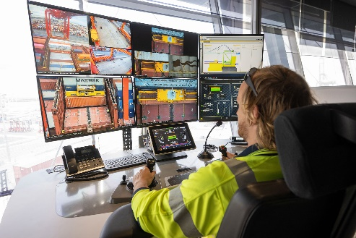

Liebherr-ros.jpg  
A remote operator keeps a watchful eye and handles containers on the vessel at Patrick Terminals – Brisbane Autostrad

Contact

Trevor O’Donoghue  
Marketing Manager  
Phone: +353 64 668 0459  
E-mail: trevor.odonooghue@liebherr.com

Published by

Liebherr Container Cranes Ltd.   
Killarney / Ireland  
www.liebherr.com