Press release

First Liebherr LTM 1150-5.3 in Chile

⸺

Grupo Vivargo S.A.C. takes delivery of first LTM 1150-5.3 in Chile

LTM 1150-5.3: Versatile, fast-operating crane with long boom

Liebherr service and support are important to the Chilean company

**The first LTM 1150-5.3 in Chile goes to Grupo Vivargo S.A.C. The versatile Liebherr 5-axle crane impresses, among other things, with its long telescopic boom, high lifting capacities and the variable support base VarioBase®. Vivargo also sees Liebherr as a reliable partner in the areas of support and service. After the exhibition at the Chilean trade fair Expomin, the main areas of application for the new LTM 1150-5.3 at Vivargo will be in the mining and energy sectors.**

Ehingen (Donau) (Germany), June 16, 2023 - After a month-long sea voyage, the Liebherr LTM 1150-5.3 mobile crane arrived at its new owner Grupo Vivargo S.A.C. in Chile in April. The 5-axle crane is the first of this type in Chile. Its main applications at Vivargo will be in the mining and energy sectors. "According to our market analysis, the LTM 1150-5.3 is exactly the type of crane our fleet needs due to its features and technology. Boom length, lifting capacity, and VarioBase® were key factors in the purchase decision," explains Andres Varas, who runs the company together with his brother Christopher. Father Victor Varas, president of Grupo Vivargo, adds, "We decided to buy the LTM 1150-5.3 because the crane meets all our expectations in terms of quality, safety, technology and service."

**Economical all-terrain crane with long boom.**

"The LTM 1150-5.3 is a great fit for our fleet. We also considered buying a larger crane, but this crane is versatile and very economical to use," says a pleased Cristopher Varas. The key to these features is the single-engine strategy with mechanical drive of the uppercarriage. By using this innovative technology, the weight of the uppercarriage motor can be saved and used instead for a longer boom and more lifting capacity. With its 66-meter telescopic boom, the majority of crane jobs eliminate the need for additional equipment. To extend the boom even further if needed, Vivargo has purchased a double folding jib to complement the LTM 1150-5.3. This, like other jibs on the 150-tonner, is compatible with many Liebherr cranes between 100 and 180 tons capacity.

Another indicator of the LTM 1150-5.3's high cost-effectiveness is that it can carry nine tons of ballast on public roads with an axle load of twelve tons. This eliminates the need for an additional ballast vehicle on many jobs, and the crane can be deployed immediately on the construction site. This results in time and cost savings and also protects the environment.

**Liebherr service has important status**

"Service and support are important to us. We need to feel that we have a reliable crane partner for our business," says Cristopher Varas, explaining the decision in favour of Liebherr.

The family-owned company Grupo Vivargo S.A.C., which has been in existence for 74 years, was founded in Peru and is now run by the third generation. It has been in the crane business for more than 50 years and has earned a reputation as a professional crane rental company. Of particular importance to Vivargo are long-term relationships with its customers and suppliers, holistic service and the highest safety standards. The fleet includes lattice cranes, telescopic cranes, aerial work platforms and telescopic loaders. Approximately 400 employees work at the three locations on the west coast of South America in Peru, Ecuador and Chile. The Chilean company's projects focus on mining, energy and infrastructure.

**About Liebherr-Werk Ehingen GmbH**

Liebherr-Werk Ehingen GmbH is a leading manufacturer of mobile and crawler cranes. Its range of mobile cranes extends from 2-axle 35 tonne cranes to heavy duty cranes with a lifting capacity of 1200 tonnes and a 9-axle chassis. Its lattice boom cranes on mobile or crawler crane chassis deliver lifting capacities of up to 3000 tonnes. With universal boom systems and extensive additional equipment, they can be seen in action on construction sites throughout the world. The Ehingen site has a workforce of 4,300. Extensive, global service guarantees the high availability of Liebherr mobile and crawler cranes. In 2022, the Liebherr plant in Ehingen recorded a turnover of 2.37 billion euros.

**About the Liebherr Group**

The Liebherr Group is a family-run technology company with a highly diversified product portfolio. The company is one of the largest construction equipment manufacturers in the world. It also provides high-quality and user-oriented products and services in a wide range of other areas. The Liebherr Group includes over 140 companies across all continents. In 2022, it employed more than 50,000 staff and achieved combined revenues of over 12.5 billion euros. Liebherr was founded in Kirchdorf an der Iller in Southern Germany in 1949. Since then, the employees have been pursuing the goal of achieving continuous technological innovation, and bringing industry-leading solutions to its customers.

**Image**

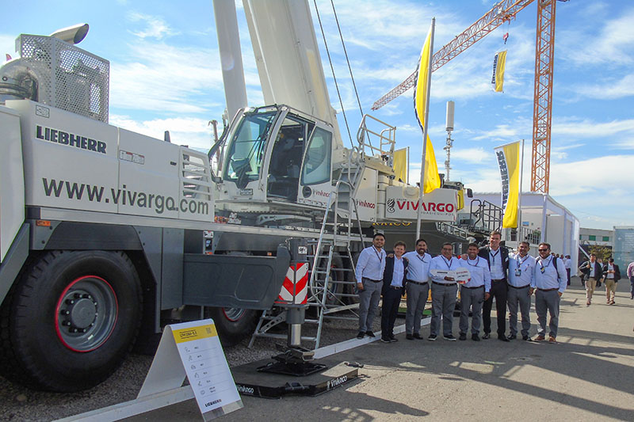

lwe-ltm-1150-5-3-handover-vivargo.jpg  
Arrived and directly at the Expomin fair: the first LTM 1150-5.3 in Chile.

**Contact**

Wolfgang Beringer  
Marketing and Communication  
Phone: +49 7391/502 - 3663  
Email: wolfgang.beringer@liebherr.com

**Published by**

Liebherr-Werk Ehingen GmbH  
Ehingen (Donau) / Germany  
www.liebherr.com