Press release

Liebherr supplies air management system for Deutsche Aircraft D328eco

⸺

Toulouse, June 2023 – Deutsche Aircraft GmbH has announced that it has selected Liebherr to supply the air management system for the D328eco™ aircraft, a platform that is accelerating the aviation industry’s transition towards lower emissions.

Liebherr-Aerospace Toulouse SAS, Toulouse (France) will design, supply and service the integrated air management system for the D328eco. The system meets the efficiency, weight, and performance requirements of this modern aircraft, offering cabin comfort and optimized power consumption.

“Liebherr-Aerospace is a reputable partner in the aviation industry not only with many other airframe OEMs but also a close partner since years for Deutsche Aircraft. On the D328eco program, we are pleased to have Liebherr join us, also as the supplier for the integrated air management system and thereby further reduce development times. This latest contract is based on and will further strengthen the reliable partnership we have on the flap and spoiler actuation system and reach another important milestone for the D328eco program. Deutsche Aircraft, as the only German OEM for regional aircraft, is teaming up with the finest suppliers of the industry to have the most competitive Turboprop in service. The cooperation with Liebherr perfectly fits in that picture”, says Maximilian Fahr, Vice President Supply Chain at Deutsche Aircraft.

“We are very pleased that in addition to the flap and spoiler actuation system, we are now also able to supply the integrated air management system. Our center of competence for air and thermal management systems in Toulouse will provide a modern air management system for the D328eco”, says Alex Vlielander, Chief Customer Officer, Liebherr-Aerospace & Transportation SAS.

**About Deutsche Aircraft**

Deutsche Aircraft is a German aircraft manufacturer built on the heritage of aviation pioneers that continues to propel the aviation industry forward with innovative solutions. Supported by a highly skilled and passionate team of international engineers and aviation experts, Deutsche Aircraft is developing the most advanced regional aircraft on the market: the D328eco. As type certificate holder and service partner for existing D328 (both prop and jet) operators worldwide, the company is uniquely positioned to complement the existing fleet with this next-generation aircraft.

Deutsche Aircraft employs the latest technologies and best practices to ensure the highest levels of reliability, efficiency and sustainability for the D328eco. As a strategic partner for the sustainable development of regional air transport, Deutsche Aircraft is working with key players in the industry to achieve climate-neutral flights. [www.deutschaircraft.com](http://www.deutschaircraft.com)

About Liebherr-Aerospace & Transportation

Liebherr-Aerospace & Transportation SAS, Toulouse (France), is one of eleven divisional control companies within the Liebherr Group and coordinates all activities in the aerospace and transportation systems sectors.

Liebherr-Aerospace is a leading supplier of systems for the aviation industry and has more than six decades of experience in this field. The range of aviation equipment produced by Liebherr for the civil and military sectors includes flight control and actuation systems, gears and gearboxes, landing gear and air management systems as well as electronics. These systems are deployed in wide-bodied aircraft, single aisle and regional aircraft, business jets, combat aircraft, military transporters, military training aircraft, civil helicopters and combat helicopters.

Liebherr’s aerospace and transportation systems division employs around 6,000 people. It has three aviation equipment production plants at Lindenberg (Germany), Toulouse (France) and Guaratinguetá (Brazil). These production sites offer a worldwide service with additional customer service centers in – among others - Saline (Michigan/USA), Seattle (Washington/USA), Montreal (Canada), Hamburg (Germany), Dubai (UAE), Bangalore (India), Singapore and Shanghai (People’s Republic of China).

About the Liebherr Group

The Liebherr Group is a family-run technology company with a highly diversified product portfolio. The company is one of the largest construction equipment manufacturers in the world. It also provides high-quality and user-oriented products and services in a wide range of other areas. The Liebherr Group includes over 140 companies across all continents. In 2022, it employed more than 51,000 staff and achieved combined revenues of over 12.5 billion euros. Liebherr was founded in Kirchdorf an der Iller in Southern Germany in 1949. Since then, the employees have been pursuing the goal of achieving continuous technological innovation, and bringing industry-leading solutions to its customers.

Image

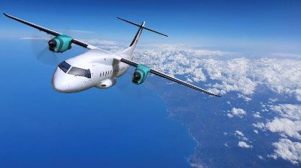  
 D328eco 12-copyright-Deutsche-Aircraft.png

The D328eco is capable of fulfilling the efficiency and performance requirements for a modern, more eco-friendly aircraft.   
– © Deutsche Aircraft   
   
 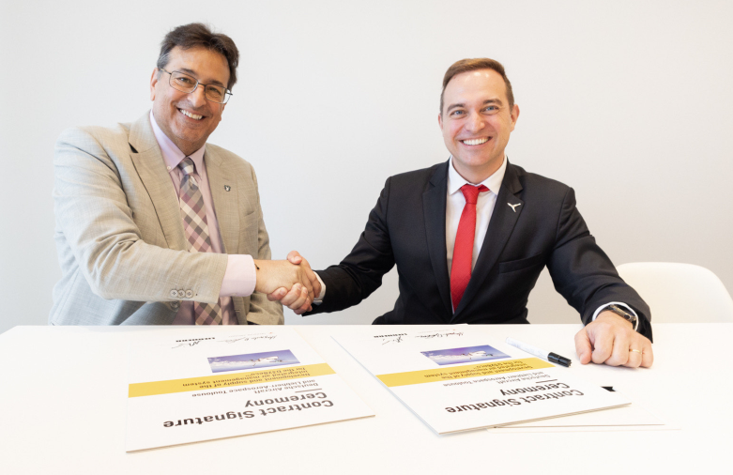

deutsche-aircraft-liebherr-paris-air-show2023.jpg

Contract signature ceremony at the Liebherr chalet during Paris Air Show 2023: Maximilian Fahr, Vice President Supply Chain at Deutsche Aircraft (right) and Alex Vlielander, Chief Customer Officer at Liebherr-Aerospace & Transportation SAS – © Deutsche Aircraft

Contact persons

Deutsche Aircraft GmbH Liebherr-Aerospace & Transportation SAS  
Christian Pürschel Ute Braam  
Head of Communications & PR Corporate Communications  
Phone: +49 8153 88 111 2359 Phone: +49 8381 / 46 - 4403  
E-mail: Christian.puerschel@deutscheaircraft.com E-mail: ute.braam@liebherr.com

**Published by**

Deutsche Aircraft GmbH Liebherr-Aerospace & Transportation SAS  
Wessling / Germany Toulouse / France  
[www.DeutscheAircraft.com](http://www.DeutscheAircraft.com) [www.liebherr.com](http://www.liebherr.com)