Press release

Liebherr and Bharat Forge sign Letter of Intent

⸺

Liebherr-Aerospace & Transportation SAS and Bharat Forge Ltd. have announced the signature of a Letter of Intent about cooperation in the field of technologies for future aircraft and transportation applications in India.

Paris (France) June 2023 – Liebherr-Aerospace & Transportation SAS and Bharat Forge Ltd., India, signed at this year’s Paris Air Show a Letter of Intent regarding collaboration.

The Original Equipment Manufacturer Liebherr-Aerospace & Transportation SAS has a vast expertise in the design, development, certification, production and support of systems and components for civil and defense fixed-wing aircraft and helicopters. Its product range covers air management systems, cooling systems, flight control and utility actuation systems, landing gears, hydraulic and transmission systems and electronics for aerospace application. For railway rolling stock the company offers HVAC and hydraulic systems and for road-bound commercial vehicles trailer cooling systems.

Bharat Forge is the world's largest and most technologically advanced commercial forging company, a specialized engineering product manufacturer and is, inter alia, engaged in the business of manufacturing of critical performance and safety related fully machined forgings and sub-systems/assemblies for the automotive, industrial and aerospace sector.

Both companies will enter a phase of joint analysis, discussions and negotiations in view of determining the appropriate way to join their efforts to develop business in India and for global requirements.

Alex Vlielander, Chief Customer Officer of Liebherr-Aerospace & Transportation SAS, explains: “By combining our and Bharat Forge’s technologies, know-how and expertise, we could be be able to offer on-board systems that are best suited to the next generation of Indian vehicles for air, rail and road transport.”

Amit Kalyani, Joint Managing Director, Bharat Forge, adds: “Through this potential collaboration, our objective is to deliver pionieering solutions tailored to the unique requirements of the Indian and global markets.”

About Liebherr-Aerospace & Transportation

Liebherr-Aerospace & Transportation SAS, Toulouse (France), is one of eleven divisional control companies within the Liebherr Group and coordinates all activities in the aerospace and transportation systems sectors.

Liebherr-Aerospace is a leading supplier of systems for the aviation industry and has more than six decades of experience in this field. The range of aviation equipment produced by Liebherr for the civil and defense sectors includes flight control and actuation systems, gears and gearboxes, landing gear and air management systems as well as electronics. These systems are deployed in wide-bodied aircraft, single aisle and regional aircraft, business jets, defense aircraft, defense transporters, defense training aircraft and civil and defense helicopters.

Liebherr’s aerospace and transportation systems division employs around 6,000 people. It has three aviation equipment production plants at Lindenberg (Germany), Toulouse (France) and Guaratinguetá (Brazil). These production sites offer a worldwide service with additional customer service centers in Saline (Michigan/USA), Seattle (Washington/USA), Montreal (Canada), Hamburg (Germany), Dubai (UAE), Bangalore (India), Singapore and Shanghai (People’s Republic of China).

About the Liebherr Group

The Liebherr Group is a family-run technology company with a highly diversified product portfolio. The company is one of the largest construction equipment manufacturers in the world. It also provides high-quality and user-oriented products and services in a wide range of other areas. The Liebherr Group includes over 140 companies across all continents. In 2022, it employed more than 51,000 staff and achieved combined revenues of over 12.5 billion euros. Liebherr was founded in Kirchdorf an der Iller in Southern Germany in 1949. Since then, the employees have been pursuing the goal of achieving continuous technological innovation, and bringing industry-leading solutions to its customers.

**Photo**

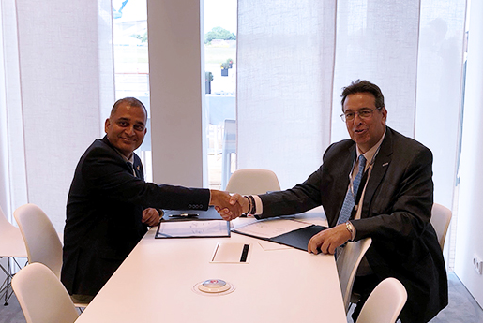  
liebherr-bharat-forge.jpg

Guru Biswal, CEO Aerospace, Bharat Forge (left) and Alex Vlielander, Chief Customer Officer, Liebherr-Aerospace & Transportation SAS at the signature ceremony of the Letter of Intent in the Liebherr Chalet at Paris Air Show 2023 – © Liebherr

Contact

Ute Braam  
Corporate Communications   
Telephone: +49 8381 46 4403  
E-mail: ute.braam@liebherr.com

Published by

Liebherr-Aerospace & Transportation SAS   
Toulouse/France  
www.liebherr.com