Press release

On behalf of science: Crane deployment at the Deutsches Museum with Maier-Landshut

⸺
Liebherr LTM 1250-5.1 moves large exhibit to Munich museum
VarioBase® enables crane to be parked in confined spaces
As part of renovation work at the Deutsches Museum in Munich, a Liebherr LTM 1250-5.1 mobile crane has moved a 44-tonne impeller of a Francis turbine. The work was carried out by
Kran-Maier GmbH & Co. KG from Landshut.
Ehingen (Donau), (Germany), 22 June 2023 – The dismantling of the more than 80-year-old impeller took place in the courtyard of the Deutsches Museum in Munich in mid-May. As part of a multi-year renovation, the main entrance was moved to the Corneliusbrücke side. The large exhibit relocated at the same time. Since there was limited space available at the new, permanent exhibition area, the crane benefited from its variable VarioBase® support: The increased safety and simple operation provide relief for the crane driver so that they could fully concentrate on an efficient lift during this deployment too.
Equipped with 88 tonnes of ballast, the LTM 1250-5.1 lifted the impeller, which weighs 44 tonnes and has a diameter of 4.6 metres, from its usual place at the former main entrance onto a heavy transporter. “In addition to the partly sloping museum garden, the traffic conditions in Munich were also challenging – narrow bridges and narrow streets filled with parked cars therefore required special skill on the part of our drivers. But thanks to the compactness and active rear axle steering of the LTM 1250-5.1, that wasn’t a problem either,” reports Susanne Maier, Managing Director of Kran-Maier. In a convoy with escort vehicles and police escort, the historic impeller arrived at its destination within a very short time.
Excursion into the future and the past
Since October 2015, the Deutsches Museum in Munich has been updating and redesigning its exhibitions. In the process, the exhibition building is also being brought up to the latest technical standard. The first modernisation phase was completed in July 2022. To mark the 125th anniversary of the Deutsches Museum’s founding in 2028, the building is to be completely revamped. Currently, a small container village is being built in the courtyard in front of the original main entrance. To make room for this, various large exhibits – including the historic impeller – had to make way.
The impeller itself was produced in 1939 by Heidenheim-based J. M. Voith GmbH and was part of a turbine for a river power station on the Sungari River in the Chinese region of Manchuria. However, due to the start of the Second World War, the impeller was not delivered – it would have passed 8820 cubic metres of water at a drop height of 69 metres and a frequency of 125 revolutions per minute, thus achieving an output of 85 MW.
About Liebherr-Werk Ehingen GmbH
Liebherr-Werk Ehingen GmbH is a leading manufacturer of mobile and crawler cranes. Its range of mobile cranes extends from 2-axle 35 tonne cranes to heavy duty cranes with a lifting capacity of 1200 tonnes and a 9-axle chassis. Its lattice boom cranes on mobile or crawler crane chassis deliver lifting capacities of up to 3000 tonnes. With universal boom systems and extensive additional equipment, they can be seen in action on construction sites throughout the world. The Ehingen site has a workforce of 3,800. Extensive, global service guarantees the high availability of Liebherr mobile and crawler cranes. In 2021, the Liebherr plant in Ehingen recorded a turnover of 2.33 billion euros.

About the Liebherr Group

The Liebherr Group is a family-run technology company with a highly diversified product portfolio. The company is one of the largest construction equipment manufacturers in the world. It also provides high-quality and user-oriented products and services in a wide range of other areas. The Liebherr Group includes over 140 companies across all continents. In 2021, it employed more than 49,000 staff and achieved combined revenues of over 11.6 billion euros. Liebherr was founded in Kirchdorf an der Iller in Southern Germany in 1949. Since then, the employees have been pursuing the goal of achieving continuous technological innovation, and bringing industry-leading solutions to its customers.
Images
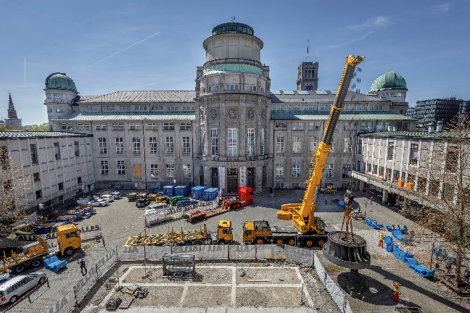

liebherr-deutsches-museum-panorama.jpg
A Liebherr LTM 1250-5.1 mobile crane from Kran-Maier lifts a 44 tonne impeller out of the courtyard of the Deutsches Museum in Munich.

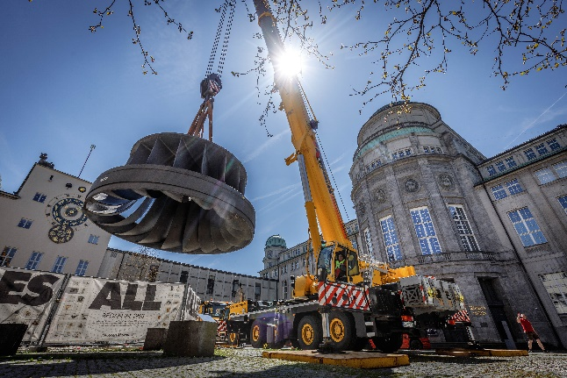

liebherr-deutsches-museum-innenhof.jpg
Carefully, the crane driver lifts the large exhibit from its original exhibition site to place it on a heavy transporter.

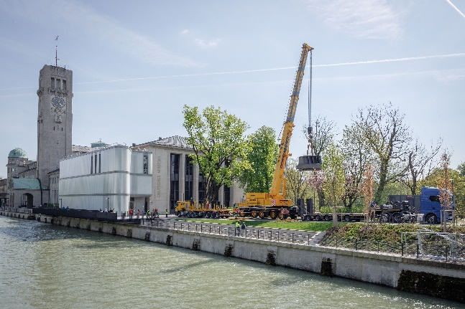
liebherr-deutsches-museum-corneliusbrücke.jpg
Sloping riverside promenade: Thanks to VarioBallast®, the LTM 1250-5.1 is stable even when space is limited.
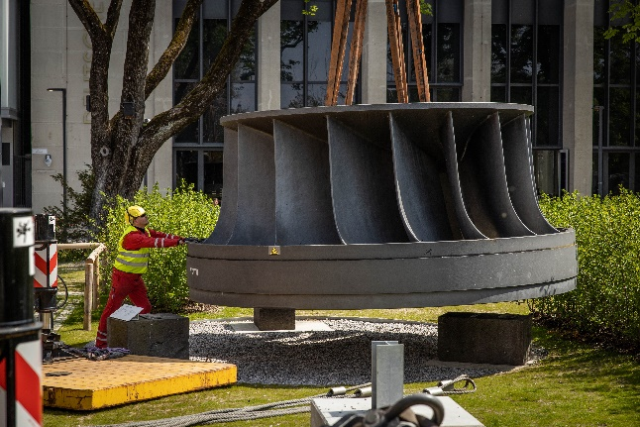
liebherr-deutsches-museum-museumsgarten.jpg
Enormous proportions: The impeller, which weighs 44 tonnes and measures 4.6 metres in diameter, will be placed in the museum garden.

Contact
Berenike Nordmann
Marketing and Communication
Phone: +49 7391 502-4541
Email: berenike.nordmann@liebherr.com
Published by
Liebherr-Werk Ehingen GmbH
Ehingen (Donau) / Germany
www.liebherr.com

