Press release

Market introduction of the Liebherr R 9300: a cutting-edge 250-tonne mining excavator

⸺

The R 9300 mining excavator – which premiered at Bauma 2022 – is now available for purchase and will enter serial production in 2024

A pre-series performance test on site confirmed the excavator’s high performance with an average availability of 94%

This latest machine uses 15% less fuel and improves fuel efficiency by 25% over that of the R 9250, Liebherr Mining’s previous 250-tonne class excavator

The R 9300 Generation 8 – the newest excavator in the Liebherr Mining range – can now be purchased. Following successful validation at a mine in Indonesia, the R 9300 has proven its ability to improve both productivity and efficiency on site. Once the machine enters serial production in 2024, it will replace the R 9250 within the 250-tonne class.

Colmar (France), 26 June 2023 – Liebherr Mining’s latest addition to its excavator portfolio – the R 9300 Generation 8 (G8) – is now available for purchase. This new machine was first presented to an international audience at the 2022 Bauma exhibition in Munich and will take over from the R 9250 in the 250-tonne class. The R 9300 is the second Generation 8 excavator in Liebherr’s product range and as such comes with the latest Liebherr Mining technology as standard. This technology provides the machine with improved onsite performance as well as compatibility with Liebherr’s Assistance Systems and future product enhancements such as automation, zero emission technologies, and digital services.

Production study in Indonesia: proven efficiency and productivity benefits

As part of the validation phase for the R 9300, Liebherr Mining partnered with its customer PT Karunia Armada Indonesia (Karunia) to establish the capabilities of the excavator on site. Karunia – a mining contractor based in East Kalimantan, Indonesia – began operating a pre-series unit of the R 9300 in September 2022 to remove and load overburden into 100- and 130-tonne trucks at the Tabang mine.

Since September 2022, the R 9300 has averaged 486 operational hours per month and 94% availability – surpassing Karunia’s KPIs for the machine. These results highlight the true potential of the excavator for improving onsite productivity.

To further demonstrate the capabilities of the R 9300, a production study of the pre-series excavator at Tabang mine was conducted in March 2023. During the study, the R 9300 achieved a 26-second average cycle time, helping the excavator reach instantaneous productivity of 1,371 bank cubic metres (BCM) per hour (3,017 tonnes per hour) – an impressive result for an excavator in the 250-tonne class. The R 9300 also attained a fuel efficiency ratio of 9.22 BCM per litre of fuel burned. When considered alongside the productivity of the machine, this establishes the next-level efficiency of the R 9300.

Effective drivetrain: 25% improved fuel efficiency and electric drivetrain in development

As a result of Liebherr Mining’s commitment to reducing emissions, the R 9300 has been designed to lower fuel consumption, and therefore decrease the amount of greenhouse gasses emitted by the machine. The R 9300’s engine is available in FCO and US EPA Tier 4/EU Stage V compliant versions (with SCR after-treatment technology) to adhere to strict international emissions standards.

Liebherr Power Efficiency (LPE) – a proprietary engine and hydraulics management system that helps to decrease the amount of fuel a machine consumes while maintaining optimal productivity and performance – comes as standard in the R 9300. With this system, the R 9300 reduces fuel consumption by 15% when compared to its predecessor, the R 9250. Further, this decrease in fuel consumption contributes to a 25% increase of fuel efficiency for the R 9300 compared to Liebherr’s previous 250-tonne excavator.

An electric-drive version of the R 9300 is currently under development and will be available in the near future.

Latest design: improved attachment, service life, and operator comfort

To increase productivity and efficiency, a range of design improvements have been implemented in the R 9300, setting this new machine apart from other excavators in the 250-tonne class.

The R 9300 has an updated attachment design that is lighter and stronger than that of the R 9250. The new attachment comes with high-performance components such as a new stick and boom design and aluminium covers all installed as standard. This lean design has enabled an increase in bucket size in both the backhoe and face shovel configurations. The standard bucket sizes of 16.5 m3 in backhoe configuration and 16 m3 in face shovel configuration (at 1.8t/m3 with the heavy-duty wear package) make the excavator an effective pass match for trucks with 100-, 130-, and 180-tonne payloads.

The R 9300 has also been designed for simplified maintenance and a longer service life. This excavator shares parts commonality with Liebherr’s current excavators to help minimise maintenance costs and streamline onsite inventory. The lifespan of the R 9300 has been increased by 33% above the R 9250 from 45,000 to 60,000 hours. Extending the service life of the R 9300 helps the machine to better align with the service life of major excavator components.

Further improvements can be found in the cab design of the R 9300. The new cab includes enhanced cabin ergonomics, larger touch screens, a new control panel design, and optimised visibility to help promote operator wellbeing while increasing safety.

The R 9300 will enter serial production in 2024, with the backhoe configuration available from Q1 and the face shovel configuration from Q2.

About the Liebherr Group

The Liebherr Group is a family-run technology company with a highly diversified product portfolio. The company is one of the largest construction equipment manufacturers in the world. It also provides high-quality and user-oriented products and services in a wide range of other areas. The Liebherr Group includes over 140 companies across all continents. In 2022, it employed more than 50,000 staff and achieved combined revenues of over 12.5 billion euros. Liebherr was founded in Kirchdorf an der Iller in Southern Germany in 1949. Since then, the employees have been pursuing the goal of achieving continuous technological innovation and bringing industry-leading solutions to its customers.

Images

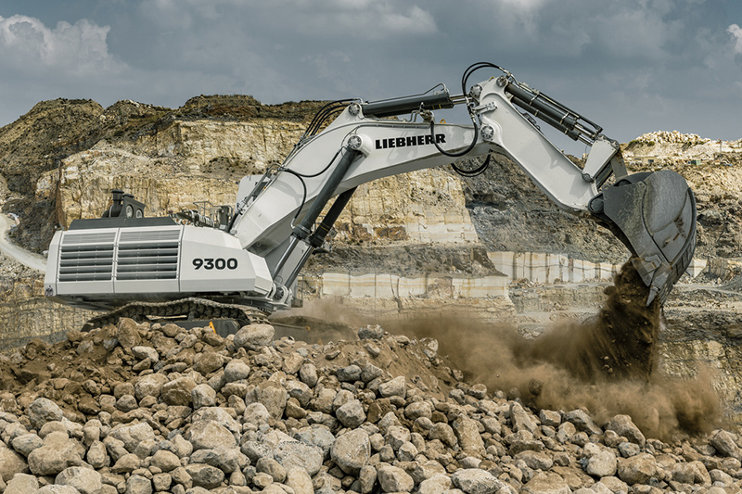

liebherr-R9300-96dpi.jpg  
The R 9300 is the second Generation 8 excavator in Liebherr Mining’s portfolio.

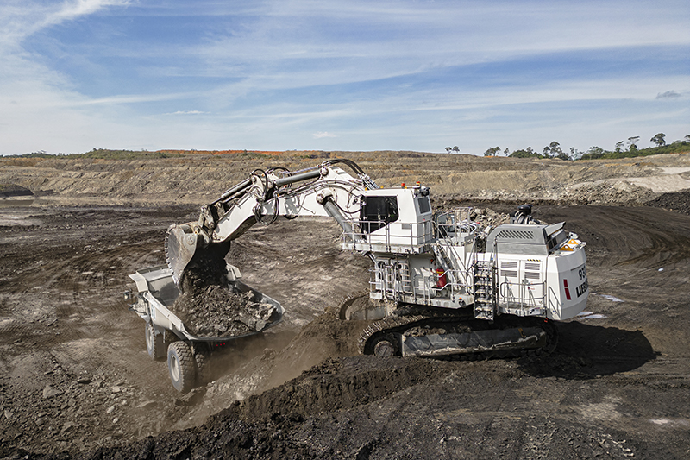

liebherr-R9300-Indonesia-96dpi.jpg  
A R 9300 currently being used to load overburden at the Tabang mine, Indonesia.

Contact

Swann Blaise  
Divisional General Manager: Marketing & Business Intelligence  
Telephone: [+1 757 928 2239](tel:+17579282239)  
Email: [swann.blaise@liebherr.com](mailto:swann.blaise@liebherr.com)

**Published by**

Liebherr-Mining Equipment Colmar SAS  
Colmar / France  
[www.liebherr.com](http://www.liebherr.com)