Pressinformation

All size classes covered: seven new Liebherr mobile construction cranes for

Fröhlich Bau

⸺
Berlin-based crane company orders MK 73-3.1, MK 88-4.1, MK 140-5.1 and MK 140 cranes
Agile and compact MK 73-3.1 is ideal for confined inner-city areas
Environmentally sound machines thanks to hybrid power concept and HVO refuelling
The right Liebherr lifting solution for every job: Fröhlich Bau Kran und Baustellenlogistik is adding another seven machines to its fleet of mobile construction cranes. With three MK 73-3.1, two MK 88-4.1, an MK 140, and an MK 140-5.1, this major order covers all size classes available in the MK series. The crane rental company is now well positioned for a variety of future jobs in the Berlin and Brandenburg area.
Biberach/Riß (Germany), 4 July 2023 – Liebherr mobile construction cranes cover a wide range of lifting work, from renovations and façade construction to the installation of windows and air-conditioning systems. Short set-up times, no additional transport units, optimal manoeuvrability and clear visibility on the road all combine to make these machines incredibly mobile. Plus, they also offer the advantages of Liebherr tower cranes, including strong performance at long reaches, fast and responsive drives, a cabin with load view, and intelligent assistance systems.
Useful in urban areas
Fröhlich Bau primarily benefits from such advantages when it comes to contracts in Berlin, as urban areas in particular involve numerous tall buildings with projecting edges. The nearer the crane can be positioned to a building, the less disruption there is for road traffic. MKs can be unfolded directly at a building without difficulty and don't require much floor space. Their supports can be freely adjusted.
“We made a conscious decision to include the smaller MK 73-3.1 in our portfolio alongside the MK 88-4.1 and the MK 140-5.1. The three-axle crane is perfect for urban challenges and can take on jobs where the two larger mobile construction cranes wouldn’t be suitable in terms of space,” says managing director Rainer Fröhlich. “And the MK 73-3.1 offers a bit more flexibility than larger machines, as it can get to site quickly with simple permits and without the need for an accompanying vehicle.” His company has been a Liebherr customer for many years and already successfully deploys ten mobile construction cranes from Liebherr-Werk Biberach GmbH, including the MK 88 and MK 140.
Powerful luffed positions with the MK 73-3.1
The MK 73-3.1 is extremely compact, measuring 13.80 metres in overall length, 2.75 metres in width and four metres in height. Nevertheless, long reaches and high lifting capacities are possible. With a 38.5 metre-long jib, the crane is capable of lifting up to 2,000 kilograms at its jib head. It offers a maximum load capacity of six tonnes. The Trolley Plus function allows powerful luffed positions (15, 30 and 45 degrees) to be achieved with a hook height of up to 51 metres and a jib head load capacity of 1,850 kilograms. No additional accompanying vehicles are required for transporting the crane.
Future-oriented hybrid power concept
Like the four-axle MK 88-4.1 and five-axle MK 140-5.1, the MK 73-3.1 features an ecological hybrid power concept. This enables the crane to work on site without emissions when connected to a power grid. If that isn’t an option, an efficient diesel generator ensures self-sufficient operation. Plus, the taxi cranes can be fuelled with HVO (Hydrogenated Vegetable Oils) for environmentally responsible operation.
The MK 88-4.1 offers a maximum lifting capacity of eight tonnes, a radius of up to 45 metres and a jib head load capacity of 2,200 kilograms. A radius of up to 65 metres and a jib head load capacity of 1,900 kilograms are possible with the MK 140-5.1, It likewise has a maximum lifting capacity of eight tonnes. The MK 140-5.1 is the only crane in the series with “VarioJib” function. This allows the crane to be operated either in trolley mode for a high handling capacity or in luffing mode for an even longer reach.
About Fröhlich Bau Kran und Baustellenlogistik
Fröhlich Bau Kran und Baustellenlogistik was established in 2014 and has sites in Berlin and Leipzig. Its crane fleet includes Liebherr mobile cranes ranging from 45 to 700 tonnes, Liebherr mobile construction cranes of all size classes, and a range of crawler and tower cranes. In addition to lifting solution rentals, the company's portfolio also includes heavy haulage services.
About the Liebherr Tower Cranes Division
More than seven decades of experience have made Liebherr a recognised specialist for lifting technology on all types of construction sites. The range of Liebherr Tower Cranes encompasses an extensive selection of high-quality tower cranes that are used worldwide. This includes fast-erecting, top-slewing, luffing jib and special-purpose cranes as well as mobile construction cranes. In addition to these products, Liebherr also offers a wide range of services that complete the company’s portfolio: Tower Crane Solutions, the Tower Crane Center and Tower Crane Customer Service.
About the Liebherr Group
The Liebherr Group is a family-run technology company with a highly diversified product portfolio. The company is one of the world's largest manufacturers of construction machinery. It also offers high-quality, user-oriented products and services in multiple other areas. Today, the group consists of more than 140 companies across all continents. In 2021, it employed more than 49,000 people and achieved combined revenues of over 11.6 billion euros. Liebherr was founded in 1949, in Kirchdorf an der Iller in southern Germany. Ever since then, the company’s employees have been committed to satisfying customers with advanced solutions and to helping drive technological progress.

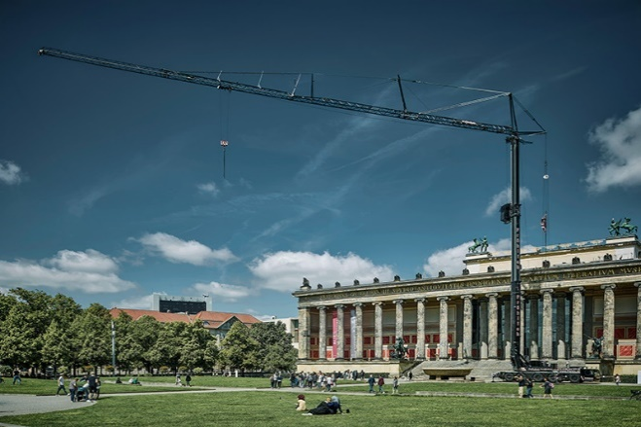
Image

liebherr-mk-140-froehlich.jpg
Working in Berlin and Brandenburg: The MK 140 five-axle crane from Fröhlich Bau Kran und Baustellenlogistik.

Contact
Daniel Haefele
Global Communication
Phone: +49 7351 / 41 - 2330
Email: daniel.haefele@liebherr.com
Published by
Liebherr-Werk Biberach GmbH
Biberach / Germany
www.liebherr.com

