Press release

Grúas Alhambra takes delivery of first Liebherr LTM 1300-6.3 mobile crane on the Iberian Peninsula

⸺

Long telescopic boom decisive purchase criterion for Grúas Alhambra

High performance and versatility of the LTM 1300-6.3 enable a wide range of applications

World record: LTM 1300-6.3 carries complete 90-metre telescopic boom at 12-tonne axle load on public roads

**With the procurement of the Liebherr LTM 1300-6.3 mobile crane, the Spanish crane company Grúas Alhambra is becoming a pioneer: It takes over the first unit of this new type on the Iberian Peninsula. The innovative all-terrain crane with a 90-metre telescopic boom is ideal for the company’s current needs, as it was looking for a crane with greater lifting capacity and height. Grúas Alhambra will use the LTM 1300-6.3 for refinery work, wind turbine maintenance and many other applications thanks to its versatility.**

Ehingen (Donau) (Germany), 5 July 2023 – Increasingly, cranes with high lifting capacity at great heights are required for construction projects. To meet this requirement, Grúas Alhambra decided to invest in the Liebherr LTM 1300-6.3 mobile crane. “We were faced with the need for equipment with longer booms. The LTM 1300-6.3 best meets our current needs,” says Abraham Molina, Managing Director of Grúas Alhambra.

With its 90-metre telescopic boom, the LTM 1300-6.3 sets standards in the 6-axle class and far surpasses other cranes on the market. It is designed to be used as a fast-erecting crane with a high capacity at great hoist heights.

Grúas Alhambra has received the first unit of the new Liebherr 300-tonne all-terrain crane both in Spain and throughout the Iberian Peninsula. “The capabilities of the new crane are undoubtedly a plus for our customers and will pave the way for new lifting projects,” says Abraham Molina. The LTM 1300-6.3 is an important addition to Grúas Alhambra’s fleet and is equipped with various lattice extensions, as well as preparation for a second winch and various innovations such as cameras and remote control system.

**On the move on public roads with 90-metre telescopic boom**

Liebherr holds a world record with the LTM 1300-6.3: Being able to carry a 90-metre telescopic boom on a mobile crane with a 12-tonne axle load is unsurpassed. The 300-tonne crane completes Liebherr’s range of 6-axle cranes and significantly improves the current market offering. This is a versatile, easy-to-set-up crane equipped with Liebherr’s latest technological innovations to ensure cost-effective, safe and powerful operation: ECOmode, ECOdrive, VarioBase®Plus, VarioBallast®, Auto-Ballast, single-engine concept and wind speed load charts.

“Grúas Alhambra will use the Liebherr LTM 1300-6.3 mobile crane mainly in refineries and in the maintenance of equipment in wind farms – but thanks to its versatility it will also be able to work in other areas. Its very long telescopic boom usually does away with the need to mount a lattice extension, thereby saving a lot of time,” Abraham Molina concludes.

For the crane company Grúas Alhambra, Liebherr is not only one of the most important crane manufacturers, but also a reliable partner it can rely on to carry out its customers’ lifting projects. The machine park comprises more than 40 machines, 36 of which are from Liebherr. With its expert knowledge and quickness to respond, Liebherr Ibérica’s after-sales service provides tremendous security during crane operations.

**About Grúas Alhambra**

Grúas Alhambra was founded in 1968 as a family business in the crane rental sector. With 55 years of experience, the company offers its services throughout the Andalusia region. Occupational safety is always in the foreground. The company has innovative machines that set standards in the lifting industry. All this has made Grúas Alhambra one of the leading companies in the crane sector. Based in Granada, Andalusia, the company currently employs around 70 people.

**About Liebherr Ibérica, S.L.**

Liebherr Ibérica is the Liebherr Group’s Spanish sales and service company and was founded in 1988. Liebherr Ibérica is currently responsible for the sales and after-sales service of the mobile and crawler cranes, tower cranes, earthmoving machinery, mining machinery, maritime cranes and concrete technology product ranges.

**About Liebherr-Werk Ehingen GmbH**

Liebherr-Werk Ehingen GmbH is a leading manufacturer of mobile and crawler cranes. Its range of mobile cranes extends from 2-axle 35 tonne cranes to heavy duty cranes with a lifting capacity of 1200 tonnes and a 9-axle chassis. Its lattice boom cranes on mobile or crawler crane chassis deliver lifting capacities of up to 3000 tonnes. With universal boom systems and extensive additional equipment, they can be seen in action on construction sites throughout the world. The Ehingen site has a workforce of 4,300. An extensive, global service network guarantees the high availability of Liebherr mobile and crawler cranes. In 2022, the Liebherr plant in Ehingen recorded a turnover of 2.37 billion euros.

**About the Liebherr Group**

The Liebherr Group is a family-run technology company with a widely diversified product range. The company is one of the largest manufacturers of construction machines in the world. However, it also supplies high quality, user-focused products and services in many other sectors. The group currently comprises more than 140 companies based in every continent of the world. In 2022, it had a workforce of over 50,000 and recorded a consolidated total turnover of more than 12.5 billion euros. The company was founded in 1949 in Kirchdorf an der Iller in southern Germany. Since then, its aim has been to win customers by supplying high quality solutions and to contribute to technological progress.

**Images**

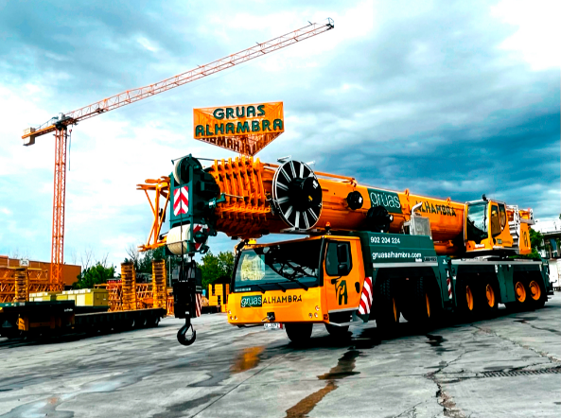

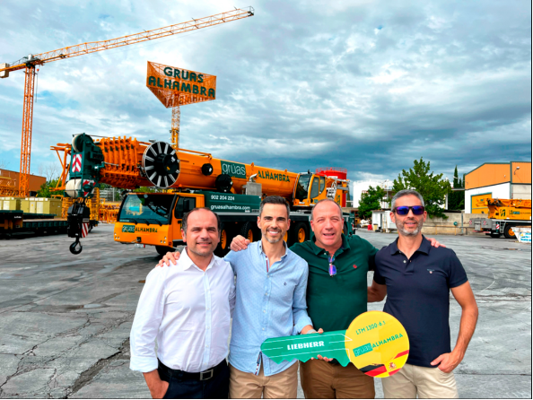liebherr-ltm-1300-6-3-gruas-alhambra.jpg  
Grúas Alhambra is leading the way in taking delivery of the first Liebherr LTM 1300-6.3 mobile crane on the Iberian Peninsula.

liebherr-ltm-1300-6-3-gruas-alhambra-handover.jpg  
Official handover of the Liebherr LTM 1300-6.3 mobile crane to Grúas Alhambra: (from left to right) Marcos Presa (Liebherr Ibérica), Raúl Molina (Grúas Alhambra), Tobias Böhler (Liebherr Ibérica) and Abraham Molina (Grúas Alhambra).

**Contact**

Wolfgang Beringer  
Marketing and Communication  
Phone: +49 7391/502 - 3663  
Email: wolfgang.beringer@liebherr.com

**Published by**

Liebherr-Werk Ehingen GmbH  
Ehingen (Donau) / Germany  
www.liebherr.com