Press release

Liebherr and Leica Geosystems: Expanded range of semi-automatic machine control systems for crawler excavators

⸺
Leica Geosystems semi-automatic machine control system is now available for Generation 8 crawler excavator models
Machine control systems are available in 2D, 3D and 2D "3D-ready" versions
Driver assistance systems for more productivity, efficiency and precision
Liebherr, in cooperation with Leica Geosystems, part of Hexagon, offers various machine control systems for hydraulic excavators ex works. Machine control systems are driver assistance systems that make construction projects and processes more efficient, productive and safer. Liebherr is now extending its range of machine control systems for its Generation 8 crawler excavator models.
Kirchdorf an der Iller (Germany), 11 July 2023 – The digital transformation in the construction industry continues apace with construction sites becoming increasingly digital and networked. Driver assistance systems such as machine control systems from Leica Geosystems are thus gaining in importance. They support the machine operators in carrying out their activities by means of the latest technologies and real-time information. The quality of the work results, the efficiency of the work processes as well as safety can be significantly increased – and the implementation times in planning and construction reduced at the same time.
Semi-automatic machine control system ex works: For Liebherr G8 crawler excavators
Leica Geosystems' machine control systems are already available in different versions for Liebherr mobile and crawler excavators. They include the 2D passive and 3D passive machine control system for Generation 6 and 8, as well as the 2D "3D-ready" semi-automatic and the 3D semi-automatic for Generation 6.
The availability of semi-automatic machine control systems, both 2D "3D-ready" and 3D, has been extended to Generation 8 crawler excavators; they are now available for the R 922, R 924, R 926, R 928, R 930, R 934, R 938 and R 945 models. The 2D "3D-ready" passive machine control system is also offered for these models.
The respective equipment variants are available from Liebherr ex works. All machine control components from Leica Geosystems are optimally installed during the production process and the customer receives a pre-calibrated machine. Downtimes due to subsequent installation can thus be avoided.
Passive or semi-automatic operation: Targeted support for the machine operator
Depending on the situation and requirements on the construction site, Liebherr offers the right machine control system for every application. Whereas with a passive system, machine operators have to follow the indications on the display in the cab and operate the machine themselves to complete the job, the semi-automatic machine control system provides active support with a semi-automated removal mode. The machine operator must only control the machine's stick movements and speed via the joystick. The system automatically adjusts the correct movement of all the equipment to create the target profile.
Productivity can be significantly increased by using a semi-automatic machine control system. Work can also be carried out much more precisely over a longer period, reducing time-consuming and cost-intensive reworking. Generation 8 machines with a passive machine control system can be retrofitted with a semi-automatic system by means of a corresponding software package at the customer's request, provided that they are equipped with a Master 5 Premium.
Different variants of machine control systems: 2D, 3D or 2D "3D-ready"
2D or 3D machine control systems from Leica Geosystems provide the machine operator with information about the height and inclination of the machine as well as the corresponding position via the display in the operator's cab.
While a 2D machine control system is designed for working from flat and sloping surfaces, a 3D machine control system uses reference models and GNSS to guide the machine operator. Through 3D GNSS positioning in conjunction with 3D model data, all information on excavation and removal as well as the machine's position on the construction site is visible in real time.
With the 2D "3D-ready" variant, work can be done immediately in 2D, either passively or semi-automatically depending on the purchased option. A 2D control can be subsequently upgraded to a fully-fledged 3D machine control system at any time.
Significance of machine control systems on the market
Machine control systems are becoming increasingly important for a wide variety of construction projects. They offer significant added value to machine operators, companies and the environment and enable the operators to use their machines even more productively and precisely. The consistent use of sensors and software provides the operator with real-time information, which in turn enables work processes to be optimised in terms of time and costs thanks to various automation functions. Waiting times for surveyors are shortened and the need for control measurements on the construction site is reduced. In addition, this increases safety on the construction site, as fewer people are needed in the direct vicinity of the machine. In addition, the operator's workload is reduced, which prevents driver fatigue and his or her associated susceptibility to errors.
About the Liebherr Group
The Liebherr Group is a family-run technology company with a highly diversified product portfolio. The company is one of the largest construction equipment manufacturers in the world. It also provides high-quality and user-oriented products and services in a wide range of other areas. The Liebherr Group includes over 140 companies across all continents. In 2022, it employed more than 50,000 staff and achieved combined revenues of over 12.5 billion euros. Liebherr was founded in Kirchdorf an der Iller in Southern Germany in 1949. Since then, the employees have been pursuing the goal of achieving continuous technological innovation, and bringing industry-leading solutions to its customers.
About Leica Geosystems – when it has to be right
Leica Geosystems, part of Hexagon, with more than 200 years of history, is a trusted supplier of high-quality sensors, software and services. Leica Geosystems adds value to companies in surveying, construction, infrastructure, mining, mapping and other geographic content-dependent industries every day, leading the industry with innovative solutions to empower our autonomous future.
Hexagon (Nasdaq Stockholm: HEXA B) has about 24,000 employees in 50 countries and net sales of about EUR 5.2 billion. Learn more at hexagon.com and follow us @HexagonAB.

Images
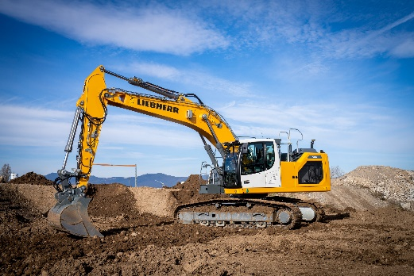
liebherr-leica-r928-1-300dpi.jpg
Leica Geosystems' semi-automatic machine control system is now available for selected Liebherr Generation 8 crawler excavators.
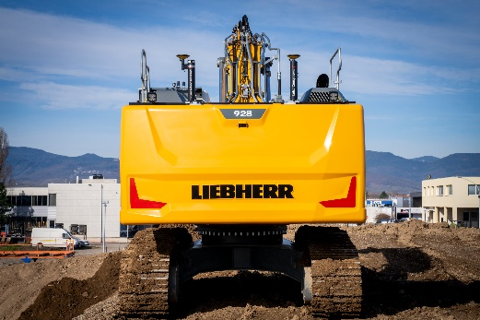
liebherr-leica-r928-2-300dpi.jpg
Antennas with GNSS technology determine the exact position of the machine on the construction site.
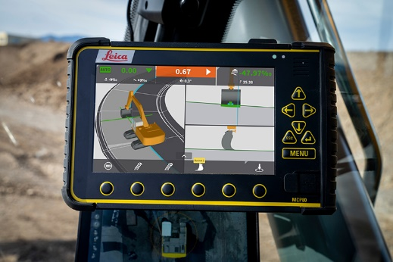
liebherr-leica-r928-3-300dpi.jpg
The Leica MCP80 control unit shows the machine operator in the operator's cab both the machine's position and all information on excavation and removal.
Contact
Nadine Willburger
Marketing
Phone: +49 7354 / 80 - 7332
Email: nadine.willburger@liebherr.com
Alban Villaumé
Marketing & Communication
Phone: +33 3 89 21 36 09
Email: alban.villaume@liebherr.com
Published by
Liebherr-Hydraulikbagger GmbH
Kirchdorf an der Iller / Germany
www.liebherr.com
Contact for further information:
Leica Geosystems AG
Reka Vasszi
Communications Manager
Mobile: +41 79 124 7164
Email: reka.vasszi@hexagon.com

