Press release

Liebherr at steinexpo 2023: Alternative drives and digitalisation in the quarrying industry

⸺

More than ten Liebherr machines and numerous technologies as part of a static exhibition, on the demo site and in the Liebherr pavilion

Robust TA 230 Litronic articulated dump truck for tough use in the mining industry and overburden transport

Improved crawler excavators R 992 and R 978 SME of the new 70 to 100 t machines and the mining excavator R 9150 for particularly demanding projects in the mining industry

L 546 and L 586 XPower® wheel loaders as well as the dozers PR 756 and PR 726 with assistance systems for more power and safety

Liebherr will be represented at steinexpo 2023 from 23 to 26 August 2023 with over ten machines from its earthmoving and mining product segments. In addition to the products on static display and presented in live shows, the main focus of Liebherr's presence will also be on alternative drives and the latest developments in the field of digitalisation. Several crawler excavators, an articulated dump truck, the largest Liebherr wheel loader as well as other wheel loader models, dozers and a mining excavator will be on display on Liebherr's main booth, which covers around 1,200 m2.

Biberach a. d. Riss (Germany), 14 July 2023 - For Liebherr, steinexpo has been an important trade exhibition in the earthmoving and quarrying sector for many years. This year, too, the Group will give around 50,000 visitors in Homberg in central Germany an insight into the product highlights and solutions for quarries and mines. For example, the earthmoving and mining product segments will present a highlight, the TA 230 articulated dump truck, as well as other machines for earthmoving in the extraction industry and a 100-tonne mining excavator. In Europe's largest basalt quarry, many of these machines can be demonstrated to the public in a real working environment during daily live shows.

In the field of new technologies, at the exhibition Liebherr will put one focus on alternative drives. As part of its technology-neutral approach, the Group will provide an insight and outlook on various drive concepts at the exhibition: from the conventional combustion engine to hydrogen-based drives and electric drives. In addition, digitalisation in the field of earthmoving and mining machines, for example through digital assistance systems or virtual product simulations, will also play a major role.

**Alternative drive technologies for the extraction industry**

At the exhibition, the Group will present, among other things, its work on electric and hydrogen-based drives specifically for the use of machines in the extraction industry. In heavy-duty applications in particular, promising opportunities are opening up with hydrogen-based drives that offer representative ranges with high overall performance. The use of low-emission alternative fuels, such as HVO (Hydrotreated Vegetable Oil), which can already be already used in the majority of Liebherr machines, will also play a role at the exhibition.

One exhibition highlight awaiting visitors to steinexpo is Liebherr's first hydrogen combustion engine. The H966 was developed by the Components product segment for demonstration and field trials and is based on port fuel injection technology (also known as PFI). The results achieved using this technology show the great future potential of hydrogen-based drives and speak in favour of using such drives, especially for off-road applications. The engine was first demonstrated at Bauma 2022 in the R 9XX H2, a hydrogen excavator prototype. In addition, Liebherr will be presenting an innovative solution for the mobile refuelling of construction machinery with gaseous hydrogen together with Maximator Hydrogen GmbH.

Powerful and all-terrain dump truck

The TA 230 Litronic articulated dump truck will be on display at steinexpo in both the static exhibition and the live show. The robust and durable dump truck is specially designed for demanding use in the quarrying industry and for overburden transport. In addition, the machine offers a wide range of optional equipment especially for the tough and wear-intensive use in quarries, as well as assistance systems.

Modern assistance systems make work easier: efficient dozers for extraction

In practical use, the PR 756 Generation 8 dozer shows in the live demo the advantages and possibilities offered by modern assistance systems. They make the driver's work easier and at the same time enable safe and economical use of the machine. In addition to the Liebherr Silent Design, which enables particularly quiet operation, the revised electronically controlled hydrostatic drive with EcoMode allows for even greater fuel efficiency. The hydrostatic drive concept, which is standard in the new Generation 8 dozers, also enables significant cost savings for the customer thanks to the efficiency improvements.

Lower fuel consumption: improved crawler excavators in the 70 to 100 t class

The new R 992 crawler excavator will also be on show. Like the entire product range of 70 to 100 t excavators, it is characterised by optimised performance data, increased driving comfort, new assistance functions and low fuel consumption after numerous improvements. The new and patented Liebherr Power Efficiency (PE) - Engine Control system contributes to the latter in particular. Particularly suitable for use in mining or quarrying is, among other things, the crawler excavator R 978 SME, equipped with a new frame and further optional services, which will be demonstrated in the demo shows. An R 992 Generation 8 complements the crawler excavator range at the exhibition in the static exhibit area.

Efficient and safe: Powerful wheel loaders with various assistance systems

With the mid-sized L 546 at the booth and the large L 586 XPower® in the live demonstration, two particularly powerful Liebherr wheel loaders will be presented. Both machines feature efficient and powerful drive technologies and are available with innovative assistance systems. The L 586 XPower®, for example, is equipped with a weighing system developed by Liebherr that provides the driver with numerous information and enables the weighing data to be evaluated via Liebherr's LiDAT fleet management portal, which, among other things, provides an overview with relevant machine and application data. The L 546 exhibited at steinexpo is equipped with the active person detection and thus significantly increases safety in the quarry.

Powerful 100 t mining excavator for quarry and mining applications

The exhibition will feature the Liebherr R 9150 100 t mining excavator designed for quarrying and mining. In addition to this most powerful excavator at the show, the Mining product segment will also exhibit the 18.7 m3 capacity bucket of an R 9350. The latest technologies, products and solutions for modern mining can be explored in a virtual mine: With the aid of virtual reality goggles, visitors can test the various assistance systems from Liebherr Mining in a virtual R 9600, which is one of the largest Liebherr mining excavators with an operating weight of 600 tonnes.

About the Liebherr Group

The Liebherr Group is a family-run technology company with a highly diversified product portfolio. The company is one of the largest construction equipment manufacturers in the world. It also provides high-quality and user-oriented products and services in a wide range of other areas. The Liebherr Group includes over 140 companies across all continents. In 2022, it employed more than 50,000 staff and achieved combined revenues of over 12.5 billion euros. Liebherr was founded in Kirchdorf an der Iller in Southern Germany in 1949. Since then, the employees have been pursuing the goal of achieving continuous technological innovation, and bringing industry-leading solutions to its customers.

Images

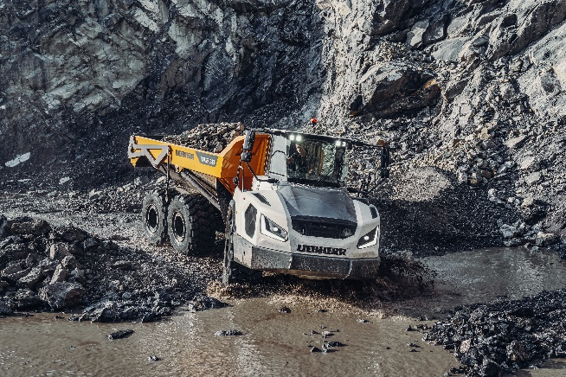

liebherr-ta-230-steinexpo.jpg  
The TA 230 Litronic from Liebherr is designed for demanding off-road applications such as the mining industry and impresses with outstanding off-road capability, maximum traction and concentrated pulling power.

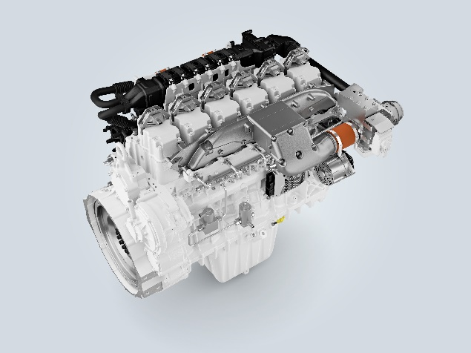

liebherr-h966-pfi-engine.jpg  
The H966 engine is developed and produced at Liebherr Machines Bulle SA in Switzerland.

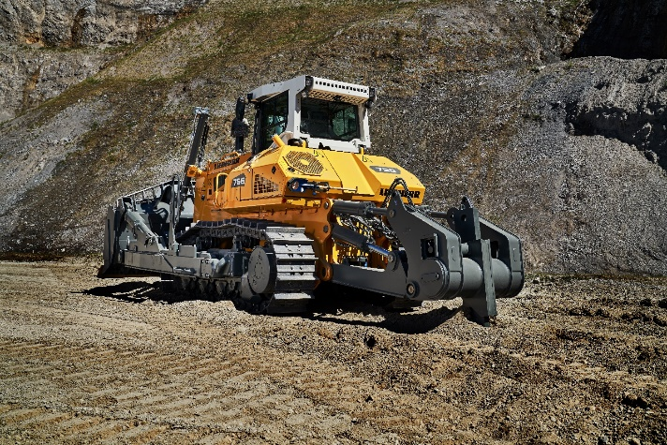

liebherr-pr-756-steinexpo.jpg  
The Liebherr PR 756 Generation 8 dozer demonstrates in the live demo the advantages offered by modern assistance systems.

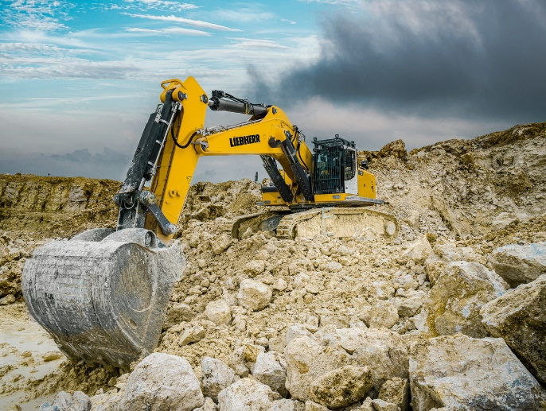

liebherr-r-978-sme-steinexpo-961dpi  
The Liebherr crawler excavator R 978 SME will be demonstrated live in the demo shows at steinexpo 2023.

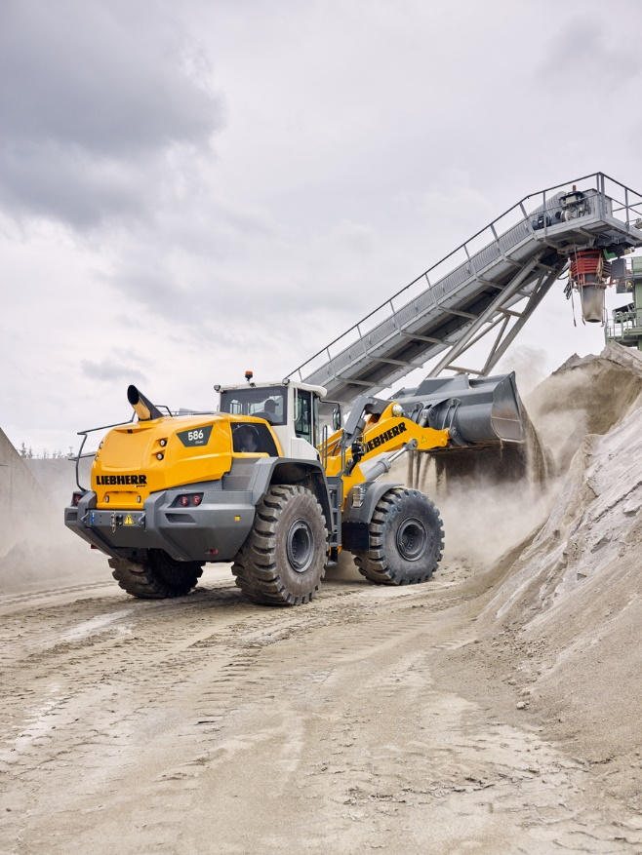

liebherr-l-586-xpower-steinexpo.jpg

Liebherr is showing its largest wheel loader at steinexpo, the L 586 XPower®, which weighs around 33 tonnes.

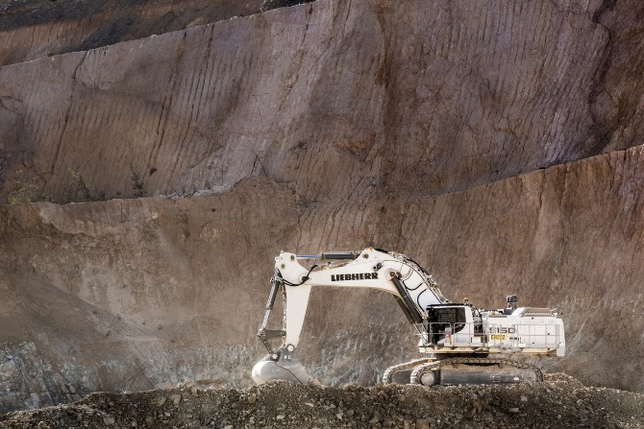

liebherr-r-9150-steinexpo.jpg

The 100 t R 9150 mining excavator designed for quarrying and mining will be the highlight of Liebherr's Mining product segment at steinexpo 2023.

Contact

Larissa Lunitz  
Public Relations  
Phone: +49 (7351) 41 4384  
E-Mail: larissa.lunitz@liebherr.com

Published by

Liebherr-International Deutschland GmbH  
Hans-Liebherr-Straße 45  
88400 Biberach an der Riß / Deutschland  
[www.liebherr.com](http://www.liebherr.com)