Press release

Flange laying of LS 800 E: Project Orca sets sail for a sustainable future

⸺
Liebherr provides the first all-electric heavy lift ship crane LS 800 E for SAL Heavy Lift and the Orca project
The crane features the precise and reliable Litronic crane control, which enables seamless and efficient operation
Liebherr delivers state-of-the-art solutions that redefine efficiency, reliability, and performance

Together with Liebherr, SAL Heavy Lift, a leading provider of forward-looking and sustainable vessel solutions, celebrated a significant milestone. The flange laying ceremony of the new all-electric heavy lift crane, LS 800 E took place in Rostock and welcomed esteemed guest SAL Heavy Lift, marking the go-ahead for the production of the first of a number of groundbreaking all-electric heavy lift ship cranes.

Rostock (Germany), July 2023 – In the course of the flange laying, the kick-off for the production period, a signing ceremony took place to seal the contract for a joint cooperation within the framework of the Orca project. This agreement solidifies the partnership between Liebherr and SAL Heavy Lift, paving the way for a collaborative effort towards the common goal of transforming the maritime industry.
The Orca project represents the journey towards sustainable shipping and the energy turnaround. This modern and future-oriented ship concept aims to contribute to the decarbonization of the maritime industry. To align with this vision, Orca sought crane solutions that embodied the same commitment to sustainability. The LS 800 E crane seamlessly fits into the sustainability concept of the Orca fleet, solidifying a partnership built on shared values.
“We are proud to equip the Orca fleet with our LS 800 E units,” states Robert Pitschmann, Global Application Manager Heavy Lift Offshore and Ship Cranes, Liebherr MCCtec Rostock GmbH. “The foundation stone of trust and partnership between Liebherr and SAL Heavy Lift has been laid today. With this all-electric heavy lift ship crane, we set sail towards a sustainable future, where advanced technology and environmental consciousness go hand in hand.”

A true giant
The LS 800 E impresses with its all-electric drive concept, which increases energy efficiency and minimises CO₂ emissions. With its internal development and procurement capacities, Liebherr is excellently positioned to meet future environmental standards in the maritime sector.
The cutting-edge crane is equipped with all its components neatly housed within the crane column, ensuring optimal space utilization and a sleek design. One of the standout features of this electric crane is its power-saving capabilities, achieved through active communication between the crane, power electronics, and switch cabinets. By constantly optimizing energy usage, this intelligent system maximizes efficiency while minimizing power consumption.
Liebherr takes great pride in developing and producing fundamental components in-house, ensuring the highest quality standards and complete control over the manufacturing process. This approach allows for easy integration and optimal performance of the crane as a whole. Additionally, this remarkable crane sports a vertical boom rest with a locking pin discreetly located inside the crane column. This feature provides secure and stable positioning, enhancing safety and facilitating smooth operations.
A landmark initiative
SAL Heavy Lift, renowned for its expertise in heavy lift transportation and project cargo, is honored to be a part of this landmark initiative. “We are delighted to collaborate with Liebherr on this very special project,” said Dr Martin Harren, CEO of SAL Heavy Lift and the Harren Group. “The LS 800 E crane represents the pinnacle of engineering excellence and sustainability, and we are confident that it will play a crucial role in our fleet.”
The flange laying ceremony of LS 800 E showcases the commitment of both Liebherr and SAL Heavy Lift to push the boundaries of innovation and pave the way for a greener maritime industry. As production commences on the first unit of this state-of-the-art crane, Liebherr remains steadfast in its dedication to creating a sustainable fleet that embraces cutting-edge technology.

About Liebherr-MCCtec Rostock GmbH
Liebherr-MCCtec Rostock GmbH is one of the leading European manufacturers of maritime handling solutions. The product range includes ship, mobile harbour and offshore cranes. Reach stackers and components for container cranes are also included in the product portfolio.
About the Liebherr Group
The Liebherr Group is a family-run technology company with a highly diversified product portfolio. The company is one of the largest construction equipment manufacturers in the world. It also provides high-quality and user-oriented products and services in a wide range of other areas. The Liebherr Group includes over 140 companies across all continents. In 2022, it employed more than 50,000 staff and achieved combined revenues of over 12.5 billion euros. Liebherr was founded in Kirchdorf an der Iller in Southern Germany in 1949. Since then, the employees have been pursuing the goal of achieving continuous technological innovation and bringing industry-leading solutions to its customers.

Images
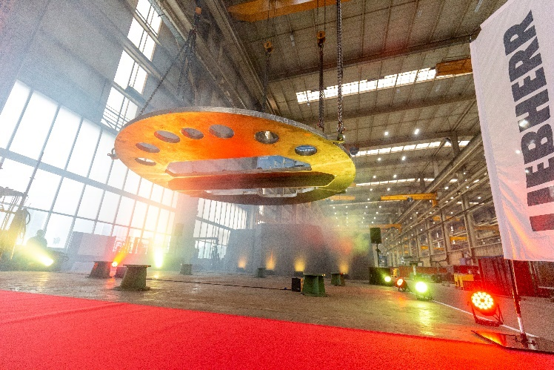
liebherr-flange-laying-ceremony-ls800e-1.png
The flange-laying ceremony took place in the Liebherr Group’s longest factory hall. In shipping, it is customary to place a coin under the keel for good luck. Liebherr has adapted this tradition and places the coin under the flange of the ship’s crane.

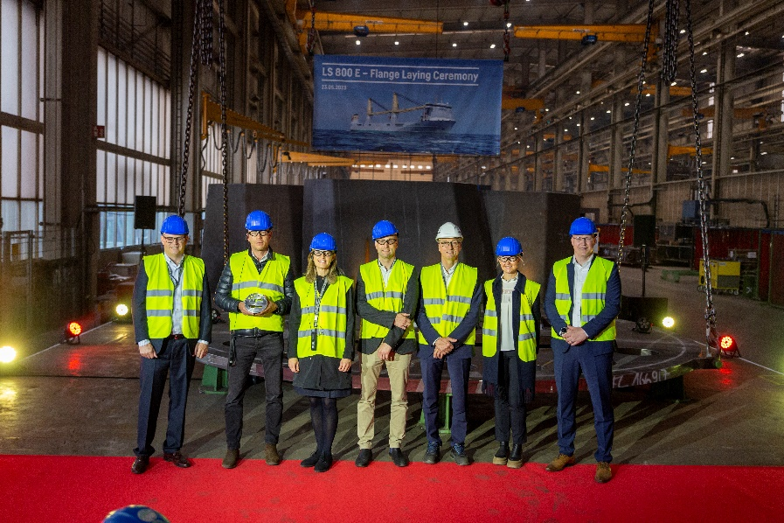
liebherr-flange-laying-ceremony-ls800e-2.png
VIPs from Liebherr, SAL Heavy Lift and the Harren Group attended the ceremony. (f.l.t.r.: Leopold Berthold, Managing Director Liebherr-MCCtec Rostock GmbH; Martin Harren, CEO SAL Heavy Lift and the Harren Group; Patricia Rüf, Member of the Board of Directors Liebherr-International AG; Sebastian Westphal, Managing Director Harren Group; Rudolf Ganser, Managing Director Production Liebherr-MCCtec Rostock GmbH; Stephanie Schillgalies, Head European Chartering Desk Harren Group; Gregor Levold, General Manager Sales - Offshore, Ship and Port Cranes Liebherr-MCCtec Rostock GmbH).
Contact
Anne Lau
Product Marketing Manager SC/PTS
Phone: +49 381 6006 5031
E-mail: Anne.Lau@liebherr.com
Published by
Liebherr-MCCtec Rostock GmbH
Rostock / Germany
www.liebherr.com

