Press release

Reducing CO2 emissions: Liebherr LTM 1650-8.1 mobile crane installs silo at cement plant

⸺

LTM 1650-8.1 from Schmidbauer hoists loads of over 50 tonnes with a 31.5 metre luffing jib

New silo system adds aggregates to cement production to reduce clinker and therefore CO2 emissions

**Heidelberg Materials is investing heavily in the reduction of CO2 emissions in cement production. A Liebherr LTM 1650-8.1 mobile crane from the crane and heavy haulage contractor Schmidbauer GmbH & Co. KG has now installed a silo at the Schelklingen cement plant for storing aggregates that can reduce the proportion of clinker in the cement.**

Ehingen (Donau) (Germany), 5 July 2023 - Clinker is fired from limestone in a rotary kiln at 1,450 degrees Celsius. This process releases CO2 which damages the climate. “The less clinker we need for cement production, the less CO2 is released into the atmosphere,” explains Frank Hartwig, the Project Manager responsible for new builds and modifications at Heidelberg Materials’ Schelklingen plant. “Therefore, we want to replace the clinker in the cement with other suitable materials. We can store 1,500 tonnes of them in the new silo. The dosing station in the so-called penthouse above it feeds the aggregate straight into the cement production process.”

Schmidbauer GmbH & Co. KG sent its one-and-a-half-year-old Liebherr LTM 1650-8.1 with three transport vehicles for the counterweight and two vehicles for the luffing jib from Munich to Upper Swabia to install the new silo system. The two crane operators Stephan Pirner and Robert Halsner used the Liebherr 8-axle crane for initial assembly work and the two main hoists, each of around 53 tonnes. They set up the crane with 145 tonnes of ballast and a 31.5 metre luffing jib for the work.

After installing the bottom part, the actual silo was put in position. A day later, the penthouse, which weighed around the same, was mounted on top of the silo. The biggest challenge was to attach the load to the sloping penthouse roof. A special chain system, whose length can be adjusted pneumatically, was used to level the huge component.

The two crane operators are full of praise for the Liebherr LTM 1650-8.1. “This is the best crane I have ever used,” says Stephan Pirner, who has worked for Schmidbauer for 27 years and has operated large cranes from various manufacturers for 23 years. “The set-up process is particularly efficient. Liebherr has designed it in such a way that very little physical work is required from the crane operators.” His colleague Robert Halsner, a crane operator for seven years, agrees: “The LTM 1650-8.1 is really user-friendly and very flexible to use with VarioBase® and VarioBallast®. And it is extremely powerful.”

Project Manager Hartwig is also pleased with the installation of the new silo system: “In recent years, our company has made a number of investments for the future here at the site. More projects are already planned, so it's good to be able to rely on competent partners.”

**About Heidelberg Materials**

Heidelberg Materials is one of the world's largest integrated manufacturers of building materials and solutions, with leading market positions in cement, aggregates, and ready-mixed concrete. We have more than 51,000 employees at almost 3,000 sites in over 50 countries. Responsibility for the environment is at the heart of everything we do. We are pioneers in attempts to achieve CO2 neutrality and a circular economy in the building materials industry, we are working on sustainable building materials and solutions for the future. We are creating new opportunities for our customers through digitalisation.

**About Schmidbauer**

Schmidbauer is Germany’s leading provider of mobile crane and special transport services of all sizes and installation with “Performance Plus" - a full-service concept that combines state-of-the-art technology with sophisticated engineering and human expertise. Founded in 1932, the company serves many industries and is an innovative partner for hoisting and moving heavy loads for customers in the construction, energy and chemical industries as well as plant and mechanical engineering.  
The Schmidbauer Group, based in Gräfelfing near Munich, employs around 600 people and provides a nationwide service with its subsidiaries Fricke-Schmidbauer Schwerlast GmbH and Rieger & Moser GmbH & Co. KG, with its large fleet of special vehicles at almost 30 sites throughout Germany and also has an international presence with branches and sales offices in Estonia, Finland and France.

**About Liebherr-Werk Ehingen GmbH**

Liebherr-Werk Ehingen GmbH is a leading manufacturer of mobile and crawler cranes. Its range of mobile cranes extends from 2-axle 35 tonne cranes to heavy duty cranes with a lifting capacity of 1200 tonnes and a 9-axle chassis. Its lattice boom cranes on mobile or crawler crane chassis deliver lifting capacities of up to 3000 tonnes. With universal boom systems and extensive additional equipment, they can be seen in action on construction sites throughout the world. The Ehingen site has a workforce of 4,300. An extensive, global service network guarantees the high availability of Liebherr mobile and crawler cranes. In 2022, the Liebherr plant in Ehingen recorded a turnover of 2.37 billion euros.

About the Liebherr Group

The Liebherr Group is a family-run technology company with a widely diversified product range. The company is one of the largest manufacturers of construction machines in the world. However, it also supplies high quality, user-focused products and services in many other sectors. The group currently comprises more than 140 companies based in every continent of the world. In 2022, it had a workforce of over 50,000 and recorded a consolidated total turnover of more than 12.5 billion euros. The company was founded in 1949 in Kirchdorf an der Iller in southern Germany. Since then, its aim has been to win customers by supplying high quality solutions and to contribute to technological progress.

**Images**

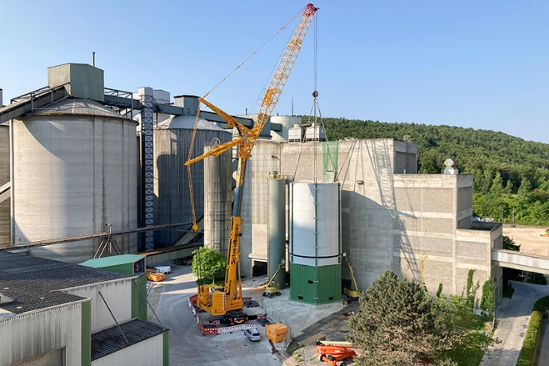

liebherr-ltm1650-8.1-schmidbauer-schelklingen-01.jpg  
The Liebherr LTM 1650-8.1 mobile crane installs the new silo for aggregates for cement production.

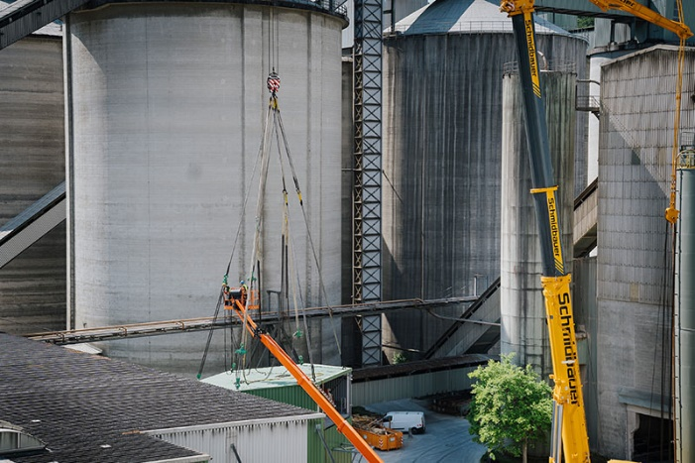

liebherr-ltm1650-8.1-schmidbauer-schelklingen-02.jpg  
The filling station, known as the penthouse, is levelled with a special chain system that can be adjusted in length pneumatically.

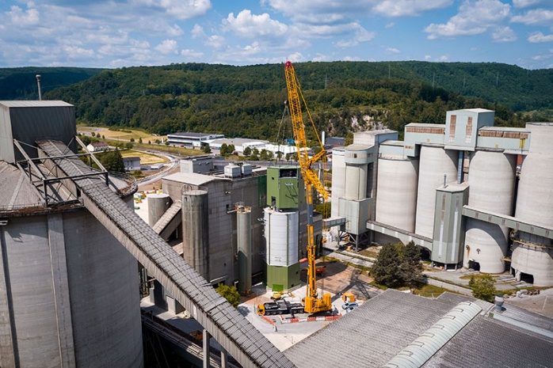

liebherr-ltm1650-8.1-schmidbauer-schelklingen-03.jpg  
The penthouse is carefully positioned on top of the silo.

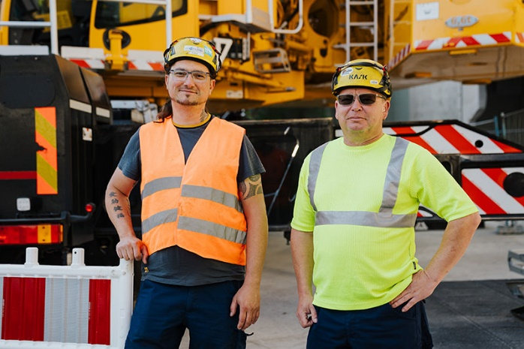  
liebherr-ltm1650-8.1-schmidbauer-schelklingen-04.jpg  
Crane operators Stephan Pirner (right) and Robert Halsner are pleased with how easy the LTM 1650-8.1 is to operate.

**Contact**

Wolfgang Beringer  
Marketing and Communication  
Phone: +49 7391/502 - 3663  
Email: wolfgang.beringer@liebherr.com

**Published by**

Liebherr-Werk Ehingen GmbH  
Ehingen (Donau) / Germany  
www.liebherr.com