Press release

Liebherr drilling rig put to the test

⸺

The Swiss company Kibag is installing new mooring piles for the Lake Lucerne Navigation Company. For the first time, Kibag is using a drilling rig from Liebherr’s LB series. The LB 30 is facing challenges which literally couldn’t be harder.

Nenzing (Austria), 28. July 2023 - "The problem is that we can't drive the piles here," explains Markus Waldis, Foreman at Kibag. “The ground is too hard. We have to drill the piles and then fill them with concrete.”

In Seelisberg on the southern shore of Lake Lucerne, Markus Waldis’ team are drilling the piles from a pontoon using the LB 30 drilling rig from Liebherr. From the surface of the water around 12 metres deep and with a diameter of 1,300 millimetres. After 3 metres of water comes a stone segment and then at least 6 metres of drilling in the rocks.

This rock is an endurance test for the construction personnel and especially for the new LB 30. “The stone is exceedingly hard! The whole machine vibrates,” Markus explains the extreme challenges. Also, the fact that insufficient pressure can be applied from the pontoon with the drilling rig makes it even more difficult. “Otherwise, we just lift the pontoon. We have to secure it very well so that it holds during drilling,” so Markus Waldis describing the different conditions when drilling on water instead of land.

Successful premiere

Gianluca Diaco has been a machine operator for 14 years, works for Kibag and this is his first time on a water construction site. “Because the ground is very hard, we have to change the chisels on the auger starter quite often in order to be able to drill through the rocks.” Despite the difficult conditions he is pleased to be operating the Liebherr LB 30. “It’s very strong, compact and moves fast. You can really do everything.”

After the hydraulic engineering specialists from Kibag have concreted the outer casings, the mooring pile is inserted. A rubber strap between the outer casing and the pile ensures that the pile is not too rigid and can move a little when the boats moor. To prevent the mooring pile from rotating, it must be secured under water by a diver.

The construction site demands everything from the personnel and the drilling rig. Nevertheless, Markus Waldis is pleased with the successful premiere of the LB 30, “The machine works perfectly - tip-top. It has to withstand huge vibrations. It is a great endurance test for the machine. So far it is coping wonderfully.”

A journey with obstacles

To bring the drilling rig to the construction site, the Kibag team travelled across the lake by pontoon for about 6 hours. The Acheregg Bridge in the southwest of Lake Lucerne was the first challenge, explains Markus Waldis, “We had to watch the height and were only able to erect the drilling rig after the bridge, meaning at sea. Our pontoon is relatively large, about 18 metres wide and 40 metres long, and there is a lot of weight on it. That made things very difficult.”

About the Liebherr Group

The Liebherr Group is a family-run technology company with a highly diversified product portfolio. The company is one of the largest construction equipment manufacturers in the world. It also provides high-quality and user-oriented products and services in a wide range of other areas. The Liebherr Group includes over 140 companies across all continents. In 2022, it employed more than 50,000 staff and achieved combined revenues of over 12.5 billion euros. Liebherr was founded in Kirchdorf an der Iller in Southern Germany in 1949. Since then, the employees have been pursuing the goal of achieving continuous technological innovation, and bringing industry-leading solutions to its customers.

Film: [Liebherr - LB 30 put to the test - YouTube](https://www.youtube.com/watch?v=bptZ9GglzPM&t=32s)  
LB 30: [LB 30 Drilling rig (LB series) | Liebherr](https://www.liebherr.com/en/deu/products/construction-machines/deep-foundation/drilling-rigs/lb-series/details/lb30.html)  
LB series: [Drilling rigs LB series | Liebherr](https://www.liebherr.com/en/deu/products/construction-machines/deep-foundation/drilling-rigs/drilling-rigs.html)

Images

An image containing outside, sky, water, mountain.

Automatically generated description

liebherr-lb30-kibag_1.jpg  
The water construction site in Seelisberg challenges the LB 30 drilling rig with extremely hard rock.

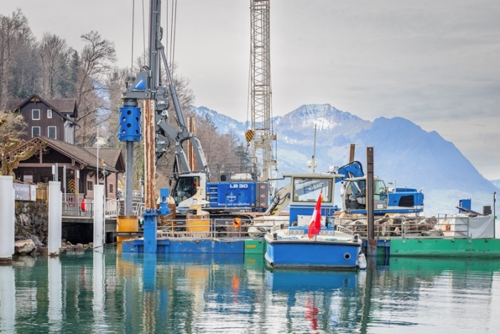

liebherr-lb30-kibag_2.jpg  
Kibag is using the LB 30 to install new mooring piles for the Lake Lucerne Navigation Company.

Contact

Gregor Griesser  
Strategic Marketing and Communications  
E-Mail: [gregor.griesser@liebherr.com](mailto:gregor.griesser@liebherr.com)

Wolfgang Pfister  
Head of Strategic Marketing and Communications  
Tel.: +43 50809 41-444  
E-Mail: [wolfgang.pfister@liebherr.com](mailto:wolfgang.pfister@liebherr.com)

Published by:

Liebherr-Werk Nenzing GmbH  
Nenzing/Austria  
[www.liebherr.com](http://www.liebherr.com)