Press release

Two powerful Liebherr wheel loaders at steinexpo 2023

⸺

The L 546 wheel loader – representative of the new mid-size series – can be seen at the Liebherr stand

The L 586 XPower® – the largest Liebherr wheel loader – can be seen in action in live demonstrations

Wheel loader assistance systems increase safety and productivity in the extraction process

Liebherr is presenting two powerful wheel loaders from two different series at this year's steinexpo, the international demonstration trade fair for the raw materials and building materials industry. Among them is the L 546, representative of the mid-sized Liebherr wheel loaders. Liebherr has recently redeveloped and fundamentally revised this series. Innovations include newly designed lift arms that ensure maximum breakout, holding and return forces. The second Liebherr wheel loader at steinexpo is the L 586 XPower®, Liebherr's largest and heaviest wheel loader with an operating weight of around 33 tonnes.

Nieder-Ofleiden (Germany), August 23, 2023 – As a special highlight for trade fair visitors, Liebherr will be showcasing the L 586 XPower® in several live demonstrations, where the wheel loader will be exhibiting its high performance in work applications. Like all Liebherr wheel loaders in the XPower® series, it has a power-split travel drive as standard. This combines a hydrostatic drive, perfect for short loading cycles, with a mechanical drive, whose advantages are clearly apparent over long distances. The interaction of the two drive types adapts automatically to the respective operation, resulting in low fuel consumption and maximum performance even if the wheel loader has to deliver short loading cycles and drive steep inclines or long distances in a quarry.

Powerful and versatile: Mid-sized wheel loaders with new lift arms and optimised z-bar kinematics

As can be seen on the L 546 wheel loader at steinexpo, the mid-sized Liebherr wheel loaders have new lift arms. The reinforced steel structure on the front carriage and structural improvements on the new lift arms – for example on the bucket arms or the cross tube – increase robustness. The optimised z-bar kinematics with electrohydraulic pilot control has larger hydraulic cylinders and more powerful working pumps. The combination of these innovations enables faster cycle times and facilitates dynamic and powerful working movements. This means that the new mid-sized Liebherr wheel loaders are optimally prepared for handling heavy loads, for example in quarries or gravel pits.

With the increased performance as a basis, Liebherr offers numerous equipment options for the lift arms for industry-specific challenges: For example, the High Lift arms, an extended variant of the z-bar kinematics, which ensures greater range and efficient loading processes at great heights. For wheel loader applications that regularly require different attachments, there is a view-optimised quick coupler and the fully automatic LIKUFIX quick-coupler system. This allows the machine operator to quickly change between mechanical and hydraulic attachments from the cab at the touch of a button. This saves time and reduces the risk of accidents.

Innovative and modern: Liebherr wheel loaders at steinexpo with numerous assistance systems

To increase productivity, safety, and comfort in daily work, Liebherr offers several innovative assistance systems as options for its wheel loaders. The L 586 XPower®, for example, which visitors can see at steinexpo, is equipped with Liebherr's weighing system. This solution, developed by Liebherr, is a checking scale that works automatically and provides the machine operator with valuable information on the loading operation. It helps the operator to accurately load trucks or dumpers with the right amount of material and avoid overloading. In addition, the operator can evaluate the weighing data via the Liebherr LiDAT data transmission system in order to analyse their production process or the productivity of their wheel loader fleet.

One of the many optional assistance systems that the steinexpo exhibit L 546 features is active personnel detection at the rear of the machine. This system warns the machine operator of dangers in the rear area both visually on the display and with acoustic signals in the cabin. In order to provide a specific warning of imminent injury to people, the assistance system independently distinguishes between people and objects using smart sensors. As soon as active personnel detection emits a warning signal, the brake assistant automatically reduces the wheel loader's speed. This eliminates the human reaction time required for conventional braking. This shortens the stopping distance by crucial metres, further reducing the frequency and severity of potential accidents and making the quarry or gravel plant safer.

About Liebherr-Werk Bischofshofen GmbH

Liebherr-Werk Bischofshofen GmbH develops, produces and sells wheel loaders from the Liebherr Group. The plant in Salzburger Land (Austria) has grown steadily over the decades thanks to sustainable innovations, creative solutions and high quality standards. The wheel loader range is constantly being expanded and includes models in different product groups: compact loaders, stereo loaders, and mid-sized and large wheel loaders with impressive, innovative drive designs.

About the Liebherr Group

The Liebherr Group is a family-run technology company with a highly diverse product portfolio. The company is not only one of the largest construction equipment manufacturers in the world, but also provides high-quality and user-oriented products and services in a wide range of other areas. The Liebherr Group now includes over 140 companies across all continents. In 2022, the group employed more than 50,000 staff and achieved combined revenues of over €12.5 billion. Liebherr was founded in 1949 in Kirchdorf an der Iller, Germany. Since then, staff have pursued the goal of contributing to technological advancement and bringing industry-leading solutions to its customers.

Images

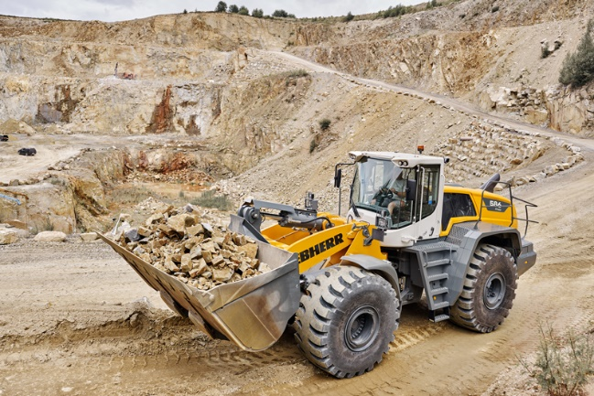

liebherr-wheel-loader-l586-xpower-quarry.jpg  
Liebherr will showcase its largest wheel loader, the L 586 XPower®, at steinexpo 2023 in daily live demonstrations.

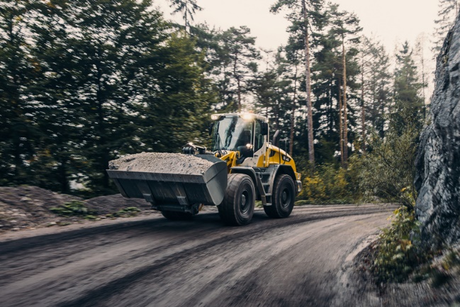

liebherr-mid-sized-wheel-loader-l546.jpg  
Liebherr has recently fundamentally revised its mid-sized wheel loaders and is presenting the L 546 model at steinexpo.

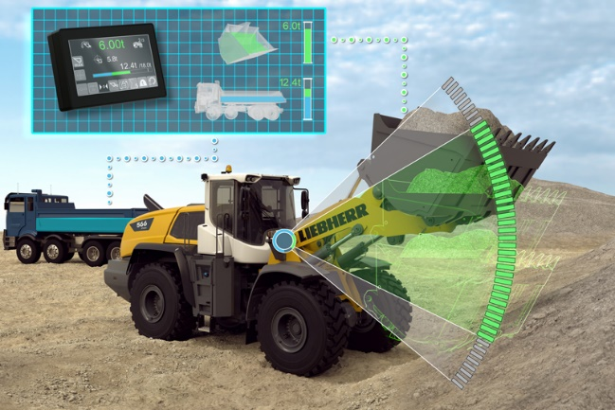

liebherr-weighing-system-for-wheel-loaders.jpg  
The weighing system for Liebherr wheel loaders is a checkweigher that operates automatically and provides the machine operator with valuable information about the loading process.

Contact

Martin Koller  
Marketing and Public Relations  
Phone: +43 50809 11475  
E-mail: [martin.koller.lbh@liebherr.com](mailto:martin.koller.lbh@liebherr.com)

Published by

Liebherr-Werk Bischofshofen GmbH  
Bischofshofen/Austria  
[www.liebherr.com](http://www.liebherr.com)