Press release

The new R 992 crawler excavator presented at steinexpo

⸺

**The R 972, R 978 SME, R 992 and R 998 SME crawler excavators, which replace the R 966, R 970 SME, R 976 and R 980 SME respectively, were exhibited for the first time at Bauma 2022 in Munich. The R 992 will have more specific visibility at steinexpo and will represent the entire range. Featuring numerous improvements, the new 70 to 100 tonne crawler excavators are distinguished by their improved performance data, level of operator comfort, new assistance functions and low fuel consumption.**

Colmar (France), 23 August 2023. The new model names for the 70 to 100 tonne Liebherr crawler excavators directly reflect the operating weight of these machines. To go with the change of name, there is an updated exterior design that emphasises the family relationship to the future generation 8. On stationary display at steinexpo, the R 992 includes specific improvements made to all of these new machines.

Less fuel, lower emissions

The R 992 has been developed with the aim of reducing total energy consumption, in particular through Liebherr’s new patented Power Efficiency (PE) – Engine Control system.  
  
This new “PE” function comes in addition to the machine’s existing modes (P+/P/E). This innovation reduces fuel consumption by 10 to 15% relative to previous models.

The Bucket Fill Assist system

The R 992 is equipped with the Bucket Fill Assist assistance option. With an anti-stalling mode to prevent the bucket from jamming when penetrating digging material, this option allows higher productivity and more comfort for the operator. There is also an automatic bucket-filling function providing an automated filling cycle for faster filling. This system enables a higher bucket filling level, faster cycles and better penetration into the digging material. In addition to reducing fuel consumption by 10 %, the Liebherr Bucket Fill Assist system also reduces vibrations to improve operator comfort. The resulting decreased wear on the bucket also helps to reduce operating costs.

****New operating modes for specific work requirements****

The R 992 is equipped with the Modetronic function, already tried and tested in generation 8 excavators. This development allows the operator to adapt a machine’s hydraulic performance to both the application and the operator’s own driving style. Modetronic applies to rotation and travel, as well as to boom, stick and bucket movements, thus always ensuring greater comfort and productivity.

The Modetronic function not only allows more dynamic machine behaviour when in "Dynamic" mode but also improves machine balance and stability in "Efficient" mode. "Custom" mode makes it possible to perform precision work more easily, and "Fine" mode allows machine movements to be specifically adjusted via the display to suit individual preferences.

****For even more ambitious projects: improved comfort and more power****

The R 992 includes developments in the cab area from generation 8 excavators. The main screen has been enlarged from seven to nine inches and new joysticks and foot pedals are included for more precise machine movements.

To ensure that all hydraulic crawler excavators meet customers' needs in the best possible way, each model includes improvements that combine innovation with enhanced machine performance. The continuous track guide is available as an option for all new excavator models in this range. These models also benefit from increased engine power. The R 998 SME, with an operating weight of more than 100 tonnes, features a new undercarriage with larger dimensions, in particular a 3,900 mm track and a 5,000 mm wheel base. With its improved stability, this model is ideally suited to mining and quarrying.

About Liebherr-France SAS

Liebherr-France SAS, based in Colmar, has been responsible for development and production of Liebherr Group earth-moving crawler excavators since 1961. The current range features about 30 crawler excavator models, from the R 914 Compact to the R 980 SME, which are designed for earth-moving and quarrying applications. The company also produces a host of special attachments for specific tasks such as demolition, material handling, and dredging or tunnelling applications, in addition to electric excavators. Crawler excavators with 14 to 100 tonne operating weights are supplied with Liebherr engines offering 90 to 420 kW power output. With more than 1200 employees, Liebherr-France SAS achieved sales of 534 million euros in 2022.

About the Liebherr Group

The Liebherr Group is a family-owned engineering company offering a very diverse range of products. The company is one of the biggest manufacturers of construction machinery in the world. It also supplies high-end products and services to cater to users’ needs in many other areas. Today the Group includes more than 140 companies on all continents. In 2022, it employed more than 50,000 people and posted total consolidated sales of more than 12.5 billion euros. Liebherr was founded in 1949 in Kirchdorf an der Iller, southern Germany. Since then, the mission of Liebherr’s employees has been to win over customers with outstanding solutions while contributing to technological progress.

Photos

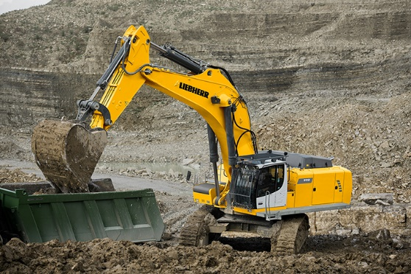

liebherr-r-992.jpg  
Offers more amenities and is more fuel efficient: Liebherr crawler R 992.

Contact

Alban Villaume  
Marketing Communication Manager  
Telephone: +33 3 89 21 36 09  
Email: [alban.villaume@liebherr.com](mailto:alban.villaume@liebherr.com)

Published by

Liebherr-France SAS  
Colmar, France  
www.liebherr.com