Press release

steinexpo 2023: Liebherr showcases pioneering solutions in the fields of digitalisation and service

⸺
Performance and maintenance data clearly presented in the MyLiebherr portal
MyAssistant for Earthmoving app provides relevant information for machine operators
Save money, resources and energy thanks to the Liebherr remanufacturing programme
Advancing digitalisation is allowing services and solutions to become even more customised, consistent and transparent. At steinexpo, Liebherr will present a wide range of digital solutions and services for its machines that make it possible to increase their efficiency, performance and reliability as well as safety and comfort.
Nieder-Ofleiden (Germany), 23 August 2023 – In future, workshop managers will benefit from clearly displayed performance and maintenance data for their machines in the MyLiebherr portal. This data will also be made available for downstream processes such as maintenance planning and spare parts ordering. At the show, Liebherr will also present numerous intelligent assistance systems and applications designed to help machine operators manage the increasingly complex requirements they now face. The MyAssistant for Earthmoving app, for example, provides machine operators with relevant information on the operation and maintenance of Liebherr machines.
As part of the Liebherr remanufacturing programme, used components from earthmoving and material handling machines are reconditioned into as-new parts. This not only reduces costs, but also saves valuable resources and energy, which can help to shrink the operator's carbon footprint. The remanufacturing programme is being continuously expanded and, alongside replacement components, also offers additional finishing stages such as general overhauls and the repair of old parts.

About the Liebherr Group

The Liebherr Group is a family-run technology company with a highly diversified product portfolio. The company is one of the largest construction equipment manufacturers in the world. It also provides high-quality and user-oriented products and services in a wide range of other areas. The Liebherr Group includes over 140 companies across all continents. In 2022, it employed more than 50,000 staff and achieved combined revenues of over 12.5 billion euros. Liebherr was founded in Kirchdorf an der Iller in Southern Germany in 1949. Since then, the employees have been pursuing the goal of achieving continuous technological innovation, and bringing industry-leading solutions to its customers.
Images
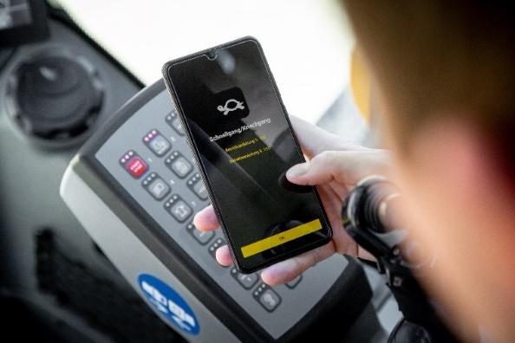
liebherr-myassistant-earthmoving-app.jpg
Presenting pioneering services and solutions: the MyAssistant for Earthmoving app digitally provides all relevant information on machine operation and maintenance for Liebherr earthmoving and material handling machines.

Contact
Nadine Willburger
Marketing
Phone: +49 7354 / 80 - 7332
Email: nadine.willburger@liebherr.com
Published by
Liebherr-Hydraulikbagger GmbH
Kirchdorf an der Iller / Germany
http://www.liebherr.com/

