Press release

Liebherr USA, Co., Celebrates the 10 Year Anniversary of Miami Branch

⸺

A decade of success, growth, and exceptional service.

Main hub for sales and service to Liebherr’s maritime cranes, tower cranes, as well as refrigerators and freezers for residential and commercial applications

Celebrating Liebherr’s continuous growth, diverse product portfolio, and commitment to the region.

Miami, FL, August 22, 2023 – Liebherr USA, Co. - The Liebherr Group, a family-run technology company with a highly diversified product portfolio and one of the largest construction equipment manufacturers in the world, proudly announces the 10-year anniversary of its Miami branch. This major milestone marks Liebherr’s successful dedication to the region and continuous growth around the globe.

Liebherr’s commitment to the United States market began in 1970 with the construction of two manufacturing facilities and its North American headquarters located in Newport News, Virginia. Over the years, the company successfully opened multiple sales and service corporate offices throughout the country, striving for continuous expansion and forming a robust network to serve customers nationwide.

"We are proud to celebrate the 10th anniversary of our Miami branch, representing our umbrella company and the diverse product units based in this location," said Dr. Tim Gerhardt, Managing Director of Liebherr USA, Co. "Our focus has been on delivering groundbreaking products, unmatched service, and industry-leading solutions for our customers. This achievement stands as a testament to the hard work and dedication of our Miami-based team over the past 10 years."

**Liebherr in Miami, Products and capabilities**

Liebherr has been serving the Miami region since the early 2000s. In 2013, the company made a multi-million-dollar investment building the Liebherr-Miami facility based in Hialeah Gardens.

Liebherr‘s 56,000 ft2 state-of-the-art Miami facility has flourished as the main hub for sales and service for the company’s maritime cranes and tower cranes product segments, as well as refrigerators and freezers for residential and commercial applications. This location has continually played a pivotal role in Liebherr’s growth strategy in the US and solidifies the company’s position as a prominent player in the industry.

Offerings for the maritime crane segment include port equipment with mobile harbor cranes, container cranes, fixed port solutions as well as offshore, ship, and floating cranes. This center not only offers diverse maritime products but serves as a worldwide training hub for maritime customers, operators, and service.

In addition to the maritime crane portfolio, Liebherr is one of the world’s largest suppliers of tower cranes. This Miami segment offers fast-erecting and top-slewing cranes, digital solutions and consulting services to provide smart data analysis and maximize efficiency for all our customers and their application needs.

Liebherr’s refrigeration and freezing segment offers customers with a full product line of high-end refrigeration solutions for residential use, and commercial refrigeration and freezing units to support major industries such as food service and health care. Customers, dealers, and partners can check out Liebherr’s luxury refrigerators and freezers in our on-site Miami showroom.

This facility also provides essential on-site customer support, advisory services, and fulfillment of spare parts as the location allows Liebherr to respond to customer inquiries quickly and accelerate the distribution of parts and services across the region.

The continued success of the company lies in the teamwork, dedication and enthusiasm of Liebherr's most valuable resource: approximately 51,000 employees worldwide. United by a passion for technology and determination, Liebherr employees have the opportunity to individually contribute through the work they do each day in the Americas and the globe.

**Connecting the Americas**

Situated in Miami, a city known for its vibrant international community, Liebherr has thrived in serving customers within this dynamic and diverse area. Through strategic partnerships, dedication to customer satisfaction, and training a highly skilled workforce, Liebherr’s Miami branch has built a solid foundation, contributing to the local economy and fostering growth within the region. The branch proximity to the Caribbean, the Gulf of Mexico and Central America, has provided unique opportunities to establish strong relationships and provide global innovations to customers throughout the Americas.

This facility is also ideally located near the port of Miami and the Miami International Airport. Utilizing this strategic location, Liebherr provides essential on-site customer support and advisory services to quickly fulfill customer inquiries and accelerate the distribution of parts and services across the region.

**About Liebherr USA, Co.**

[Liebherr USA, Co.](https://www.liebherr.com/en/usa/start/start-page.html) based in Newport News, VA provides sales and service on behalf of nine different Liebherr product segments: earthmoving, mining, mobile and crawler cranes, tower cranes, concrete technology, deep foundation machines, maritime cranes; components, and refrigeration and freezing.

About the Liebherr Group

The [Liebherr Group](https://www.liebherr.com/en/usa/about-liebherr/about-liebherr.html) is a family-run technology company with a highly diversified product portfolio. The company is one of the largest construction equipment manufacturers in the world. It also provides high-quality and user-oriented products and services in a wide range of other areas. The Liebherr Group includes over 140 companies across all continents. In 2022, it employed more than 50,000 staff and achieved combined revenues of over 12.5 billion euros. Liebherr was founded in Kirchdorf an der Iller in Southern Germany in 1949. Since then, the employees have been pursuing the goal of achieving continuous technological innovation and bringing industry-leading solutions to its customers.

**Images**

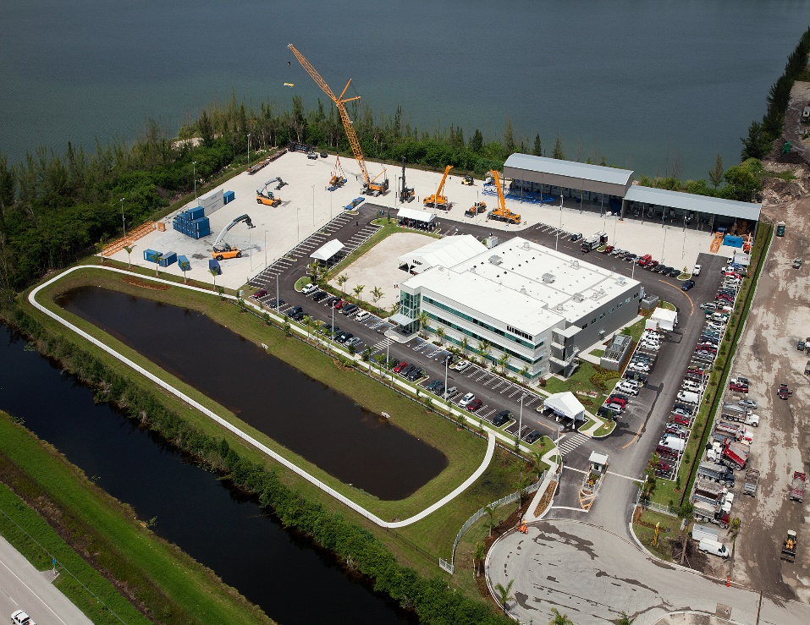

liebherr-Miami-Campus.jpg  
The Liebherr Miami location opened in 2013, and is now the central hub for maritime cranes, tower cranes as well as refrigeration and freezing.

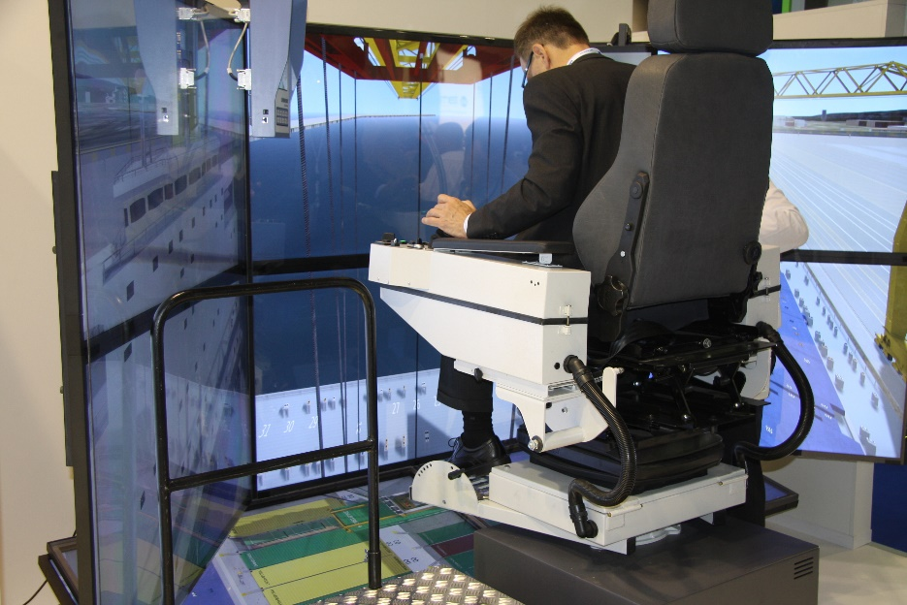

liebherr-Maritime-Simulators.jpg  
The Miami facility serves as a worldwide training hub for maritime cranes with on-site simulators and conceptual classroom training.

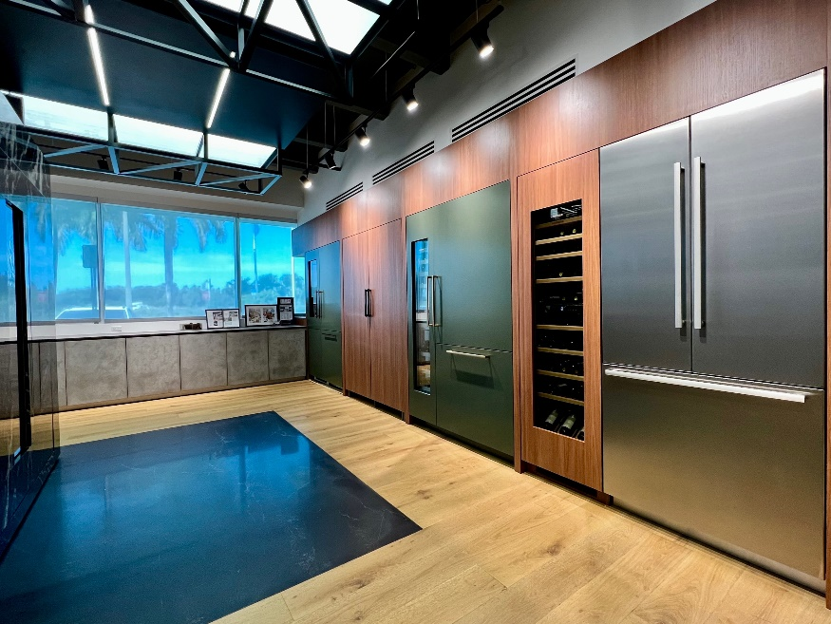

liebherr-Showroom.jpg  
The Liebherr Miami branch opened the very first North American refrigeration and freezing showroom in 2019.



liebherr-Tower-Crane-Project.jpg  
Liebherr is one of the largest suppliers of tower cranes in the world. A Liebherr tower crane dealer recently supplied multiple cranes to a Miami high rise site to dismantle equipment efficiently and safely.

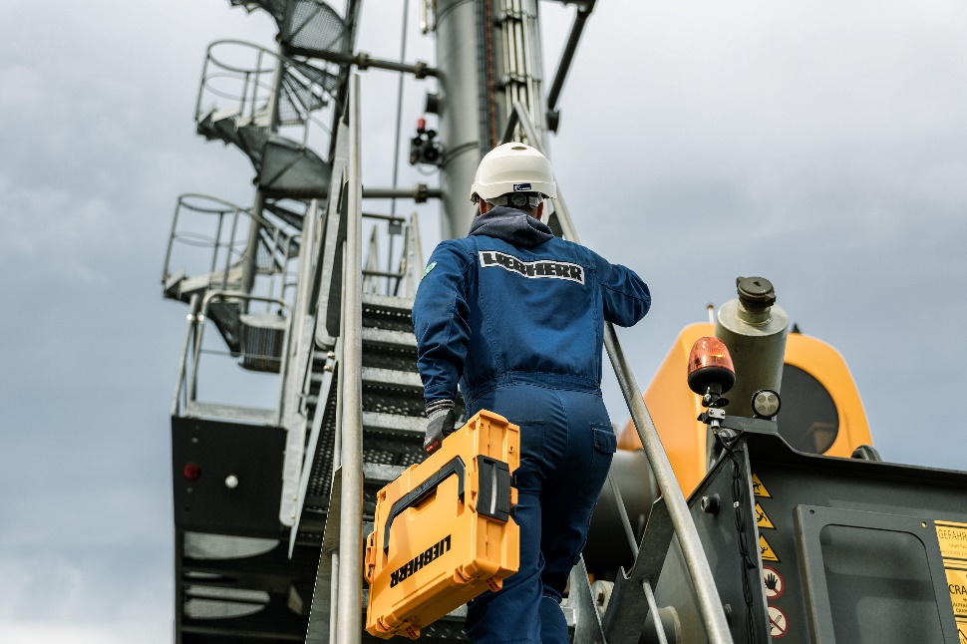

liebherr-Customer Service.jpg  
Liebherr provides essential on-site customer support and advisory services to quickly fulfill customer inquiries and accelerate the distribution of parts and services across the region.



liebherr-Miami-Key-Visual.jpg  
Liebherr celebrates the 10-year anniversary of the Miami Branch.

Contact

Ana Cabiedes Uranga  
Head of Marketing   
Liebherr USA, Co.  
Phone: +1 757 240 4250  
E-mail: ana.cabiedes@liebherr.com

Published by

Liebherr USA, Co.   
Newport News / USA  
www.liebherr.com