Press release

Liebherr at Pollutec 2023

⸺

The Liebherr Group is present at hall 3, aisle E, booth 108

The latest innovations in the handling range on the Liebherr stand

Innovations in alternative drive technologies and digitalisation

From october 10th to 13th, Liebherr will once again have a booth at the 2023 edition of the Pollutec trade fair in Lyon. At the entrance of hall 3, dedicated to recycling – material and material reuse, the Liebherr stand (Aisle E, No. 108) will unveil many new innovations and products from the earthmoving and handling sectors.

One of the innovations presented by Liebherr in hall 3, aisle E, stand 108 at the Pollutec show is the L 507 E battery-electric wheel loader. It is the first electrified wheel loader from the Liebherr Group. The wheel loader combines the proven advantages of a Liebherr stereo loader with a battery-electric drive system developed by Liebherr. The L 507 E delivers the same performance as a conventional wheel loader in the same class, with no local CO2 emissions. What's more, the new wheel loader's low noise emissions make it ideal for use in areas where low noise and exhaust levels are particularly important, such as city streets or inside a building.

New range of telescopic handlers with intelligent assistance systems and alternative drive systems

At Pollutec 2023, Liebherr is set to exhibit the T 55-7s telescopic handler for recycling applications and industrial materials handling. Apart from its continuously variable hydrostatic drive and the high-performance hydraulics, Liebherr telescopic handlers stand for high productivity and reliability with intelligent assistance systems such as EcoMotion, MultiMotion and Load Moment Plus. Advanced safety features like intervening overload warning device and Auto Hill Assist support demanding tasks.

The total of three telescopic handlers for industrial applications are powered by a powerful diesel engine (T 46-7s 105kW/136bhp, T 55-7s 115kW/156bhp, T 60-9s 115kW/156bhp). Exhaust gases are retreated through a combination of diesel oxidisation catalyst (DOC) and selective catalytic reduction (SCR). Liebherr telescopic handlers can be operated using HVO (Hydrotreated Vegetable Oil) or biofuel, enabling the utilization of a renewable fuel source while maintaining both performance and efficiency.

The LH 26 M Industry E handling machine offers greater flexibility

This year, Liebherr will also present the cable-connected Liebherr electric material handler LH 26 M Industry E. For temporary, mains-independent operation, the machine can be optionally equipped with a battery-powered Mobility Kit. The new Liebherr electric material handling machine is ideal for use in the recycling industry.

The configuration for the exhibition at pollutec also includes a straight 6.60 m-long boom and a 4.50 m-long stick with tilt kinematics. The equipment also includes the Liebherr SG 25 sorting grapple with a capacity of 0.75 m³ and 1,000 mm wide, perforated tongs. This machine also includes a hydraulic, infinitely height-adjustable cab. The cable routing is provided via a cable winding system, which allows the machine to be moved safely within a working radius of 40 metres, or more on request.

About Liebherr-France SAS

Liebherr-France SAS, based in Colmar, has been responsible for development and production of Liebherr Group earth-moving crawler excavators since 1961. The current range features about 30 crawler excavator models, from the R 914 Compact to the R 980 SME, which are designed for earth-moving and quarrying applications. The company also produces a host of special attachments for specific tasks such as demolition, material handling, and dredging or tunnelling applications, in addition to electric excavators. Crawler excavators with 14 to 100 tonne operating weights are supplied with Liebherr engines offering 90 to 420 kW power output. With more than 1200 employees, Liebherr-France SAS achieved sales of 534 million euros in 2022.

About the Liebherr Group

The Liebherr Group is a family-run technology company with a highly diversified product portfolio. The company is one of the largest construction equipment manufacturers in the world. It also provides high-quality and user-oriented products and services in a wide range of other areas. The Liebherr Group includes over 140 companies across all continents. In 2022, it employed more than 50,000 staff and achieved combined revenues of over 12.5 billion euros. Liebherr was founded in Kirchdorf an der Iller in Southern Germany in 1949. Since then, the employees have been pursuing the goal of achieving continuous technological innovation and bringing industry-leading solutions to its customers.

Images

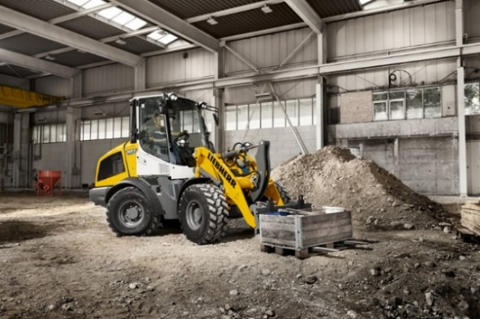

liebherr-l507e-indoor-application.jpg  
No CO2 emissions on site: the Liebherr L 507 E is also suitable for use in hangars.

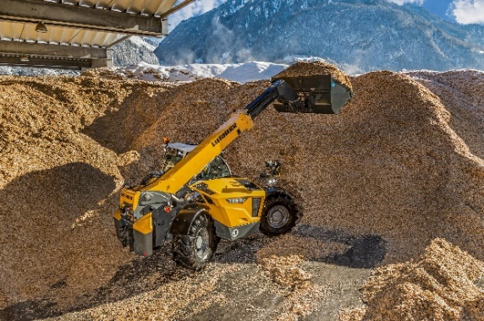

liebherr-T 55-7s-telescopic-handler.jpg  
Liebherr telescopic handler T 55-7s in recycling application.

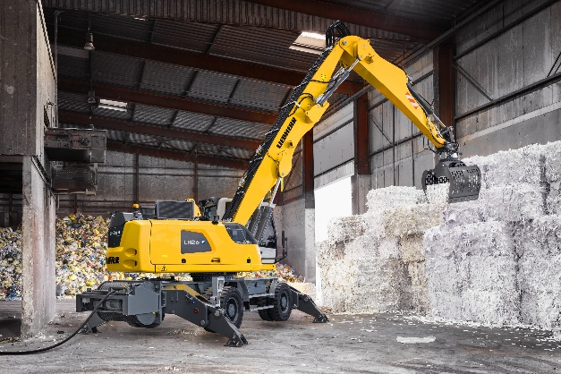

liebherr-lh-26-m-industry-e.jpg  
No CO2 emissions: the Liebherr LH 26 M Industry E is perfect for use in confined spaces.

Contact

Alban Villaume  
Marketing Communication Manager  
Telephone: +33 3 89 21 36 09  
Email: alban.villaume@liebherr.com

Published by

Liebherr-France SAS  
Colmar, France  
www.liebherr.com