Press release

Liebherr R 930 Tunnel crawler excavator launched on the world market

⸺

The R 930 Tunnel: an excavator specially designed for underground construction sites

Versatility and flexibility for the challenges of tunnelling and underground quarrying

The R 930 Tunnel’s operator's cab emphasises safety and comfort

The Liebherr tunnel excavator range expands with the new R 930 Tunnel crawler excavator, now launched on the world market. Developed at Liebherr-France SAS in Colmar (France), the R 930 Tunnel replaces the R 924 Compact Tunnel and allows high-level performance in all types of underground applications.

The R 930 Tunnel has been designed to meet as fully as possible the demands of underground construction sites, which often present tight spaces with difficult access. The R 930 Tunnel’s attachment, available in two lengths, features a bearing that can swivel to 2 x 45° angles, allowing the excavation profile to be followed. The machine’s short slewing radius and powerful, protected LED headlights considerably reduce the risks of collision with construction site personnel and walls. In addition, the cylinders and hoses are specially positioned for maximum protection from potential impacts, thus limiting damage to them. The R 930 Tunnel has steel bodywork, making it a very robust machine, ideal for underground applications. The new R 930 Tunnel crawler excavator can be equipped with the Liebherr quick coupling system, which allows tools to be changed easily and quickly.

**Versatility and flexibility on underground construction sites**

A Liebherr two- or three-tooth ripper bucket ensures high productivity on underground construction sites. The R 930 Tunnel can also be equipped with a cutter or hammer to cover a broad area of applications. The R 930 Tunnel’s grading blade allows the creation of a flat ground surface and stabilises the machine on uneven ground. It also protects the undercarriage and crawler drives against impacts from rubble.

**Comfortable, fully protected operator's cab**

The whole ROPS-, FOPS- and FGPS-certified operator's cab, along with its rear and side monitoring cameras, ensures maximum construction site safety. It also has protection for its electronic components. Comfortable and ergonomic, the R 930 Tunnel’s operator's cab is perfectly equipped to withstand dusty environments on underground sites. It comes with an easy-to-clean imitation leather operator's seat with headrest.

About Liebherr-France SAS

Liebherr-France SAS, based in Colmar, has been responsible for development and production of Liebherr Group crawler excavators since 1961. Its current product range includes around 30 crawler excavator models, from the R 914 Compact to the R 998 SME, designed for earthmoving and stone quarrying. The product range also includes a whole series of special working attachments designed for specific tasks such as demolition works, materials transport and maritime or tunnel applications, as well as large-capacity electric excavators. With their operating weight of 14 to 100 tonnes, the crawler excavators are equipped with Liebherr engines with power ratings from 90 to 420 kW. Liebherr-France SAS employs over 1,260 staff and generates annual sales of 692 million euros.

About the Liebherr Group

The Liebherr Group is a family-owned engineering company offering a highly diverse range of products. The company is among the biggest manufacturers of construction machines in the world. But it also offers high-quality, value-focused products and services in many other areas. Today, the group includes more than 140 companies on all continents. In 2022, it employed more than 50,000 people and achieved total consolidated sales of more than 12.59 billion euros. Liebherr was founded in 1949 in Kirchdorf an der Iller, southern Germany. Since then, Liebherr’s employees have pursued the goal of satisfying customers with outstanding solutions while contributing to technological progress.

Photos

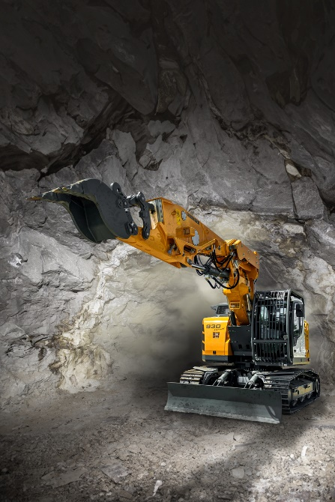

R 930Tunnel-1.jpg  
The swivel bearing on the R 930 Tunnel attachment allows the excavation profile to be followed.

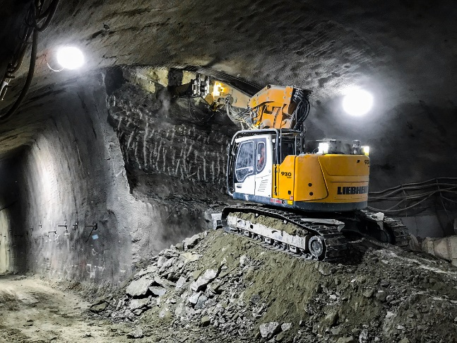

R930Tunnel-2.jpg  
The R 930 Tunnel performs in all types of underground applications.

Contact

Alban Villaumé  
Marketing and Communication  
Telephone: +33 3 89 21 36 09  
Email: alban.villaume@liebherr.com

Published by

Liebherr-France SAS  
Colmar, France  
[www.liebherr.com](http://www.liebherr.com)