Press release

Sales launch for Liebherr’s L 507 E battery-electric wheel loader

⸺

Battery-electric drive: No CO2 emissions onsite and only low noise emissions

Performance that matches a conventional Liebherr wheel loader of the same size class

The L 507 E features stereo steering and other tried-and-tested advantages of a Liebherr Stereoloader

The L 507 E battery-electric wheel loader has been available from Liebherr sales partners in several European countries since Octobre 2023. The model is the first electric wheel loader in the group. It combines the demonstrable advantages of a Liebherr Stereoloader with a battery-electric drive design developed by Liebherr.

Bischofshofen (Austria) – The performance of the L 507 E is equal to that of a conventionally powered Liebherr wheel loader in the same size class, but it emits no CO2 onsite. In addition, noise emissions are kept to a minimum, which makes the new wheel loader particularly suitable for any application where you have to consider noise or exhaust fumes, such as in inner-city areas or in halls. Liebherr relies on a high-voltage battery system – specially developed for L 507 E wheel loader applications – which ensures powerful performance and efficient charging.

Depending on the respective operating conditions, the L 507 E offers a running time of up to eight hours. Liebherr’s modular battery design also makes it possible to install a second lithium-ion battery ex works at the customer’s request, which further increases the running time. Depending on the on-board charging technology and power rating, the battery can be fully charged in about one and a half to three hours.

New drive, renowned steering system: L 507 E battery-electric Stereoloader

With the 507 E, the battery-electric drive means that full power is available at all times. The operator thus benefits from dynamic working movements and responsive handling. As standard, the wheel loader has a final speed of 20 km/h. However, the L 507 E is also optionally available as a “Speeder” and in this version reaches a speed of up to 30 km/h, which makes it easier to move the wheel loader, from one job site to another. To increase efficiency, the energy generated downhill and during braking is fed back into the battery through recuperation.

The L 507 E is based on the conventional Liebherr L 507 Stereo wheel loader. This means that the new battery-electric wheel loader also features stereo steering. This combination of articulated steering and steered rear axle combines the advantages of conventional articulated steering with those of all-wheel steering. This results in a minimal turning circle and a reduced articulation angle of 30 degrees, which increases the stability of the wheel loader. Liebherr has also installed its reputable articulated pendulum joint in the L 507 E, which compensates for uneven ground and ensures that the wheel loader has excellent stability.

L 507 E with proven technology in the lift arms and operator’s cab

Liebherr’s new battery-powered wheel loader uses the same lift arms of the conventionally powered L 507 Stereo. They showcase powerful z-bar kinematics, which also work safely in fork operation without manual readjustment. Here, the new electro-hydraulic pilot control of the L 507 E ensures highly responsive and precise movements on the lift arms. The fully automatic LIKUFIX quick-coupler system is also available. This allows the operator to change between mechanical and hydraulic attachment tools from the cab within seconds at the touch of a button.

The extensive use of glass in the operator’s cab means that the operator has excellent visibility and the cab is also extremely ergonomic and comfortable. Various setting options as well as operation-relevant data, for example the charge status of the battery, can be found on the height-adjustable display with a touch function. In addition, the operator has the option of adjusting the steering wheel and seat individually as desired. The L 507 E can be used intuitively and hardly differs from a conventional wheel loader. Therefore, even less experienced operators can work safely and efficiently with Liebherr’s battery-electric wheel loader.

About Liebherr-Werk Bischofshofen GmbH

Liebherr-Werk Bischofshofen GmbH develops, produces and sells wheel loaders from the Liebherr Group. The plant in Salzburger Land (Austria) has grown steadily over the decades thanks to sustainable innovations, creative solutions and high quality standards. The wheel loader range is constantly being expanded and includes models in different product groups: Compact loaders, Stereoloaders, and mid-sized and large wheel loaders with impressive, innovative drive designs.

About the Liebherr Group

The Liebherr Group is a family-run technology company with a highly diversified product portfolio. The company is one of the largest construction equipment manufacturers in the world. It also provides high-quality and user-oriented products and services in a wide range of other areas. The Liebherr Group includes over 140 companies across all continents. In 2022, it employed more than 50,000 staff and achieved combined revenues of over 12.5 billion euros. Liebherr was founded in Kirchdorf an der Iller in Southern Germany in 1949. Since then, the employees have been pursuing the goal of achieving continuous technological innovation, and bringing industry-leading solutions to its customers.

Images

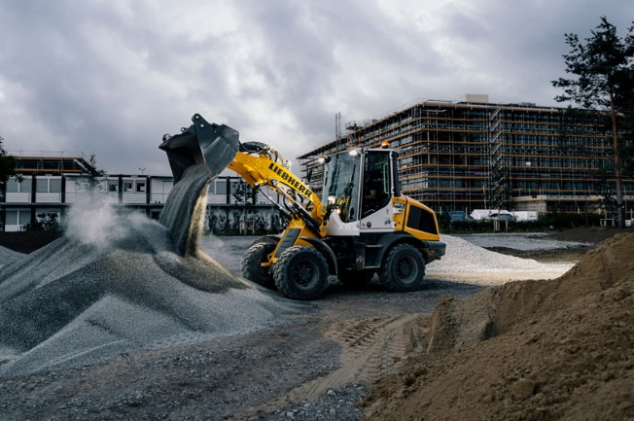

liebherr-l507e-battery-electric-wheel-loader.jpg  
Operators benefit from the low noise emissions of the L 507 E in noise-sensitive environments.

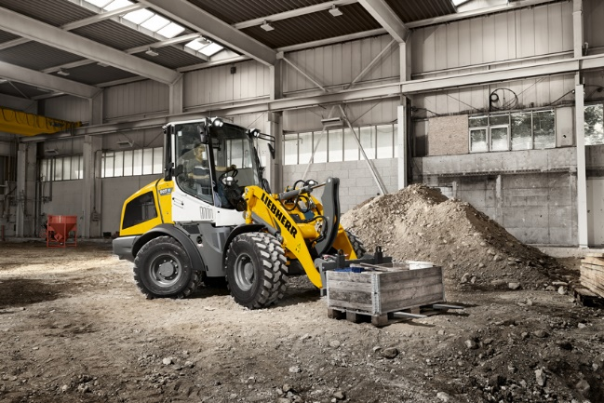

liebherr-l507e-indoor-application.jpg  
No CO2 emissions onsite: The L 507 E from Liebherr is also suitable for indoor applications.

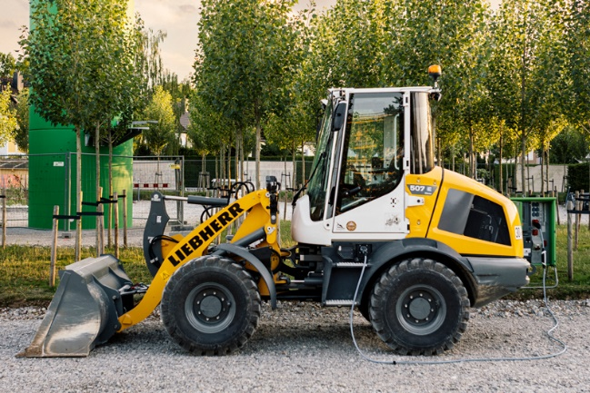

liebherr-l507e-charging.jpg   
L 507 E: Efficient charging thanks to high-voltage battery system.

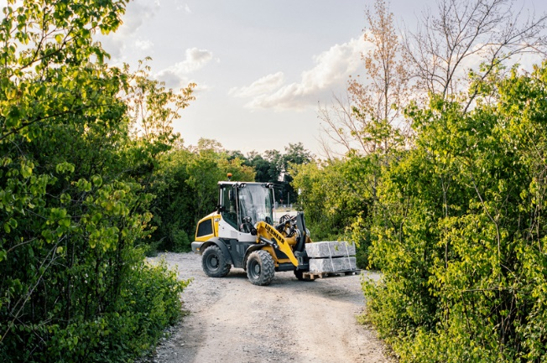

liebherr-l507e-landscaping.jpg  
The L 507 E battery-electric wheel loader from Liebherr has excellent performance capabilities.

Contact

Martin Koller  
Marketing and Public Relations  
Phone: +43 50809 11475  
E-mail: [martin.koller.lbh@liebherr.com](mailto:martin.koller.lbh@liebherr.com)

Published by

Liebherr-Werk Bischofshofen GmbH  
Bischofshofen/Austria  
[www.liebherr.com](http://www.liebherr.com)