Press release

At Ecomondo 2023: Liebherr electric material handling machine LH 26 M Industry E with Mobility Kit

⸺
At Ecomondo 2023, Liebherr will present the cable-connected Liebherr electric material handler LH 26 M Industry E. For temporary, mains-independent operation, the machine can be optionally equipped with a battery-powered Mobility Kit. The Liebherr electric material handling machine is ideal for use in the recycling industry.
Rimini (Italy), 07 November 2023 –The set-up for the trade fair exhibit includes a straight 6.60 m-long boom and a 4.50 m-long stick with tilt kinematics. The equipment also includes the Liebherr SG 25 sorting grapple with a capacity of 0.75 m³ and 1,000 mm wide, perforated tongs. The demonstration machine comes equipped with a hydraulic, infinitely height-adjustable cab. The cable routing is provided via a cable winding system, which allows the machine to be moved safely within a working radius of 40 metres, or more on request.
Liebherr's electric handling machine for efficient recycling operations
The Liebherr LH 26 M Industry E handling machine is ideal for use in the recycling sector. Example applications include handling, unloading and sorting waste paper, waste wood and waste materials. Liebherr even offers an innovative recycling package that ensures high machine availability. The included reversible fan increases productive working time by allowing the cooler and protective guard to be blown clear by reversing the fan's direction of rotation. The separate position of the A/C condenser maximises airflow in the cooler and fan unit, ensuring high reliability even under extreme dust loads.
Proven technology combined with a mature electric drive concept
The handling machine combines time-tested technology with a mature electric drive concept – low maintenance, low noise and unaffected by statutory emissions standards. The heart of the machine is the 90 kW electric motor, which enables powerful, dynamic working movements with low maintenance costs and low noise emissions. Furthermore, the drive concept includes an additional electric motor for auxiliary consumers, which ensures deliberate energy distribution as well as maximum energy efficiency.
The advanced frequency converter technology allows the motor speed to be individually adapted to the machine's respective use cases. In addition to simple adaptation to all common power supply networks worldwide, the frequency converter is also characterised by a considerable reduction in operating costs. This is due to the avoidance of inrush current peaks thanks to the soft start-up and the associated protection of the hydraulic drive components.
Temporary, mains-independent operation thanks to Mobility Kit
For temporary, mains-independent operation, the material handling machine is equipped with a battery-powered Mobility Kit. This is mounted on the machine's uppercarriage for optimum accessibility and supplies the machine with electrical energy when it is disconnected from the mains. The Mobility Kit enables mains-independent, emission-free movements for up to 30 minutes. Instead of moving the machine, the energy can also be used for short periods of work at a reduced speed.
About the Liebherr Group
The Liebherr Group is a family-run technology company with a highly diversified product portfolio. The company is one of the largest construction equipment manufacturers in the world. It also provides high-quality and user-oriented products and services in a wide range of other areas. The Liebherr Group includes over 140 companies across all continents. In 2022, it employed more than 50,000 staff and achieved combined revenues of over 12.5 billion euros. Liebherr was founded in Kirchdorf an der Iller in Southern Germany in 1949. Since then, the employees have been pursuing the goal of achieving continuous technological innovation, and bringing industry-leading solutions to its customers.

Images
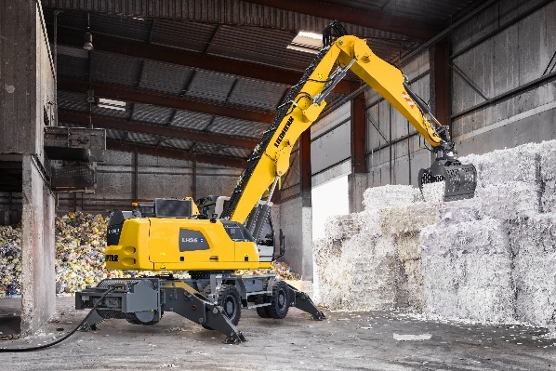
liebherr-lh-26-m-industry-e-1.jpg
Ideal for use in recycling facilities: Liebherr will present the cable-connected Liebherr LH 26 M Industry E electric material handler at Ecomondo 2023.
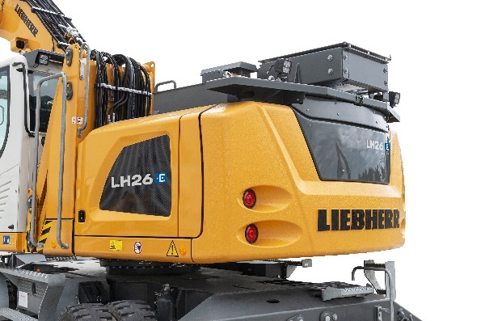
liebherr-lh-26-m-industry-e-2.jpg
For temporary, mains-independent operation, the machine can be equipped with an optionally available battery-powered Mobility Kit.
Contact
Marc Wiedenmann
Marketing
Phone: +49 7354 / 80 - 8494
E-mail: marc.wiedenmann@liebherr.com
Published by
Liebherr-Hydraulikbagger GmbH
Kirchdorf an der Iller / Germany
www.liebherr.com

