Press release

Liebherr at Ecomondo 2023: HVO Drive & Smart Assistance Systems

⸺

Telfs, Austria, 7 November 2023 - Against the backdrop of increasing demand for efficient and sustainable solutions, the continuing commitment of Liebherr in this area comes into the spotlight at Ecomondo with the presentation of an update to its Telescopic Handlers, based on the T 60-9s. Ecomondo is a renowned platform for the latest develop-ments in the circular economy and environmental solutions, providing an ideal stage to raise the curtain on the newest Liebherr advances in technology. The versatility and advanced drive of the T 60-9s are impressive. But beyond this, it also makes a significant contribution to the environment through the use of HVO (hydrogenated vegetable oil).

Alternative fuel HVO

We live in an age of ecological challenges, where solutions that can be implemented quickly are crucial. This is where HVO plays a pivotal role, as a fuel that is both sustainable and immediately available. HVO is an alternative fuel that allows ICEs to be operated in a virtually climate-neutral manner.

Using HVO as a substitute for fossil diesel fuel results in a dramatic overall reduction in emissions of greenhouse gases and air pollutants. Liebherr Telescopic Handlers can be operated with HVO without modifying or retrofitting engine components. Full advantage can be taken of this climate and environmentally friendly fuel without com-promising one bit on performance and efficiency. While taking a big step in reducing the environmental footprint, you still enjoy all the benefits of maximum lifting power, precise control and smooth operation.

Presenting the latest Assistance Systems

The new EVO level is here and ready to go, as Liebherr delivers even greater capabilities with your Telescopic Handler. In the limelight are the new assistance functions: EcoMotion and MultiMotion, which boost efficiency.

The EcoMotion assistance function enables load-free lowering of the telescopic boom without having to increase diesel engine speed. This function also, simultaneously, increases comfort and enables more efficient operating movements, as the telescopic boom can be lowered more quickly and evenly. The result: Reduced fuel consump-tion and less wear.

The MultiMotion function is a new feature common to three Telescopic Handlers, T 46-7s, T 55-7s and T 60-9s. Without the need for manual readjustment or intervention, the telescopic arm is retracted fully automatically and in proportion to the operating movement, during lowering. And at the same time, you can still retain direct load-independent control of all functions with the multifunction joystick. This also brings the further advantage of increased reliability, as hydraulic overloads are automatically avoided when lowering the load. MultiMotion saves you time and minimises the risk of damage to the machine or attachment.

The Liebherr Telescopic Handler is therefore stepping out to demonstrate further significant advances in operat-ing functionality and improved efficiency, making it a star choice for both dedicated Liebherr fans and operators seeking a productive and sustainable machine.

About the Liebherr Group

The Liebherr Group is a family-run technology company with a highly diversified product portfolio. The company is one of the largest construction equipment manufacturers in the world. It also provides high-quality and user-oriented products and services in a wide range of other areas. The Liebherr Group includes over 140 companies across all continents. In 2022, it employed more than 50,000 staff and achieved combined revenues of over 12.5 billion euros. Liebherr was founded in Kirchdorf an der Iller in Southern Germany in 1949. Since then, the employees have been pursuing the goal of achieving continuous technological innovation, and bringing industry-leading solutions to its customers.

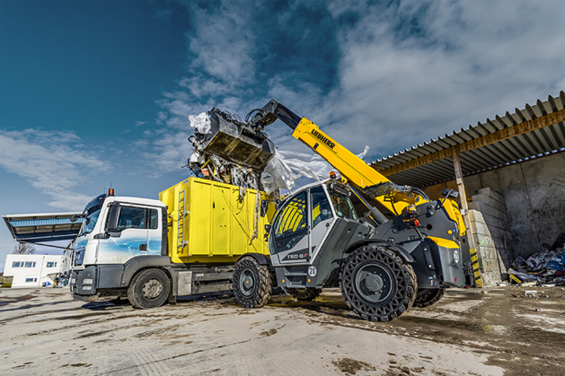Image

T 60-9s.jpg  
The T 60-9s for Waste Management

Contact

Mag. Lisa Kahlig  
Marketing Manager PR & Press  
Liebherr-Werk Telfs GmbH  
Lisa.kahlig@liebherr.com

Published by

Liebherr- Werk Telfs GmbH  
Telfs / Österreich  
[www.liebherr.com](http://www.liebherr.com)