Press release

Raising standards through operator certification

⸺

Liebherr hosted the National Commission for the Certification of Crane Operators (CCO) at the Newport News, VA facilities.

CCO task force members received training using Liebherr’s 38Z4 XXT truck mounted concrete pump to develop certification exams based on the equipment.

Liebherr is raising the bar for workforce standards by assisting the CCO in developing new certification criteria.

Newport News, VA (USA), Liebherr USA, Co. Concrete Technology, November 10, 2023 – Liebherr USA, Co., The concrete technology team recently hosted the National Commission for the Certification of Crane Operators (CCO), a non-profit issuing accredited certification for those in and around load handling equipment nationwide, to finalize the practical assessment for their new concrete pump certification program.

For four days, Liebherr provided hands-on demonstration to CCO task force members using their state-of-the-art 38Z4 XXT pump truck at their Newport News, VA location. The attendees tested Liebherr's latest safety features including the state-of-the-art XXT outrigger system and the recently launched XXA stability assistance system as they finalized the practical assessment procedures for the new concrete pump operator certification program.

Clint Nichols, National Business Manager of Concrete Technology at Liebherr explained, "Hosting the CCO allows industry experts to gain experience with our innovative equipment and demonstrates Liebherr's dedication to pump safety and training."

Liebherr, a technology leading manufacturer of concrete boom pumps, is playing a proactive role in improving safety and qualifications in the concrete pumping industry.

Supporting safety standards

Liebherr has been an avid supporter of CCO's operator certification programs, not only with the concrete pumps but also with the well-known comprehensive crane’s product line, which rigorously assesses skills and knowledge to reduce accidents. CCO's concrete pump certification is set to become the industry standard upon the finalization and launch of the practical exam.

By actively assisting CCO with hosting events and providing resources, Liebherr is helping raise the bar for workforce qualifications. As the concrete pumping industry adopts more stringent certification standards, Liebherr aims to remain at the forefront in developing the safest, most advanced concrete pumps and ensuring operators have the proper training to leverage these technologies.

According to Nichols, "Our goal is to continuously innovate while working hand-in-hand with organizations like CCO to implement robust programs that create better and safer outcomes for the industry." Liebherr's leadership and contributions will be vital in this effort.

**Assistance systems for improved handling**

The 38 XXT truck mounted concrete pump used for this training contains a 4-part Z-fold distribution boom that is easy to maneuver through the site and state-of-the-art technology to support the boom and assist the operator throughout the job such as our XXT outriggers, XXA3 stability assistance system, and Powerbloc drive unit.

The XXT outriggers built into this machine allow operators to move each outrigger individually, accommodating for narrow jobsites with our narrow support options. This technology also allows the boom to be extended over the cab, significantly adding to your working area.

With the XXA stability assistance system, operators can create partial support areas and electronically monitor them throughout operation. Because of this innovative stability system this machine becomes available for use in even more applications that require additional support options.

Additionally, the Powerbloc drive unit contained within this machine is designed to be a single unit, no longer requiring a separate control block. Designed as the first real drive unit for concrete pumps, it fully integrates all piping, sensor, and valve technology into the unit. Built with less hoses for a longer service life and operator-friendly central service and emergency control, this drive unit takes the pumping process to another level.

**About Liebherr USA, Co.**

[Liebherr USA, Co.](https://www.liebherr.com/en/usa/start/start-page.html) based in Newport News, VA provides sales and service on behalf of nine different Liebherr product segments: earthmoving, mining, mobile and crawler cranes, tower cranes, concrete technology, deep foundation machines, maritime cranes; components, and refrigeration and freezing.

About the Liebherr Group

The [Liebherr Group](https://www.liebherr.com/en/usa/about-liebherr/about-liebherr.html) is a family-run technology company with a highly diversified product portfolio. The company is one of the largest construction equipment manufacturers in the world. It also provides high-quality and user-oriented products and services in a wide range of other areas. The Liebherr Group includes over 140 companies across all continents. In 2022, it employed more than 50,000 staff and achieved combined revenues of over 12.5 billion euros. Liebherr was founded in Kirchdorf an der Iller in Southern Germany in 1949. Since then, the employees have been pursuing the goal of achieving continuous technological innovation and bringing industry-leading solutions to its customers.

Images

liebherr-38XXT-CCO-training.jpg  
Sales Manager Clint Nichols demonstrates the maneuverability of the boom on the 38Z4 XXT truck mounted concrete pump.

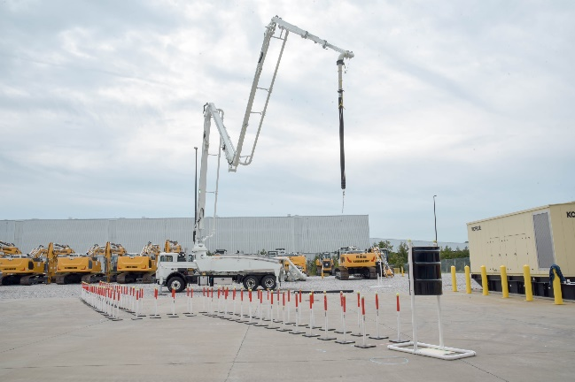

liebherr-CCO-training.jpg  
CCO task force members received training using Liebherr’s 38Z4 XXT truck mounted concrete pump to develop certification exams based on the equipment.

Contact

Ana Cabiedes Uranga  
Head of Marketing   
Liebherr USA, Co. Phone: +1 757 240 4250  
E-mail: ana.cabiedes@liebherr.com

Published by

Liebherr USA, Co.   
Newport News / USA  
www.liebherr.com