Press release

150-tonne lifting capacity: Liebherr expands its telescopic crawler crane line-up with the LTR 1150

⸺

In terms of load capacity, the LTR 1150 is midway between the LTR 1100 and the LTR 1220

Highly economical transport options

The first telescopic crawler crane with VarioBase®

**Liebherr has expanded its range of telescopic crawler cranes with a new 150-tonne machine. The LTR 1150 is positioned exactly between the LTR 1100 and the LTR 1220. Although the new crane offers around 50 per cent more lifting capacity than the LTR 1100, it can be transported just as easily and economically as its 100-tonne sibling – complete with crawler carriers at a total weight of 60 tonnes and a transport width of 3.5 metres, or optionally without crawler carriers at a total weight of just 38 tonnes and a width of only 3.0 metres. The LTR 1150 is the first telescopic crawler crane to be equipped with the Liebherr VarioBase®, which enables the crane control to determine the optimum load capacity depending on the track width and angle of rotation.**

Ehingen (Donau) (Germany), 10 November 2023 – With the launch of the LTR 1150, Liebherr is responding to the requirements of crane operators faced with lifting jobs that are beyond the LTR 1100, but for which the LTR 1220 is overkill. In terms of lifting capacity, the new 150-tonne crane falls exactly between these two models.

**"Compact and strong, transport in one"**

The real highlight of the new LTR 1150 is its economical transport concept: no other telescopic crawler crane on the market in this load class can be transported on low-loaders complete with crawler carriers with a width of just 3.5 metres. The LTR 1150 not only makes this possible but also has a total weight of just 60 tonnes. For this reason, Liebherr has coined the slogan "Compact and strong, transport in one" for the new crane.

Optionally, the new telescopic crawler crane can be transported with a width of 3.0 metres – the crawler carriers are removed to allow this, which reduces the crane's transport weight to only 38 tonnes. This variant requires a jack-up erection support consisting of four swivelling cylinders, which support the crane on the ground while the tracks are removed and the low-loader positions itself under the crane. This principle has proven its worth with the 100-tonne LTR 1100. New: on the LTR 1150, an automatic support system assists the operator. This was developed to allows faster and easier (dis)assembly of the crawler carriers.

The two crawler carriers, each weighing 11 tonnes, can be transported together on a standard semi-trailer with an economical width of 2.55 metres. The integrated access steps are folded in during transport.

In terms of ballast distribution, a strong emphasis was also placed on ensuring economical transport worldwide. With only four lifts, the entire counterweight can be ballasted on the crane: two lifts for the two 11-tonne central ballasts and two for the maximum slewing platform ballast of 41 tonnes. As with the Liebherr LTM cranes, this is attached to the slewing platform using a hydraulic ballasting device. Liebherr-AutoBallast supports the crane driver during this process. The support for the slewing platform ballast is integrated in the central ballast.

**A first for telescopic crawler cranes: VarioBase®**

The VarioBase® variable supporting base not only provides greater safety for telescopic mobile cranes, but also allows significantly higher load capacities, especially for lifts directly over the supports. The LTR 1150 is the first telescopic crawler crane to be equipped with this system, which determines the optimum load capacity in real time depending on the fixed track width and the variable rotation angle. The greatest advantages in terms of load capacity are achieved when performing lifts over the corners of the tracks, especially with reduced track widths. The maximum track width of 5.8 metres, a reduced width of 5.0 metres and a narrow 3.5-metre track width are available.

As with the other Liebherr LTR cranes, the LTR 1150 is also equipped with load charts for slopes up to a maximum of 4° – in gradations of 0.3°, 0.7°, 1.5°, 2.5° and 4°. For the first time for its telescopic crawler cranes, Liebherr has also calculated "WindSpeed Load Charts" for the new LTR 1150, which make it possible to work safely and flexibly even at higher permissible wind speeds of up to 15.6 m/s – even with the full load capacity in many boom positions.

**Ideal crane for wind farms and the construction industry**

Thanks to its high performance and excellent pick & carry characteristics, the new LTR 1150 is ideal for auxiliary tasks in the assembly of wind turbines. It is capable of assembling crawler cranes up to the 1,000-tonne class and can move components weighing over 60 tonnes. Wind turbine components such as nacelles and hubs are in a similar weight range. As well as unloading these parts from the transport vehicles, the LTR 1150 can also drive them around the construction site without any load restrictions.

This unique feature of telescopic crawlers in the telescopic crane sector also makes them extremely appealing on construction sites where many lifts need to be carried out in different places, for example in the construction of industrial buildings. With the short, powerful erection jib and the additional hoist gear, the LTR 1150 can move loads of up to 34.6 tonnes into the desired position. The range of working equipment for the 52-metre telescopic boom also includes a hydraulically adjustable double folding jib and telescopic boom extensions that allow hoisting heights of up to 83 metres to be achieved.

**About Liebherr-Werk Ehingen GmbH**

Liebherr-Werk Ehingen GmbH is a leading manufacturer of mobile and crawler cranes. Its range of mobile cranes extends from 2-axle 35 tonne cranes to heavy duty cranes with a lifting capacity of 1200 tonnes and a 9-axle chassis. Its lattice boom cranes on mobile or crawler travel gear deliver lifting capacities of up to 3000 tonnes. With universal boom systems and extensive additional equipment, they can be seen in action on construction sites throughout the world. The Ehingen site has a workforce of 4,300. An extensive, global service network guarantees the high availability of Liebherr mobile and crawler cranes. In 2022, the Liebherr plant in Ehingen recorded a turnover of 2.37 billion euros.

**About the Liebherr Group**

The Liebherr Group is a family-run technology company with a highly diversified product portfolio. The company is one of the largest construction equipment manufacturers in the world. It also provides high-quality and user-oriented products and services in a wide range of other areas. The Liebherr Group includes over 140 companies across all continents. In 2022, it employed more than 50,000 staff and achieved combined revenues of over 12.5 billion euros. Liebherr was founded in Kirchdorf an der Iller in Southern Germany in 1949. Since then, the employees have been pursuing the goal of achieving continuous technological innovation, and bringing industry-leading solutions to its customers.

**Images**

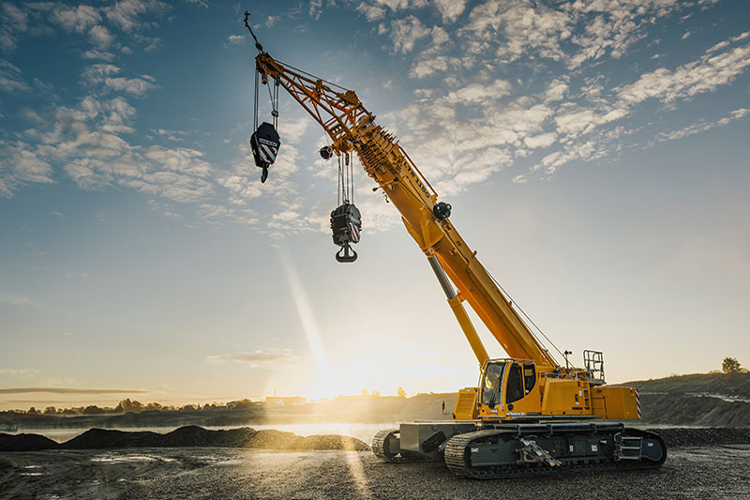

liebherr-ltr1150-01.jpg  
The new LTR 1150 complements Liebherr's portfolio of telescopic crawler cranes.

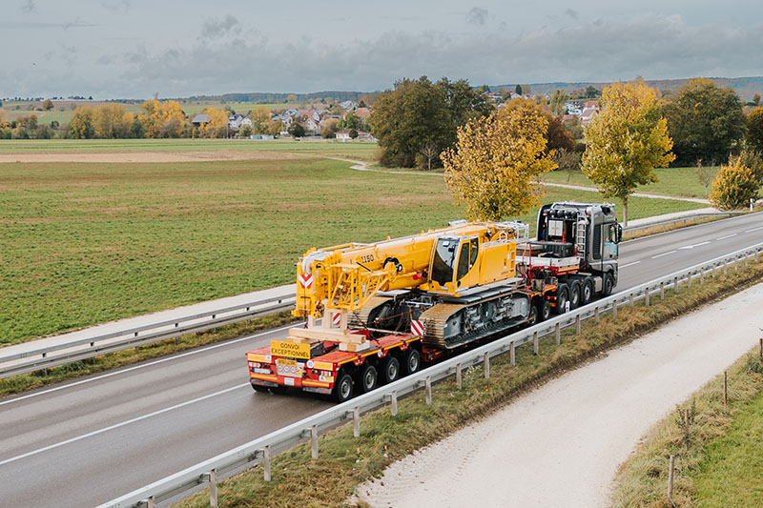

liebherr-ltr1150-02.jpg  
Economical transport concept: the LTR 1150 can be transported complete with crawler carriers on a low loader with a total weight of only 60 tonnes and a width of 3.5 metres...

**Contact**

Wolfgang Beringer  
Marketing and Communication  
Phone: +49 7391/502 - 3663  
Email: wolfgang.beringer@liebherr.com

**Published by**

Liebherr-Werk Ehingen GmbH  
Ehingen (Donau) / Germany  
www.liebherr.com