Press release

Slewing bearings and drives by Liebherr contribute to the exploration of the universe

⸺

New generation antennas by mtex antenna technology advance space exploration

The perfect interplay of Liebherr components in the mtex antennas scores with maximum precision and stiffness

Slewing bearings and drives by Liebherr ensure optimum azimuth adjustment and inclination of the antennas

**Liebherr's components product segment and mtex antenna technology join forces to provide the antennas for the next generation Very Large Array antennas (ngVLA), which will offer a glimpse into the infinite space reach. The ngVLA will be the largest radio astronomy facility in the Northern Hemisphere. The azimuth adjustment of the antennas is made possible by three-row roller bearings with a diameter of three metres and perfectly matched slewing drives. In addition, gear ring segments together with the drives ensure accurate elevation adjustment of the antenna. The perfect interaction of slewing bearings and drives guarantees precise control and positioning of the antennas for the exploration of the universe.**

Nussbaumen (Switzerland), November 20, 2023 – A new chapter in space research begins with antennas for what will be the largest radio astronomy facility in the Northern Hemisphere. "The ultra-sensitive imaging capabilities of these groundbreaking instruments will give us an unprecedented look into space and help unlock the secrets of the universe," explains Lutz Stenvers, Managing Director of mtex antenna technology GmbH. The new generation antennas, boasting a diameter of 18 metres, will be positioned in a clearly defined pattern throughout North America. The area with a total of 244 antennas will cover approximately 1,000 kilometres. The special arrangement of the antennas will ensure optimal data reception from the cosmos.

"With cutting-edge technology, precision engineering and a tireless commitment to scientific discovery, rockets the project to the forefront of astrophysical research," continues Lutz Stenvers. "And Liebherr's components take over an important role in this."

Precision at a blink of an eye: the seamless synergy of three elements

Crucial for the operation of an ngVLA are the components installed in it - a slewing bearing, two gear ring segments and azimuth drives. The slewing bearing is used for azimuth adjustment of the antenna to enable its precise positioning. Thereby, this roller bearing has a diameter of 3.3 metres. Its weight of 4,128 kilogrammes provides for more stability; its axial runout of 0.1 mm and radial runout of 0.05 mm plays a decisive role when it comes to precision. The slewing bearing is designed to be free of backlash, making it ideal for adjusting the azimuth of the antenna.

As a complementary feature to the slewing bearing, the gear ring segment is of great importance for the elevation adjustment of the antenna, meeting the high demands on the gear quality. The two gear ring segments, each positioned on the sides of the horizontal antenna rotation axis, ensure its exact elevation adjustment.

In addition, the interaction of the azimuth drives with the slewing bearing enables a high degree of precision, with which the satellite systems rotate around the tower axis. The key is a low torsional backlash and increased stiffness of the planetary gears. These optimisations make the adjustment mechanism of the entire system operate with maximum accuracy, targeting precise positioning in the long run.

The elevation adjustment, which is responsible for the inclination of satellite dishes, uses the same drives as the azimuth adjustment, but with an adapted transmission ratio. The interplay of the two adjustment systems is indispensable for exact antenna alignment.

**Rigorous testing as a prerequisite for success**

To ensure the precision of the azimuth bearing, Liebherr-Components subjected the bearing to the so-called "wobble test". At the site in Biberach (Germany), selected positions were approached several times, in order to measure and guarantee the greatest possible accuracy during operation.

Prior to market introduction, Liebherr subjects the prototypes to a comprehensive test programme, including stiffness tests, for the azimuth and elevation drives not only to meet, but to exceed highest industry standards. The expertise built up over decades is crucial for the symbiosis of the slewing bearing, gear rings and slewing drives as a unit.

With a commitment to set forth precision engineering and innovation, Liebherr and mtex antenna technology shape the future of satellite systems and push forward satellite positioning technology.

About the Liebherr-Components AG

In this segment, the Liebherr Group specialises in the development, design, manufacturing of high-performance components in the fields of mechanical, hydraulic and electric drive and control technology. Liebherr-Component Technologies AG, based in Bulle (Switzerland), coordinates all activities in the components product segment.

The extensive product range includes combustion engines, injection systems, engine control units, axial piston pumps and motors, hydraulic cylinders, slewing bearings, gearboxes and winches, switchgear, electronic and power electronics components and software. The high-quality components are used in cranes and earthmoving machinery, in the mining industry, maritime applications, wind turbines, automotive engineering or in aviation and transport technology. Synergy effects with other product segments of the Liebherr Group are used to drive continuous technological development.

About the Liebherr Group

The Liebherr Group is a family-run technology company with a highly diversified product portfolio. The company is one of the largest construction equipment manufacturers in the world. It also provides high-quality and user-oriented products and services in a wide range of other areas. The Liebherr Group includes over 140 companies across all continents. In 2022, it employed more than 50,000 staff and achieved combined revenues of over 12.5 billion euros. Liebherr was founded in Kirchdorf an der Iller in Southern Germany in 1949. Since then, the employees have been pursuing the goal of achieving continuous technological innovation and bringing industry-leading solutions to its customers.

About mtex antenna technology gmbh

mtex antenna technology gmbh, based in Wiesbaden (Germany), develops and manufactures telescopes for astronomy and geodesy, as well as special antennas for demanding applications. It also supplies antenna systems and ground stations for satellites or spacecraft communications for industry, research, ministries and government agencies. In addition to the product ranges, this also includes com-prehensive services, such as engineering services, installation, maintenance, up-grades and after-sales services. Further information is available at [https://www.mtex-at.com/](https://urldefense.com/v3/__https:/www.mtex-at.com/__;!!MjrZg_cyo6Q!OJXsKq3R_jwYdYkm_xcz_jb8e6wEiklG1ElKDz3iI8vn8J2jGrAMFZI_ZHa7sOmUbcXdqoUhwXbPECjnqbGBYnicu9nQf4UDVp1PEw$)

Images

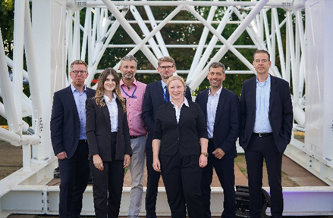

liebherr-and-mtex-antenna-technology-partnership-for-antenna-project.jpg

The team behind the ngVLA project in front of the 18-metre main reflector backup structure, consisting of Oliver Born, Chiara Cancro, Steffen Seubert, Lutz Stenvers, Eva-Maria Steibel-Wahl, Pietro Iemmi and Oliver Friedrich (from left to right).

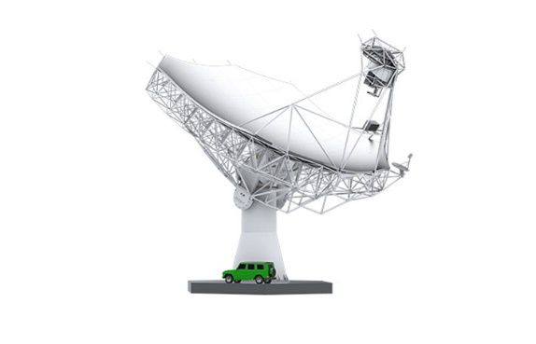

mtex-antenna-technology-gmbh.jpg

Slewing bearings, gear ring segments and drives by Liebherr provide for the azimuth adjustment and elevation of the antennas.

© mtex antenna technology gmbh

Contact

Alexandra Nolde  
Senior Communication & Media Specialist  
Telefon: +41 56 296 4326  
E-Mail: alexandra.nolde@liebherr.com

Published by

Liebherr-Components AG  
Nussbaumen / Switzerland  
[www.liebherr.com](http://www.liebherr.com)

[An interaction that rules: Drives and slewing bearings | Liebherr](https://www.liebherr.com/en/int/products/components/gearboxes-rope-winches/an-interaction-that-rules/an-interaction-that-rules.html)