Press release

Stable and strong in the wind – Liebherr power hits the road

⸺

An LTM 1300-6.3 from Felbermayr replaces a wind turbine gearbox at a height of 65 metres

No standstill thanks to a load chart for higher maximum wind speeds

Mobile crane tackles gravel track with steep inclines in mountainous region

**In October, Austrian crane hire company Felbermayr sent its new Liebherr LTM 1300-6.3 mobile crane to a wind farm in the east of the country. A defective gearbox on a wind turbine had to be replaced on a mountain ridge at an altitude of almost 1,600 metres. Despite gusts of up to thirteen metres per second, the crane was able to replace the twelve-tonne component in the nacelle at a height of around 65 metres.**

Ehingen (Donau) (Germany), 22 November 2023 – The mobile crane equipped with a 90 metre boom comes with “WindSpeed Load Charts” with higher permissible wind speeds. If the wind speed measured on the crane’s boom exceeds the set table wind speed during a job, the crane operator can simply switch to a lifting capacity table with a higher maximum wind speed so that, ideally, he can continue the crane work.

Windy locations are of course ideal for operating wind turbines. However, strong winds are the natural enemy of any well-planned schedule when erecting these systems. This also applies to repairs of older wind turbines whereby individual components such as rotor blades or gearboxes need to be replaced. Despite gusty weather conditions, a Liebherr LTM 1300-6.3 mobile crane was able to carry out precisely such a gearbox replacement on a mountain ridge in Styria – after the gearbox of an 18-year-old turbine at the “Steinriegel” wind farm failed and needed to be replaced.

“As the day went on, the gusts got stronger and stronger and I switched straight to the wind chart,” reports Robert Fuhrmann, who operates the modern 6-axle crane for Felbermayr. “I configured the load chart, which allows me to work at wind speeds of up to 13.4 metres per second.” As a rule, the permissible lifting capacities of cranes are calculated for speeds of up to nine metres per second. However, Liebherr has extended this range significantly upwards with the adapted “Wind Speed Load Charts”. During pure telescopic operation of modern LTM cranes, lifting work at up to a maximum of 15.6 metres per second is possible. This brings enormous benefits in terms of fewer standstills and a high degree of plannability on the construction site. And not only on wind farms.

**“The hill start aid is great!”**

The day before the crane job got underway, Fuhrmann had driven his machine from the Felbermayr branch in Lanzendorf, south of Vienna, to the site and set it up ready for lifting. The mobile crane with its engageable all-wheel drive had to negotiate a six-kilometre gravel track to the construction site at an altitude of almost 1,600 metres. Tight serpentine bends and gradients of over ten per cent were the main challenges on this rocky ascent. “The vehicle’s hill start aid is really great and served me well on the journey up here,” says the long-serving crane driver, who is extremely satisfied with his new work tool.

The LTM 1300-6.3 is ideal for jobs on wind turbines with hub heights of around 75 metres, as the crane carries its entire boom with a maximum telescopic length of 90 metres. With an axle load of just twelve tonnes, no other mobile crane on the market can do this. However, since the mobile crane was positioned on a raised platform for the job at the wind farm, it was sufficient to extend the mast to just 74 metres. The fitters in the nacelle had difficulty removing the damaged component; the old gearbox hung on the crane hook for many hours during the removal process. A situation tailor-made for the Liebherr crane’s advanced ECOmode control system, which minimises both fuel consumption and noise emissions by automatically disengaging the pump drive when no power is required.

Thanks to precise teamwork that included the crane driver and his machine, the men in the gondola finally succeeded in freeing the gearbox. Robert Fuhrmann then carefully lifted the defective component with a gross load of 13 tonnes out of the open turbine, carefully watching the monitor for the pulley head camera, and transported it safely to the ground. Immediately afterwards, the replacement gearbox was lifted up and installed in the nacelle.

**Crane reaches lifting heights of up to 120 metres**

Its boom makes the LTM 1300-6.3 as attractive for wind farm jobs as it is for erecting construction cranes. Not least because lift heights of up to 120 metres and impressive radii are possible thanks to attachable lattice jibs. The new crane from Felbermayr – which has been in service for around five months – has already completed a number of jobs on Austria’s wind farms, as well as lifting heavy transformer houses, and is also scheduled for construction crane assembly.

Felbermayr’s portfolio covers almost the entire range of heavy haulage, large and specialised transport, as well as the implementation of huge infrastructure projects. The company has expanded massively, above all in the countries of eastern Europe, in recent decades. The Austrian company’s portfolio includes 76 locations in 17 countries across Europe and around 500 mobile and crawler cranes. One of these is the LTM 1300-6.3 with Robert Fuhrmann at the wheel. Incidentally, he tells us that he particularly likes operating this crane. “The chassis is great to drive. It runs like no other and has extreme power on the road.”

**About Liebherr-Werk Ehingen GmbH**

Liebherr-Werk Ehingen GmbH is a leading manufacturer of mobile and crawler cranes. Its range of mobile cranes extends from 2-axle 35 tonne cranes to heavy duty cranes with a lifting capacity of 1200 tonnes and a 9-axle chassis. Its lattice boom cranes on mobile or crawler travel gear deliver lifting capacities of up to 3000 tonnes. With universal boom systems and extensive additional equipment, they can be seen in action on construction sites throughout the world. The Ehingen site has a workforce of 4,300. An extensive, global service network guarantees the high availability of Liebherr mobile and crawler cranes. In 2022, the Liebherr plant in Ehingen recorded a turnover of 2.37 billion euros.

**About the Liebherr Group**

The Liebherr Group is a family-run technology company with a widely diversified product range. The company is one of the largest manufacturers of construction machines in the world. However, it also supplies high quality, user-focused products and services in many other sectors. The group currently comprises more than 140 companies based in every continent of the world. In 2022, it had a workforce of over 50,000 and recorded a consolidated total turnover of more than 12.5 billion euros. The company was founded in 1949 in Kirchdorf an der Iller in southern Germany. Since then, its aim has been to win customers by supplying high quality solutions and to contribute to technological progress.

**Images**

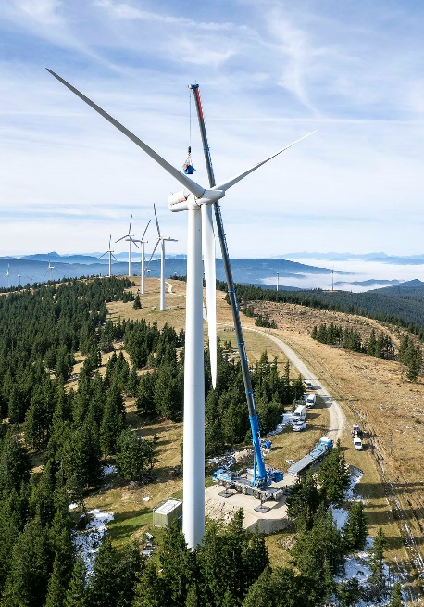

liebherr-ltm1300-6-3-felbermayr-1.jpg  
Flying high at the Steinriegel wind farm: the LTM 1300-6.3 from Felbermayr in operation on a ridge at an altitude of 1,600 metres.

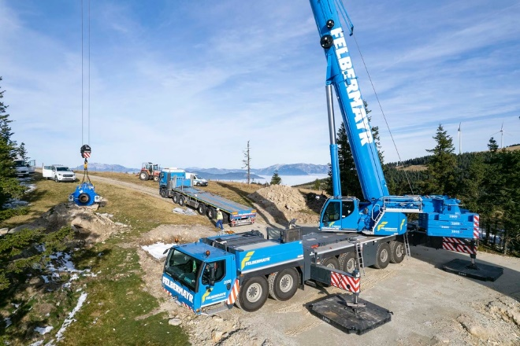

liebherr-ltm1300-6-3-felbermayr-2.jpg  
The new gearbox, which looks rather small, weighs around twelve tonnes and is being prepared for installation on the ground. With the maximum radius set, the mobile crane manages the lift with 42 tonnes of ballast.

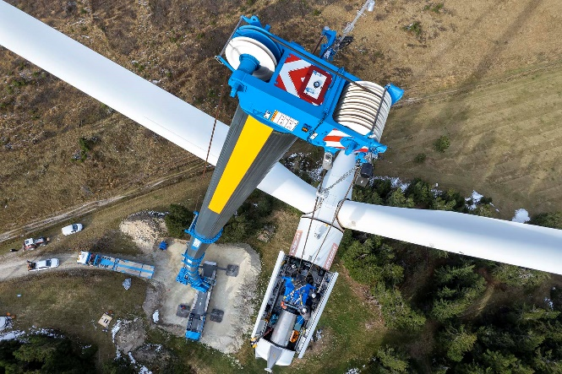

liebherr-ltm1300-6-3-felbermayr-3.jpg  
A camera on the crane’s pulley head transmits what is happening in the open gondola directly to the driver’s cab. This helpful feature increases safety when working on wind turbines.

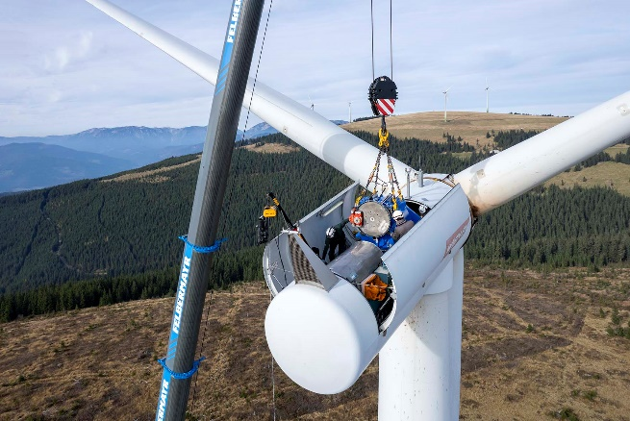

liebherr-ltm1300-6-3-felbermayr-4.jpg  
With its 90-metre-long main boom, the LTM 1300-6.3 is the ideal crane for work at extreme heights. It’s not just the fitters who need a sure instinct when removing and installing components. The assembly work also means hours of concentration for the crane driver.

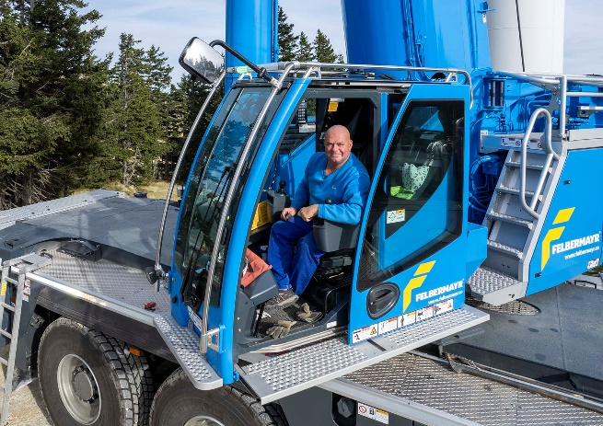

liebherr-ltm1300-6-3-felbermayr-5.jpg  
Mission successful: Robert Fuhrmann in the cab of his powerful LTM 1300-6.3.

**Contact**

Berenike Nordmann  
Marketing and Communication  
Phone: +49 7391/502 - 0  
Email: berenike.nordmann@liebherr.com

**Published by**

Liebherr-Werk Ehingen GmbH  
Ehingen (Donau), Germany  
[www.liebherr.com](http://www.liebherr.com)