Press release

40 tonne crane replaced: Kran & Transport Lausitz take delivery of new Liebherr LTM 1040-2.1
⸺
LTM 1040-2.1 has proven itself over a period of years
New technologies included
The whole of Kran & Transport Lausitz’s mobile crane fleet has been supplied by Liebherr

After 13 years of reliable service, Kran & Transport Lausitz GmbH has replaced a Liebherr LTM 1040-2.1 mobile crane with a new machine of the same type. Liebherr has continuously kept its 40 tonne crane up to date over the years by including innovative technologies, such as VarioBase®, ECOmode and ECOdrive.
Ehingen (Donau) (Germany), 27 November 2023 – As far as Mario Klar, owner and Managing Director of the family-run company based in Schleife in the Rural District of Görlitz, the LTM 1040-2.1 is a permanent presence in the company’s fleet: “We mainly drive around rural roads. That means that we need a small, manoeuvrable but powerful crane like this.”
Klar says that the main industries in which the crane operates include structural steelwork, housebuilding as well as maintenance and repair work in opencast lignite mines, an important area of work for the East Saxony company. “The old LTM 1040-2.1 proved to be ideal in all these fields and the new one has a range of additional features which will enable it to tackle even more types of work. For example, we ordered it with the variable support VarioBase®, which makes crane jobs more flexible and safer.”
Mario Klar is the second generation of his family to manage the company. A workforce of eight operates a total of seven mobile cranes with lifting capacities ranging from 30 to 90 tonnes, all of them supplied by Liebherr. “They are reliable cranes and when we need it, we get fast, straightforward support from Liebherr. All you have to do is call. The staff and the service team at the Alt-Bork repair outlet are fantastic. The whole chemistry is just perfect”, says Klar.

About Liebherr-Werk Ehingen GmbH
Liebherr-Werk Ehingen GmbH is a leading manufacturer of mobile and crawler cranes. Its range of mobile cranes extends from 2-axle 35 tonne cranes to heavy duty cranes with a lifting capacity of 1200 tonnes and a 9-axle chassis. Its lattice boom cranes on mobile or crawler travel gear deliver lifting capacities of up to 3000 tonnes. With universal boom systems and extensive additional equipment, they can be seen in action on construction sites throughout the world. The Ehingen site has a workforce of 4,300. An extensive, global service network guarantees the high availability of Liebherr mobile and crawler cranes. In 2022, the Liebherr plant in Ehingen recorded a turnover of 2.37 billion euros.
About the Liebherr Group
The Liebherr Group is a family-run technology company with a widely diversified product range. The company is one of the largest manufacturers of construction machines in the world. However, it also supplies high quality, user-focused products and services in many other sectors. The group currently comprises more than 140 companies based in every continent of the world. In 2022, it had a workforce of over 50,000 and recorded a consolidated total turnover of more than 12.5 billion euros. The company was founded in 1949 in Kirchdorf an der Iller in southern Germany. Since then, its aim has been to win customers by supplying high quality solutions and to contribute to technological progress.

Image
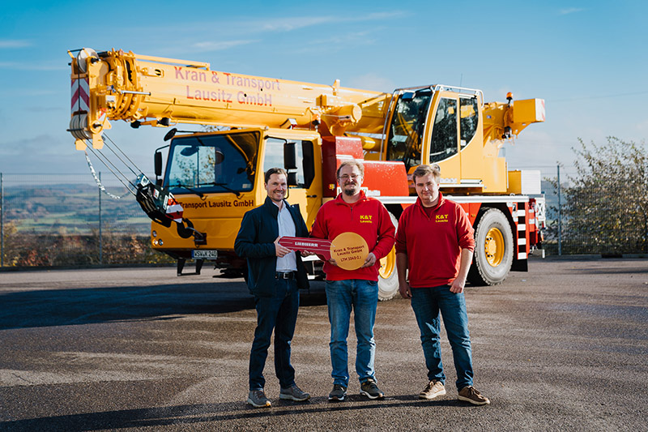
liebherr-ltm1040-2.1-k&t-lausitz.jpg
Crane handover in Ehingen: (from left to right) Sven Bahms (Liebherr-Werk Ehingen GmbH), Mario Klar, Markus Schuhmann (both from Kran & Transport Lausitz).

Contact
Wolfgang Beringer
Marketing and Communication
Phone: +49 7391/502 - 3663
Email: wolfgang.beringer@liebherr.com
Published by
Liebherr-Werk Ehingen GmbH
Ehingen (Donau) / Germany
www.liebherr.com

