Press release

Liebherr to exhibit at the 50th anniversary of World of Concrete

⸺

World of Concrete will take place at the Las Vegas Convention Center in Las Vegas, NV from January 23-25, 2024.

Liebherr will offer cross-divisional participation at booth #C6149 and booth #N1011

Attendees will be able to get hands-on with multiple machines from Liebherr’s concrete technology and earthmoving and material handling technology product segments

Liebherr’s concrete and earthmoving technology teams will be exhibiting at the annual World of Concrete in Janaury 2024 showcasing the 38 Z4 XXT truck mounted concrete pump, THP 80 LP city pump, RIM 2.25 M ring pan mixer, and L 546 wheel loader.

Newport News, VA (USA), Liebherr USA, Co, November 28, 2023 – The 50th anniverary of World of Concrete will take place in Las Vegas, Nevada from January 23-25, 2024. Liebherr will have cross-divisional participation from the concrete technology and earthmoving and material handling technology teams. Liebherr will showcase the [38Z4 XXT truck mounted concrete pump](https://www.liebherr.com/en/usa/products/construction-machines/concrete-technology/concrete-pumps/truck-mounted-concrete-pumps/details/645442.html), [THP 80 LP city pump](https://www.liebherr.com/en/usa/products/construction-machines/concrete-technology/concrete-pumps/city-pumps/details/649748.html), and [L 546 wheel loader](https://www.liebherr.com/en/usa/products/material-handling-equipment/wheel-loaders/details/650367.html) at booth #C6149 and a [RIM 2.25 M ring pan mixer](https://www.liebherr.com/en/usa/products/construction-machines/concrete-technology/mixer-systems/ring-pan-mixer/details/85957.html) at booth #N1011. There will also be a Liebherr press briefing on January 23rd from 8:00 am - 9:00 am at booth #C6149 featuring Liebherr’s Divisional Director of Concrete Technology, Guilherme Zurita.

“We are excited to exhibit at World of Concrete 2024, showcasing our newest concrete pump, the 38Z4 XXT. This premier industry event is the perfect opportunity to officially debut our most advanced 4-section pump that delivers enhanced performance, leveraged by the already proven Powerbloc and best-in-class operational support solutions, such as the XXA stability support System,” noted Zurita.

Throughout the show Liebherr will showcase equipment including the 38 Z4 XXT truck mounted concrete pump, THP 80 LP city pump, RIM 2.25 M ring pan mixer, and L 546 wheel loader. Attendees will see first-hand Liebherr’s latest technology and innovations and learn how those features can improve productivity on their jobsites. Liebherr's participation shows ongoing commitment to shaping the future of the concrete industry. Booth staff look forward to engaging with customers about their challenges and goals for the future.

[38 Z4 XXT truck mounted concrete pump](https://www.liebherr.com/en/usa/products/construction-machines/concrete-technology/concrete-pumps/truck-mounted-concrete-pumps/details/645442.html)

The 38 XXT offers a 4-part distribution boom in a practical Z-fold making it easy to handle and offers a very long reach for the 30 m class. This model comes standard with XXT-outriggers and an XXA stability assistance system. The pivoting XXT support is very flexible when supporting in tight spaces, and the new XXA stability assistance system allows partially supported areas to be electronically monitored. The concrete pump is also equipped with the latest drive unit, powerbloc. This unit does not require a separate control block, as all hydraulic switching and measuring elements are integrated.

[THP 80 LP city pump](https://www.liebherr.com/en/usa/products/construction-machines/concrete-technology/concrete-pumps/city-pumps/details/649748.html)

This strong and powerful concrete pumping unit offers versatility as well as mobility, making it incredibly cost effective for a variety of line pump jobsites. With high output range and high pressure, the city pump will fulfill your concrete pumping needs.

[RIM 2.25 M ring pan mixer](https://www.liebherr.com/en/usa/products/construction-machines/concrete-technology/mixer-systems/ring-pan-mixer/details/85957.html)

The RIM 2.25 M ring pan mixer offers a variety of advantages to concrete customers. The mixer offers continuance movement inside the mixing chamber for better performance. The large opening in the cover of the mixer as well as the gearbox position allows for easily accessible maintenance. And when service needs arise Liebherr offers a variety of spare parts and customer support to all customers.

[L 546 wheel loader](https://www.liebherr.com/en/usa/products/material-handling-equipment/wheel-loaders/details/650367.html)

The L 546 wheel loader offers power, speed, durability, and innovative technology, resulting in a modern machine design. The efficient hydrostatic travel drive and efficient components reduce operating costs in a sustainable way, putting more money in customer’s pockets.

About Liebherr USA, Co.

[Liebherr USA, Co](https://www.liebherr.com/en/usa/start/start-page.html). based in Newport News, VA provides sales and service on behalf of ten different Liebherr product segments: earthmoving, material handling, mining, mobile and crawler cranes, tower cranes, concrete technology, deep foundation machines, maritime cranes; components, and refrigeration and freezing.

About the Liebherr Group

The [Liebherr Group](https://www.liebherr.com/en/usa/about-liebherr/about-liebherr.html) is a family-run technology company with a highly diversified product portfolio. The company is one of the largest construction equipment manufacturers in the world. It also provides high-quality and user-oriented products and services in a wide range of other areas. The Liebherr Group includes over 140 companies across all continents. In 2021, it employed more than 49,000 staff and achieved combined revenues of over 11.6 billion euros. Liebherr was founded in Kirchdorf an der Iller in Southern Germany in 1949. Since then, the employees have been pursuing the goal of achieving continuous technological innovation, and bringing industry-leading solutions to its customers.

Images

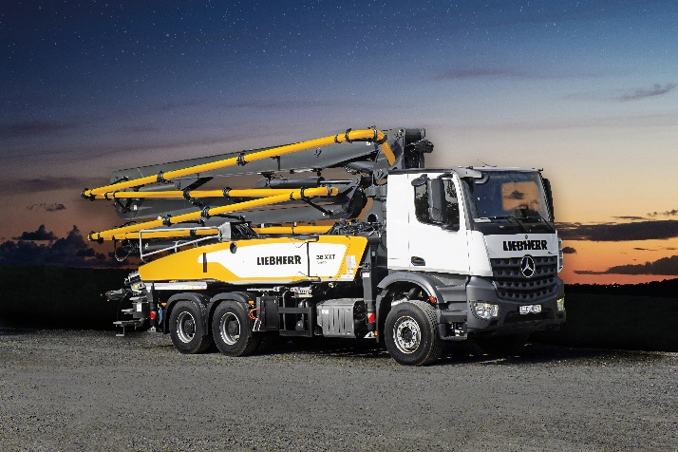

liebherr-38xxt.jpg  
The 38 XXT offers a 4-part distribution boom in a practical Z-fold making it easy to handle and offers a very long reach.

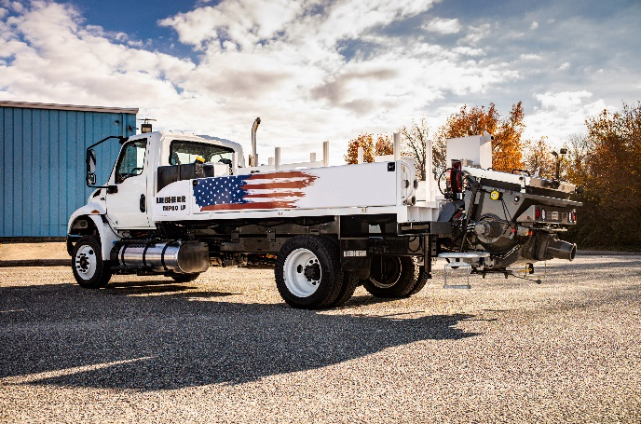

liebherr-.jpg  
The THP 80 LP City Pump is a versatile and cost-effective solution for concrete customers.

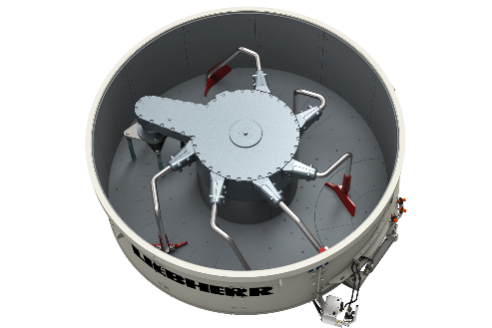

liebherr-RIM-1-5-M.jpg  
The RIM 2.25 M ring pan mixer offers continuance movement inside the mixing chamber for better performance.

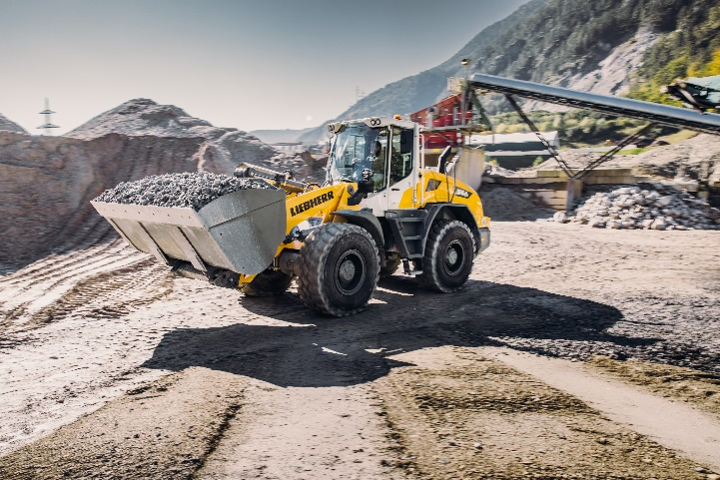

liebherr-L546.jpg  
The L 546 wheel loader combines power, speed, and durability.

Contact

Ana Cabiedes   
Head of Marketing

Liebherr USA, Co  
E-Mail: ana.cabiedes@liebherr.com

Published by

Liebherr USA, Co.   
Newport News / USA  
www.liebherr.com