Press release

Liebherr L1 fast-erecting crane at work inside Passau Cathedral

⸺

The world's largest Catholic church organ is undergoing renovation

Limited space inside the cathedral due to existing scaffolding

Access via narrow streets in Passau’s Old Town district

L1 is able to use its strengths to full effect

The organ at St Stephan's Cathedral in Passau incorporates 17,974 pipes, making it the largest Catholic church organ in the world. Renovation work means that there is currently a special visitor at the church. A Liebherr L1-24 fast-erecting crane has been given the honoured task of carefully moving the organ pipes, which weigh several hundred kilograms. It's a job that requires plenty of planning and good judgement.

Passau (Germany), 13 December 2023 – It’s all about precision: the Liebherr fast-erecting crane is slowly manoeuvred into place inside Passau Cathedral and then assembled. It is surrounded by scaffolding that reaches up to the gallery. Precision work part two: the crane, now fully assembled, has an organ pipe on its hook. The metres-long pipe is carefully lifted from its mount and lowered into the nave. This unusual visitor to Passau Cathedral is playing its part in the ongoing renovation of the organ and its pipes up in the gallery. The pipes are being removed one by one, restored, and then fitted back into place.

Precise planning in advance

A great deal of planning was needed before the crane could actually be assembled. The Liebherr Tower Crane Solutions project department, which is responsible for large-scale and special project planning and consultancy, worked closely with Liebherr dealer Beutlhauser on this. Space restrictions resulting from scaffolding inside the cathedral impacted the crane's assembly curve. Several test assemblies at Beutlhauser's premises in Passau supported this meticulous advance planning. The ground's load-bearing capacity and protection of the cathedral's marble floor during the crane's assembly and operation also had to be clarified beforehand. Ground samples were taken for this purpose, the floor was then covered with anti-slip mats and iron plates for better load distribution before assembly. Four 800-kilogram plates were put down, one for each foot of the crane.

Navigating narrow streets

Meanwhile, the L1 was on its way to the site. This required extra precision as well, as the cathedral square there can only be reached via narrow streets. A one-way street in Passau’s Old Town district was the only viable route to the destination – and this involved a police escort for driving against the direction of traffic. Once at the cathedral square, it was time to change the towing vehicle. The cathedral entrance was too narrow for the truck, so an industrial forklift truck from Beutlhauser's own hire fleet was used to transport the crane its final few metres. The Linde X50 electric forklift truck also met the requirement of working emission-free inside the cathedral. Once there, the manoeuvring continued past numerous pillars and pews. 13 rows of pews were dismantled in advance for the crane's intended position.

Fragile loads

The largest organ pipe in Passau Cathedral is over 11 metres long and weighs 306 kilograms. The pipes are made of a delicate tin-lead alloy, a very soft material. This means that lifting the pipes has to be done with great care.

The cathedral will remain open to visitors during the renovation work; the only exceptions being the crane's assembly and dismantling. The L1 is expected to remain in place until February 2024. It will then be used a second time once the restoration work is complete, when the organ pipes are lifted back up to the gallery and reinserted. If everything goes according to plan, the project should be finished in 2027.

Agile and flexible crane

The flexibility of the fast-erecting crane proved to be the decisive factor when deciding on its use. Scaffolding with an overhead crane and trolley, as initially planned, would have needed to stay in place for several years until the renovation work's completion, which would have resulted in long-term restrictions and ongoing costs.

The L1-24 is able to use its strengths to full effect in Passau. Its compact slewing radius of 1.95 metres enables it to be set up inside the cathedral. Tight turning radii are no problem thanks to its wheel gauge, and its supports can be optimally adapted to conditions on site. Radio remote control and scaling via a programmable logic controller make assembly and dismantling easy. The L1-24 can achieve a maximum radius of 27 metres and is able to lift up to 2,500 kilograms. It can still lift 950 kilograms at its jib head, depending on the radius used. Three different jib positions are possible for operation.

About the Liebherr Tower Cranes Division

More than seven decades of experience have made Liebherr a recognised specialist for lifting technology on all types of construction sites. The range of Liebherr Tower Cranes encompasses an extensive selection of high-quality tower cranes that are used worldwide. This includes fast-erecting, top-slewing, luffing jib and special-purpose cranes as well as mobile construction cranes. In addition to these products, Liebherr also offers a wide range of services that complete the company’s portfolio: Tower Crane Solutions, the Tower Crane Center and Tower Crane Customer Service.

About the Liebherr Group

The Liebherr Group is a family-run technology company with a highly diversified product portfolio. The company is one of the world's largest manufacturers of construction machinery. It also offers high-quality, user-oriented products and services in multiple other areas. Today, the group consists of more than 140 companies across all continents. In 2022, it employed more than 50,000 people and achieved combined revenues of over 12.5 billion euros. Liebherr was founded in 1949, in Kirchdorf an der Iller in southern Germany. Ever since then, the company’s employees have been committed to satisfying customers with advanced solutions and to helping drive technological progress.

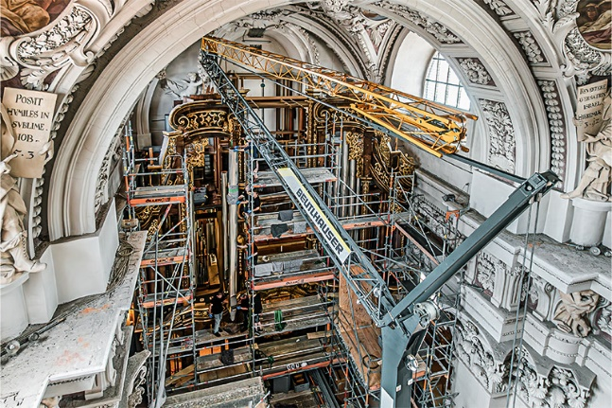Images

liebherr-l1-24-beutlhauser-passau-dom-01.jpg  
An unusual visitor at Passau Cathedral: A Liebherr L1-24 fast-erecting crane is helping to renovate the world's largest Catholic church organ.

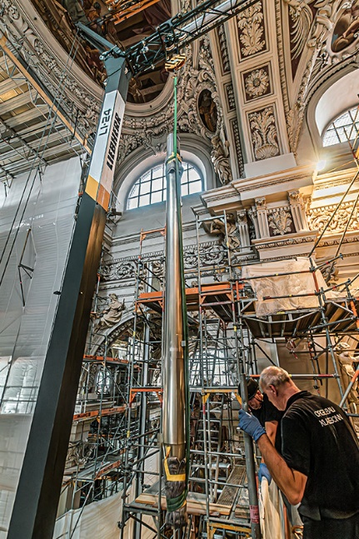

liebherr-l1-24-beutlhauser-passau-dom-02.jpg  
The organ pipes are made of a soft alloy. They are attached to the crane hook with secure padding in place.

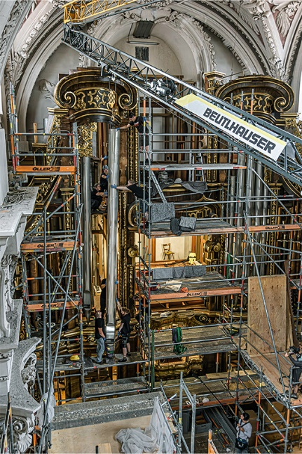

liebherr-l1-24-beutlhauser-passau-dom-03.jpg  
The metres-long pipes are lowered into the nave one by one.

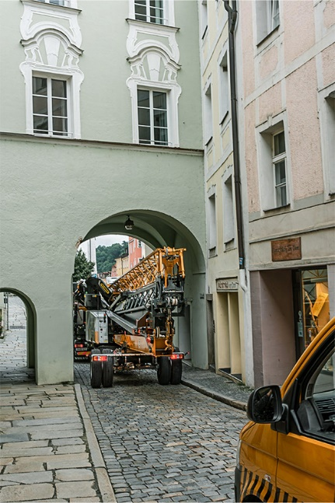

liebherr-l1-24-beutlhauser-passau-dom-04.jpg  
The access route to the cathedral lead through narrow streets and archways.

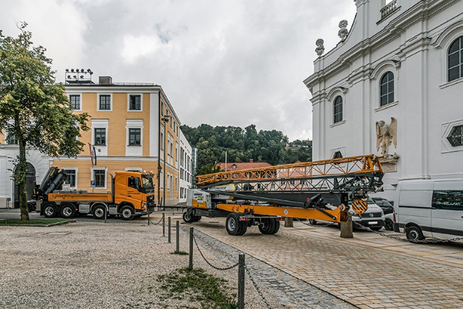

liebherr-l1-24-beutlhauser-passau-dom-05.jpg  
Its tight turning radius proved an advantage for the L1 en route.

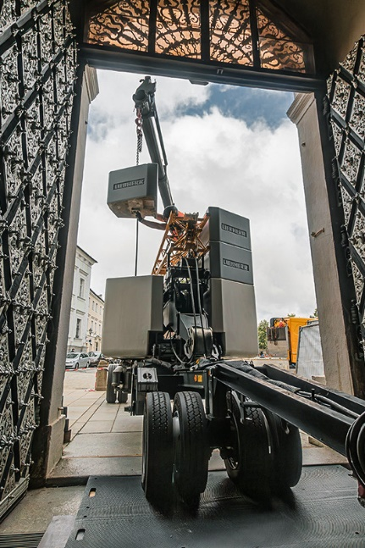

liebherr-l1-24-beutlhauser-passau-dom-06.jpg  
The L1 is towed into the cathedral by an electric forklift – the entrance was too narrow for the truck.

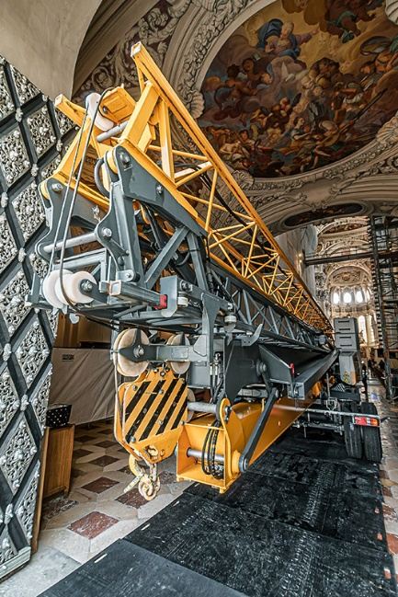

liebherr-l1-24-beutlhauser-passau-dom-07.jpg  
In it goes! The marble floor is covered with anti-slip mats.

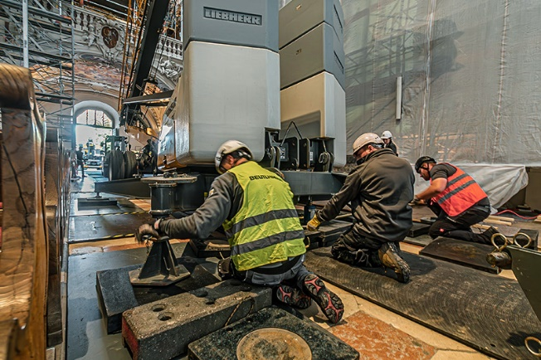

liebherr-l1-24-beutlhauser-passau-dom-08.jpg  
Iron plates were placed under each crane support to even out the load.

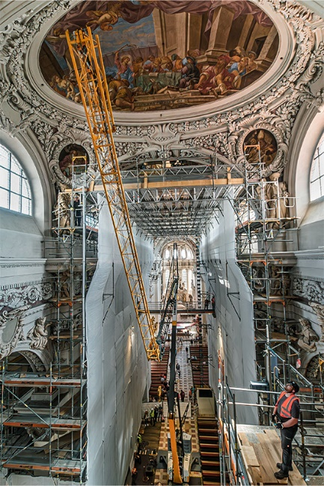

liebherr-l1-24-beutlhauser-passau-dom-09.jpg  
Precision work inside the cathedral, past the scaffolding and the ornate ceiling.

Contact

Astrid Kuzia  
Communication Specialist  
Phone: +49 7351 / 41– 4044  
Email: astrid.kuzia@liebherr.com

Published by

Liebherr-Werk Biberach GmbH  
Biberach / Germany  
www.liebherr.com