Press release

Liebherr at Excon: solutions for the Indian construction and raw material industry

⸺

Exhibits from Liebherr’s Earthmoving und Cranes product segments

Customised solutions for the construction industry in the Indian market

Presentation of the construction machines in the outdoor area, booth OD 83

Excon is the most important construction machinery exhibition in South Asia. From 12–16 December 2023 in Bangalore, Liebherr is presenting five machines from its Earthmoving und Cranes product segments. At the approx. 1000 m2 booth, visitors can see a tower crane, a rough terrain crane, two wheel loaders and a crawler dozer. The exhibited machines offer customised solutions for the construction industry in the Indian market.

Bangalore (India), 12 December 2023 – At Excon 2023 in the Indian city of Bangalore, Liebherr is presenting five exhibits from the Earthmoving und Cranes product segments. From 12–16 December 2023, visitors to booth OD 83 will be offered the opportunity to view customised products and technologies for the Indian construction market. The booth, with an area of approx. 1000 m2 comprises a larger pavilion with meeting rooms, a terrace and a lounge. The NC-LH 12-55 tower crane, the LRT 1100-2.1 rough terrain crane, the L 550 and L 566 wheel loaders, and the PR 736 crawler dozer are also being exhibited there.

**The NC-LH 12-55 impresses thanks to its slim tower system, great hook heights and high output**

“Made to build cities”: Liebherr is displaying their first hydraulic luffing jib crane at Excon. At maximum radius, the NC-LH 12-55 can lift up to 2550 kilograms at the top. These impressive values are achieved by the hydraulic luffing jib in combination with the climbable 16 EC tower system, which, with its dimensions of 1.6 x 1.6 m, requires little space and can be effortlessly transported to its destination by truck or container.

The Litronic control system with the TC-OS 1 operating system (Tower Crane Operating System) delivers user-friendliness and a streamlined menu structure of the user interface. Slim tower system, great hook heights, high output and climbable – this complete package makes the hydraulic luffing jib from Liebherr unique. In addition, the tower crane stands out from the crowd for its ease of assembly and excellent transport properties. In addition, the very small out-of-operation position and operation with the familiar Litronic assistance systems – such as Micromove, slew safety area limitation (ABB) and horizontal load travel – are of the highest standard.

**Safety and monitoring are central to the LRT 1100-2.1 rough terrain crane**

The LRT 1100-2.1 rough terrain crane has a telescopic boom featuring the telematics telescopic system that has been proven on Liebherr all-terrain cranes. With this system, individual telescopic parts are extended independently from each other with just one cylinder and bolted to the overlying telescopic part. With just two telescopic paths, strong or long, optimal lifting capacities are implemented across the entire radius range. This is particularly easy and user-friendly.

On the LRT 1100-2.1, the VarioBase® variable support base, which is integrated as standard, guarantees a maximum level of safety for crane drivers and their surroundings. It allows for higher lifting capacities with variable jib positions. Thanks to the adjustable operator’s cab, the crane driver can always keep an eye on the work process. Furthermore, the LRT crane has extensive monitoring systems. Both when telescoping and when setting the counter-ballast, the operator always has access to the displays that guarantee a safer working environment.

**L 550 and L 566 wheel loaders: robust machines with high output and low operating costs**

The wheel loaders L 550 and L 566 of the latest generation feature the proven hydrostatic Liebherr travel drive, which is renowned for its great efficiency. Thanks to increases in engine power – approximately 17% for the L 550 – the travel drive is even more powerful while maintaining the same low fuel consumption. This is advantageous when accelerating or penetrating material and lowers fleet fuel costs. Liebherr has installed the diesel engine in the rear, where it also acts as a counterweight thereby increasing the tip load for the wheel loaders.

Liebherr has three lift arm versions on offer for the new models. Firstly, the z-bar kinematics, which come to the fore particularly in the lower lifting range and for the break-out force. Secondly, the industrial kinematics, which have been designed for working with heavy working tools such as high dump buckets and log grapplers. Finally there are the High Lift lift arms – an extended version of the z-bar kinematics with the longest lift arms in this wheel loader segment. These ensure greater reach and more productive loading procedures at great heights, which is beneficial when loading railway wagons or lorries with high sides.

The working hydraulics of the wheel loaders will also impress customers with their larger components and new electrohydraulic pilot control. This technology also ensures responsive movements of the lift arms, independent of the size or weight of the working tool. The modern design of the wheel loaders has particular functional advantages in addition to the bold new look. The clean lines on the rear as well as the large glass surfaces in the cab facilitate good all-round visibility. Furthermore, the new reversing camera, which is installed in a protected position in the engine bonnet, assists the machine operator to keep an eye on the area to the rear.

**Stands out thanks to productivity and flexibility: the PR 736 crawler dozer**

In productive operation, each work step requires the ideal combination of speed and traction. In this regard, the Liebherr PR 736 crawler dozer allows for optimum application − even in the event of changing weather conditions and material qualities. The diesel-hydraulic crawler dozers from the new Generation 8 use high-performance common-rail engines that Liebherr produce in-house. An additional advantage with regard to productivity is the new geometry of the 6-way blades. The broad range of equipment is supplemented by additional variants: Straight (max. 6 m³), semi-U (max. 13.7 m³) and U blades (max. 17 m³), as well as numerous rear-side options – individually tailored to the machine size and application in question.

Thanks to electronic pre-control, the response and the speed of the front and rear working attachments can be flexibly adjusted to the operating conditions and to the operator’s requirements. Furthermore, the intelligent work hydraulics offer assistance functions, such as blade-emptying using the vibrating function, rear ripper parking position as well as automatic blade lifting during reverse travel, and allow for the integration of 2D and 3D machine controls. Furthermore, this significantly increases the operator’s comfort.

The master volume and, in particular, the hydraulic noises are reduced by virtue of the operator’s cab being decoupled from the basic machine and thanks to all additional measures of the new Liebherr Silent Design. The comfort of the crawler dozer is also impressive in extreme conditions and in any type of weather. The standard air-conditioning system keeps the temperature in the operator’s cab constant, while access and exit step lighting with timer function that can be activated from outside guarantees additional safety in low-light conditions.

About the Liebherr Group

The Liebherr Group is a family-run technology company with a highly diversified product portfolio. The company is one of the largest construction equipment manufacturers in the world. It also provides high-quality, user-oriented products and services in a wide range of other areas. The Liebherr Group includes over 140 companies across all continents. In 2022, it employed more than 50,000 staff and achieved combined revenues of over 12.5 billion euros. Liebherr was founded in Kirchdorf an der Iller in Southern Germany in 1949. Since then, the employees have been pursuing the goal of achieving continuous technological innovation, and bringing industry-leading solutions to its customers.

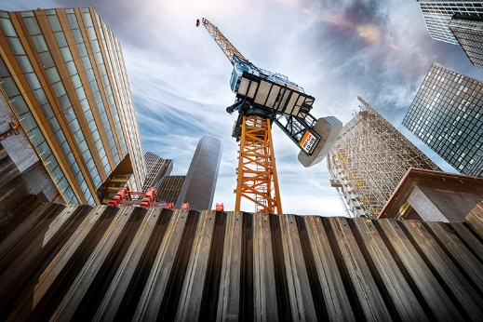Images

liebherr-nc-lh-12-55.jpg  
“Made to build cities”: The NC-LH 12-55 hydraulic luffing jib crane is easy to transport and stands out thanks to how easy it is to install and use.

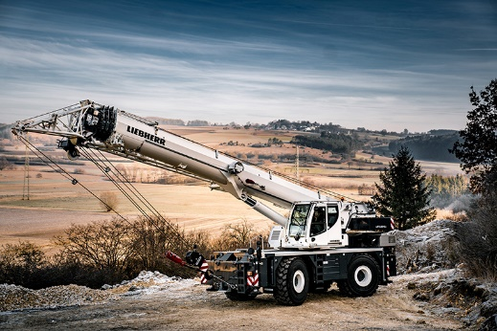

liebherr-lrt-1100-2.1.jpg  
Increased operational safety: With the LRT 1100-2.1 rough terrain crane, the crane driver has everything under control.

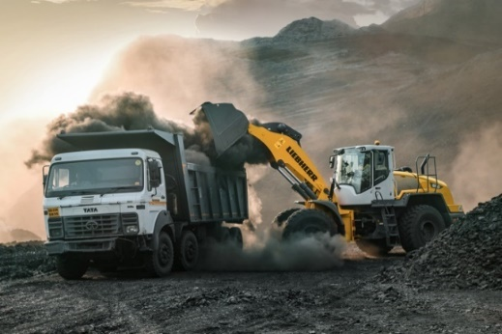

liebherr-wheel-loader-l550-coal-handling-india.jpg  
A Liebherr L 550 wheel loader loads a lorry at a coal mine in India.

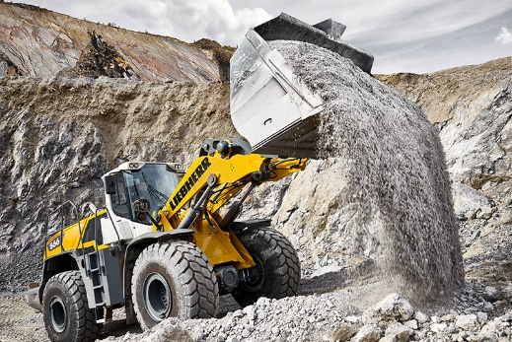

liebherr-wheel-loader-l566-quarry.jpg  
It is versatile to use, as demonstrated in mining applications: the L 566 wheel loader.

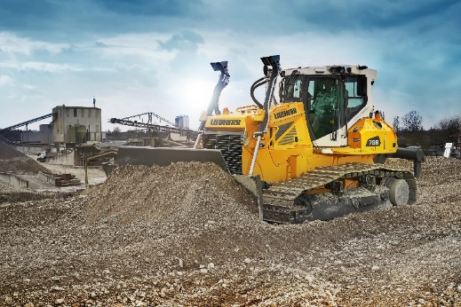

liebherr-PR736-hero.jpg  
The PR 736 G8 crawler dozer captivates with optimal dozing power and efficiency for all operational requirements.

Contact

Larissa Lunitz  
Head of Public Relations

Phone: + 41 79 645 70 67

E-mail: larissa.lunitz@liebherr.com

Published by

Liebherr-International AG

General-Guisan-Strasse 6

5415 Nussbaumen, Switzerland

www.liebherr.com