Press release

Liebherr tower crane works on unusual bridge construction

⸺

125 EC-B 6 with a unique set-up

Work is in progress on a new Elbe river bridge for the A 14 motorway near Wittenberge

Liebherr’s Tower Crane Solutions project department is providing advisory and planning support

The bridge has individual sections that will be pushed across the Elbe onto support piers in 2024

At first glance, it looks as if the Liebherr tower crane is floating in the air. Only the new bridge structure and the ground beneath it can be seen where the crane's foundations would normally be. The challenge at the construction site in Wittenberge (Brandenburg) is that the landscape surrounding the bridge is a nature reserve, so everything has to take place in as little space as possible. This has created an unusual site situation involving an approach that has never been seen before in Germany.

Wittenberge (Germany), 14 December 2023 – It’s the first job of its kind in Germany: the 125 EC-B 6 tower crane is mounted on a platform attached to the side of the new bridge. It stands on a moveable unit that advances with the bridge as construction progresses.

A hook height of 16 metres is enough

The Liebherr 125 EC-B 6 tower crane has an important role to play in the project. It doesn't need to be its maximum size for this job though: a hook height of 16.5 metres and a jib length of 42.5 metres are enough. The flat-top crane can actually reach a hook height of up to 59 metres and a radius of up to 58 metres. But for this project, the crane is mounted at around the same height as the top edge of the bridge; extending 16 metres upwards above the bridge is sufficient.

The tower crane is ably supported by three Liebherr 81 K.1 fast-erecting cranes, which are being used for general work on site and can lift up to 6 tonnes. These cranes achieve a maximum radius of 48 metres and a maximum hook height of 40.4 metres. An additional Liebherr crane may join them as construction progresses: a mobile construction crane from the LTM series.

The crane is being supplied by Hüffermann Krandienst GmbH, based in Wildeshausen near Bremen. The full service provider in the field of crane and heavy-duty logistics is relying on the expertise of Liebherr Tower Crane Solutions for this particular job. The project department for special assignments has been on hand from the outset to advise on the crane platform for the moveable scaffolding system. The flat-top crane has been contracted by leading Swiss construction services provider Implenia.

Construction site needs to be kept as small as possible

The Elbe landscape surrounding the bridge is a nature conservation area, which means that all those involved have to meet special requirements. This can be seen from the construction method, which uses a moveable scaffolding system due to the need for the construction site to operate in as little space as possible. The bridge is being divided into four segments, which will be assembled on land. The individual sections will then be pushed across the Elbe one by one to their respective support piers, a process that is expected to start in early 2024. The final bridge section will be transported across the Elbe on a floating pontoon. The crane has been in Wittenberge since September 2023 to help with preparations and is scheduled to be on site for a full year.

9,000 tonnes of steel are to be used for the bridge, which is around 2,000 tonnes more than was needed for the Eiffel Tower. The separate bridge sections are made up of individual 20 metre-long components that are manufactured in Saxony.

Expansion of the A 14 motorway in full swing

The motorway currently ends at Magdeburg and starts again at Schwerin. As part of the northern extension of the A 14 motorway, traffic will in future be able to cross the Elbe via a bridge measuring approx. 1,100 metres in length; the longest bridge of the entire motorway extension northwards. One end of the bridge will stand near Wittenberge, Brandenburg, the other near Seehausen in Saxony-Anhalt. It is due to open in 2026 but won't yet be part of the motorway at that time, as the surrounding motorway sections won’t have been completed by then. The approximately 155-kilometre-long new section is currently the largest new motorway construction project in Germany and is expected to be completely open to traffic from 2028.

About the Liebherr Tower Cranes Division

More than seven decades of experience have made Liebherr a recognised specialist for lifting technology on all types of construction sites. The range of Liebherr Tower Cranes encompasses an extensive selection of high-quality tower cranes that are used worldwide. This includes fast-erecting, top-slewing, luffing jib and special-purpose cranes as well as mobile construction cranes. In addition to these products, Liebherr also offers a wide range of services that complete the company’s portfolio: Tower Crane Solutions, the Tower Crane Center and Tower Crane Customer Service.

About the Liebherr Group

The Liebherr Group is a family-run technology company with a highly diversified product portfolio. The company is one of the world's largest manufacturers of construction machinery. It also offers high-quality, user-oriented products and services in multiple other areas. Today, the group consists of more than 140 companies across all continents. In 2022, it employed more than 50,000 people and achieved combined revenues of over 12.5 billion euros. Liebherr was founded in 1949, in Kirchdorf an der Iller in southern Germany. Ever since then, the company’s employees have been committed to satisfying customers with advanced solutions and to helping drive technological progress.

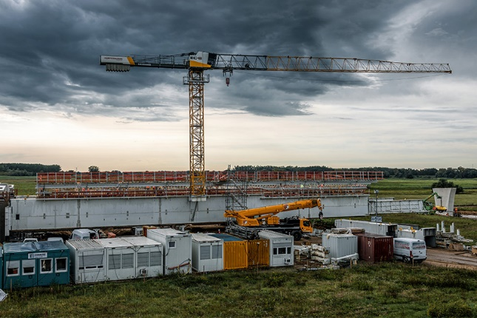Images

liebherr-125-ec-b-wittenberge-hueffermann-01.jpg  
The crane is attached to the side of the bridge on a moveable unit that keeps up with the bridge as construction progresses.

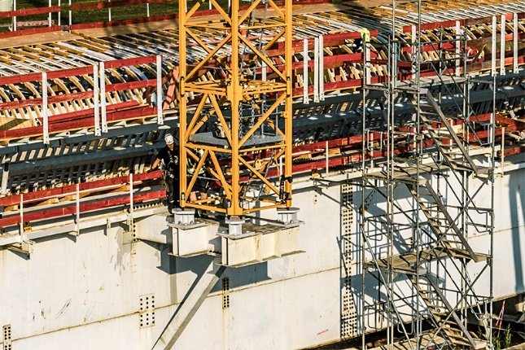

liebherr-125-ec-b-wittenberge-hueffermann-02.jpg  
The crane's mounting was precisely planned and calculated ahead of time by Liebherr Tower Crane Solutions.

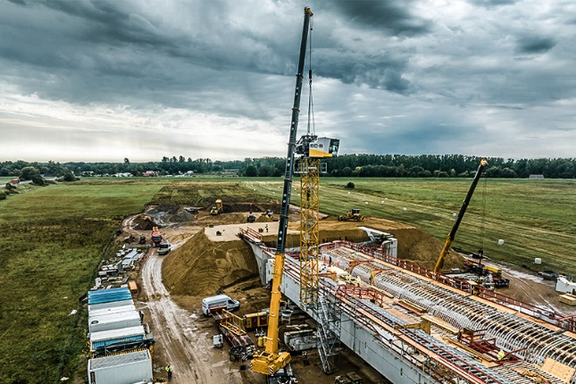

liebherr-125-ec-b-wittenberge-hueffermann-03.jpg  
The first metres of the new bridge's substructure were already in place on land when the flat-top crane was assembled.

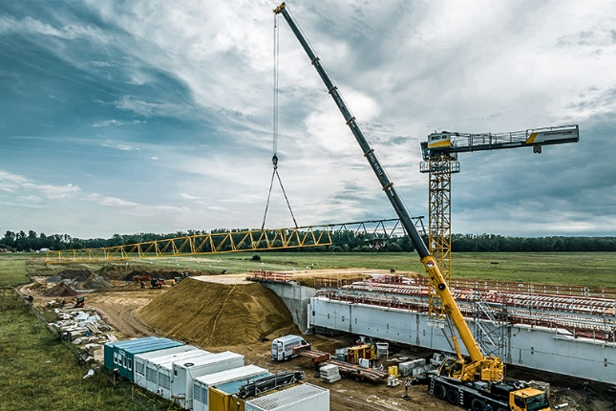

liebherr-125-ec-b-wittenberge-hueffermann-04.jpg  
Assembly of the 125 EC-B 6 with the help of a Liebherr mobile crane.

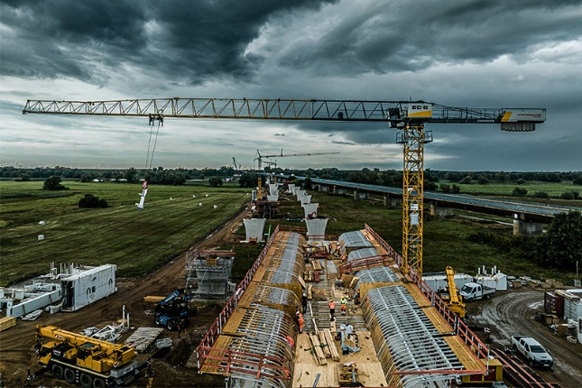

liebherr-125-ec-b-wittenberge-hueffermann-05.jpg  
First lifts for the new bridge. The parallel running federal highway Bundesstraße 189 can be seen in the background; the existing bridge will remain in place.

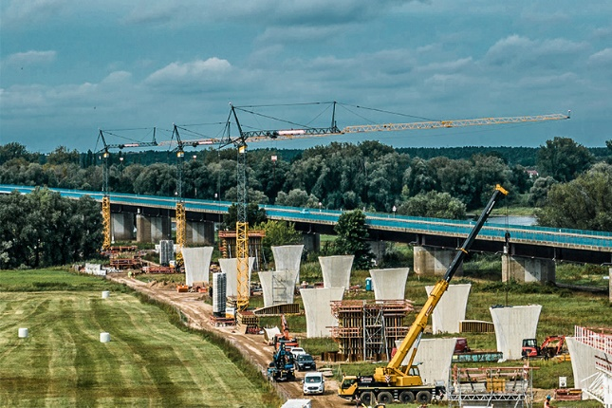

liebherr-125-ec-b-wittenberge-hueffermann-06.jpg  
As well as the tower crane mounted on the bridge, there are also three Liebherr 81 K.1 fast-erecting cranes on site. Work on the bridge piers is progressing and the first bridge sections are due to be pushed across the Elbe in early 2024.

Contact

Astrid Kuzia  
Communication Specialist  
Phone: +49 7351 / 41– 4044  
Email: astrid.kuzia@liebherr.com

Published by

Liebherr-Werk Biberach GmbH  
Biberach / Germany  
www.liebherr.com