Press release

Liebherr articulated dump trucks involved in major project at Lake Reschen

⸺

Ten Liebherr TA 230 Litronic dump trucks are involved in a major project at Lake Reschen

Efficient material movement: Liebherr dump trucks support backfilling work on a dam

Marx GmbH, a construction company involved in the project, is impressed by the innovative machine concept

A major project worth around 21.5 million euros is being implemented at Lake Reschen in the municipality of Graun in Vinschgau (Italy). In order to make the SS40 state road safer, it is being relocated closer to the reservoir. The gigantic project, which will be implemented in two construction phases over three years, started in April 2023. Numerous Liebherr machines, including ten Liebherr TA 230 Litronic dump trucks, are involved and are responsible for both the earthmoving and execution of the backfill.

Kirchdorf an der Iller (Germany), 04 October 2023 – The decision was taken to protect the state road at Lake Reschen from rockfalls and landslides. To achieve this, a section of the road about one and a half kilometres in length is being relaid 50 metres inside Lake Reschen. A total of six construction companies are involved in this major project – with around 60 earthmoving machines, including ten Liebherr dump trucks as well as further Liebherr dozers and Liebherr crawler excavators. One of these construction companies is Marx GmbH. The company currently has around seven TA 230 Litronic trucks in operation, some of which were purchased through Liebherr-Mietpartner GmbH.

Efficient material handling with Liebherr dump trucks

The Liebherr dump trucks are assisting with the backfilling of an embankment on which the new state road will run. For this purpose, they are transporting excavated material from the bottom of the drained Lake Reschen to the operating location. The dam will be about 70 metres wide and 20 - 22 metres thick. This corresponds to approximately 2.5 million cubic metres of earth.

Franz Marx, Managing Director of Marx GmbH, is enthusiastic about the Liebherr dump trucks. Up to 28 tonnes of material can be moved with the machines per loading process. A powerful drivetrain combined with automatic traction control allows the machine to deliver outstanding driving performance with concentrated pulling power. "The dumpers are proving themselves thanks to their outstanding operational efficiency. This increases our handling capacity and allows longer cycle times here on the construction site," says Marx.

Every day, the dumpers at Lake Reschen are in use for up to twelve hours at a time. "So far they have proven to be very reliable, durable and robust construction machines," says Marx, who is full of praise for the Liebherr dump trucks. All maintenance points can be reached quickly, easily and safely from a standing area thanks to the optimised arrangement of the components and easy accessibility.

TA 230 impresses with outstanding driving performance and off-road capability

Between the excavation zone in the middle of the lake and the unloading zones at the dam, an extra lane was laid down for the dump trucks in order to achieve high average speeds and thus guarantee high productivity during this large-scale project. Marx describes the ground conditions on the drained lakebed, which includes some slopes, as difficult in certain places. But even there, the TA 230 is proving its worth and demonstrating its enormous tractive power, even when fully loaded.

The reason for this is the optimal combination of a powerful engine, efficient drivetrain and maximum traction. Under the bonnet there is a 6-cylinder construction machinery engine with 12 litres displacement and 265 kW / 360 hp, which ensures excellent driving performance. The machine has a top speed of up to 57 km/h in forward travel and up to 16 km/h in reverse. The efficient drivetrain consists of an automatic 8-speed powershift gearbox for optimal power transmission. The 6 x 6 permanent all-wheel drive and load-switchable longitudinal and lateral differential locks give the dump truck lasting traction, even on rough terrain.

**Articulated trucks offer excellent driving comfort and ride quality**

In order to work productively during long shifts, the Liebherr dump trucks are based on a machine concept that maximises driving comfort. According to the contractor, all machine operators at Marx GmbH have reported positively about this aspect: the TA 230 combines operator comfort with technical driving comfort. The operator's cab is generously proportioned and characterised by a modern interior design. Large glass surfaces, without pillars obstructing the view, ensure optimal all-round visibility from the cab. Staggered steps and a generous driver's door provide easy and safe access to the cab. Various storage areas, stowage compartments (one of which is air-conditioned) and bottle holders further expand the available space. The clearly and intuitively arranged control elements make the machine operators' work easier. Hydropneumatic shock absorbers on the front axle and the elastic suspension on the operator's cab optimally absorb the vibrations that occur during operations. The soundproofed cab reduces the interior noise level to just 72 dB(A).

About the Liebherr Group

The Liebherr Group is a family-run technology company with a broadly diversified product range. The company is one of the largest construction machinery manufacturers in the world. However, it also offers high-quality, benefit-oriented products and services in many other areas. Today, the Group comprises more than 140 companies on all continents. In 2022, it employed more than 50,000 people and generated a total consolidated turnover of over 12.5 billion euros. Liebherr was founded in 1949 in Kirchdorf an der Iller in southern Germany. Since then, its employees have pursued the goal of convincing their customers with sophisticated solutions and contributing to technological progress.

Images

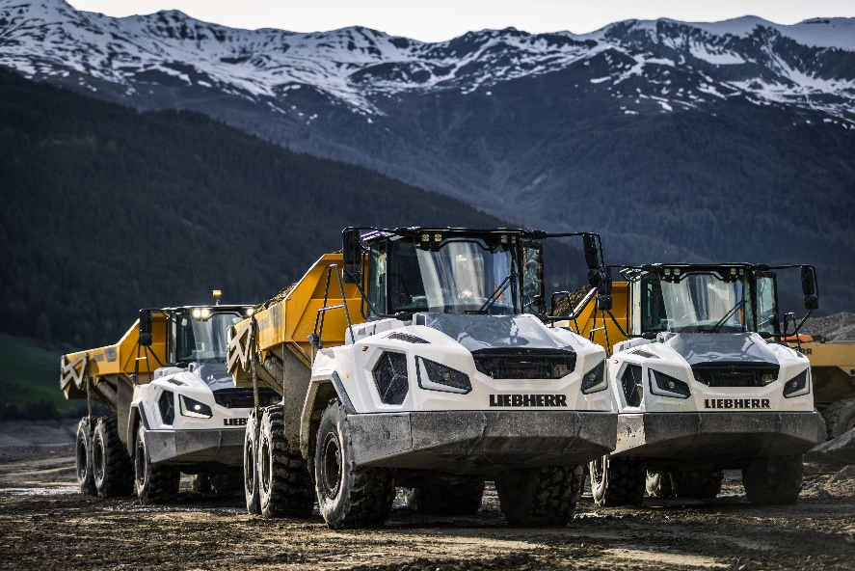

liebherr-ta230-1.jpg  
Ten Liebherr TA 230 Litronic dump trucks are involved in a major project at Lake Reschen in the municipality of Graun in Vinschgau (Italy).

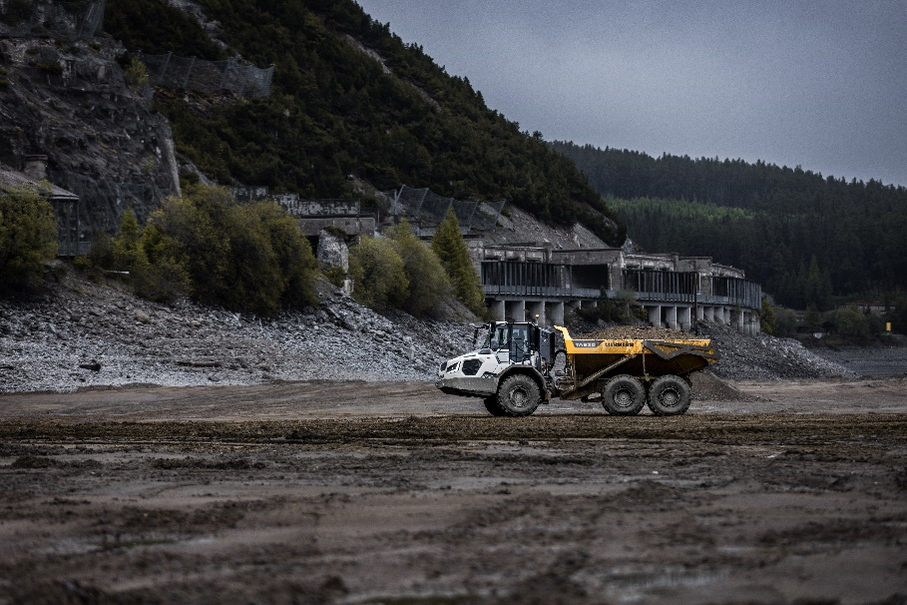

liebherr-ta230-2.jpg  
The Liebherr dump trucks are supporting the backfilling work on a dam and transporting excavated material from the bottom of the drained Lake Reschen to the operating location.

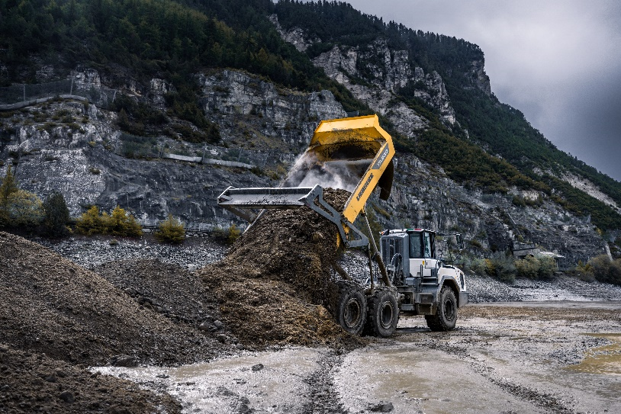

liebherr-ta230-3.jpg  
The TA 230 Litronic transports up to 28 tonnes of material per loading operation.

Contact

Nadine Willburger  
Marketing  
Phone: +49 7354 / 80 - 7332  
Email: nadine.willburger@liebherr.com

Published by

Liebherr-Hydraulikbagger GmbH  
Kirchdorf/Iller / Germany  
[www.liebherr.com](http://www.liebherr.com)