Press release

Global Wind Projects and Global Crane Services expand their crane fleet with a Liebherr LG 1750  
⸺

The new addition is the second LG 1750 in the corporate fleet

Global Group uses the new crane for wind power projects and heavy-duty hoists in ports, industry and for infrastructure projects

The LG 1750 lattice boom mobile crane combines the advantages of crawler and mobile cranes.

**Global Wind Projects, a leading UK provider of crane and installation services for wind turbines, has joined forces with its sister company Global Crane Services to strengthen their joint crane fleet with a Liebherr LG 1750. The 750-tonne lattice boom mobile crane, which combines the performance of a crawler crane with the mobility of an all-terrain mobile crane, joins an LG 1750 and LR 1750 crawler crane, as well as over 60 mobile cranes with lifting capacities ranging from 25 to 750 tonnes in the Global fleet, and will help the company to meet growing demand from the wind industry in the UK and Ireland.**

Ehingen (Donau) (Germany), 4 October 2023 – While Global Wind Projects will use the new LG 1750 primarily for onshore wind power projects, Global Crane Services will use it for heavy-duty tasks in ports, on infrastructure projects and in the petrochemical industry in the UK and Ireland. Both companies are subsidiaries of Global Port Services, part of the Inverness and Aberdeen-based Global Energy Group, a services group for the energy sector.

Ryan Burke, General Manager at Global Wind Projects, explains the expansion of the crane fleet: "With the purchase of the new Liebherr LG 1750, we are doubling our capacity for the specific requirements of wind projects. This procurement is therefore a very significant investment for our company. The new crane was put to work for the first time in Ireland, where it installed five onshore wind turbines at ABO Wind Ireland's Sheskin wind farm in County Mayo. It then went to County Offaly to install 29 onshore turbines at the Yellow River wind farm. With two LG 1750s in our fleet, we can meet the increasing demand for our onshore wind crane and erection services and support the continued growth of Global Wind Projects."

Liebherr sales manager Lyle Sibbald comments: "We have built up a very close relationship with Global Port Services over a number of years and are delighted to supply this brand new LG1750 to support Global Wind Projects' expansion. The LG1750 is recognised as one of the most versatile and efficient heavy lift cranes on the market and is sure to play an important role in Global Wind Projects' wind farm work as well as Global Crane Services' heavy lift projects."

The LG 1750 lattice boom mobile crane offers the flexibility and performance of a 750-tonne crawler crane as well as the mobility of a high-speed mobile crane. In other words, it combines the benefits of these two crane types in a single concept. The LG 1750 uses the crane superstructure and boom system from the LR 1750 crawler crane, together with an eight-axle chassis of the latest design with speed-dependent rear-axle steering. This makes the lattice boom mobile crane ideal for fast erection work for wind power projects, industrial construction or infrastructure work.

Global Wind Projects was established in April 2021 by Global Port Services to meet the increased demand for onshore and offshore wind power in the UK and Ireland. Since then, the company has experienced rapid growth and established itself as a reliable partner for some of the largest contractors in the renewable energy sector.

**About Liebherr-Werk Ehingen GmbH**

Liebherr-Werk Ehingen GmbH is a leading manufacturer of mobile and crawler cranes. Its range of mobile cranes extends from 2-axle 35 tonne cranes to heavy duty cranes with a lifting capacity of 1200 tonnes and a 9-axle chassis. Its lattice boom cranes on mobile or crawler travel gear deliver lifting capacities of up to 3000 tonnes. With universal boom systems and extensive additional equipment, they can be seen in action on construction sites throughout the world. The Ehingen site has a workforce of 4,300. An extensive, global service network guarantees the high availability of Liebherr mobile and crawler cranes. In 2022, the Liebherr plant in Ehingen recorded a turnover of 2.37 billion euros.

**About the Liebherr Group**

The Liebherr Group is a family-run technology company with a widely diversified product range. The company is one of the largest manufacturers of construction machines in the world. However, it also supplies high quality, user-focused products and services in many other sectors. The group currently comprises more than 140 companies based in every continent of the world. In 2022, it had a workforce of over 50,000 and recorded a consolidated total turnover of more than 12.5 billion euros. The company was founded in 1949 in Kirchdorf an der Iller in southern Germany. Since then, its aim has been to win customers by supplying high quality solutions and to contribute to technological progress.

**Images**

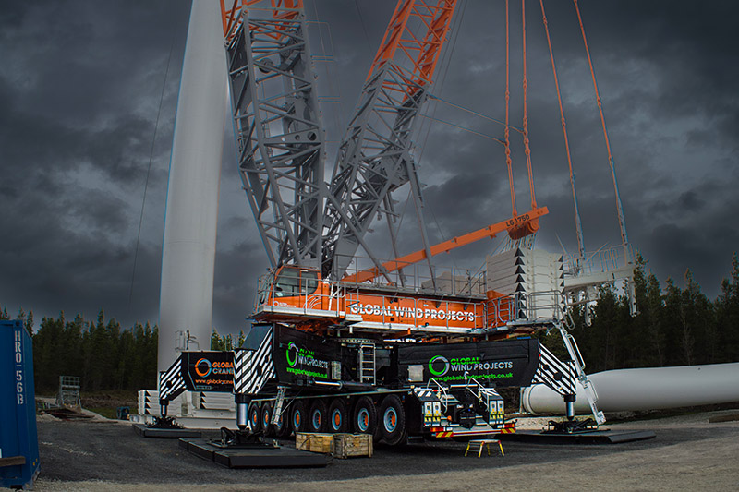  
liebherr-lg1750-global-01.jpg  
Global Wind Projects and Global Crane Services have now taken delivery of the second LG 1750 in their joint crane fleet.

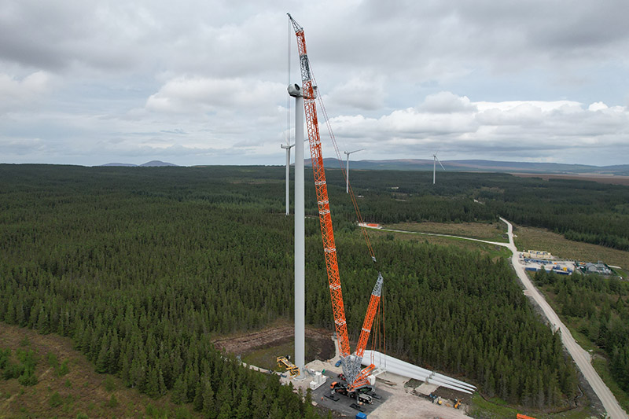

liebherr-lg1750-global-02.jpg  
The Liebherr LG 1750 lattice boom mobile crane is ideal for use in the wind power sector as well as for heavy-duty hoists in the field of industrial construction and infrastructure.

**Contact**

Wolfgang Beringer  
Marketing and Communication  
Phone: +49 7391/502 - 3663  
Email: wolfgang.beringer@liebherr.com

**Published by**

Liebherr-Werk Ehingen GmbH  
Ehingen (Donau) / Germany  
www.liebherr.com