Press release

Complete RL series from Liebherr equips one FLNG

⸺

Wison (Nantong) Heavy Industry Co., Ltd., provider of power engineering services, acquires five new Liebherr Ram Luffing Cranes to be used on a liquefied natural gas carrier to develop subsea gas fields

The ordered cranes have a lifting capacity up to 50 tonnes and an outreach of maximum 40 metres and are primarily used for maintenance, supply work and assist in the general process of the FLNG

The delivery of the fully ex rated cranes is planned for the period 2024-2025

As a leader in the monetisation of natural gas, the manufacturer Wison has decided to purchase five new RL series cranes. This investment is part of a natural gas liquefaction plant (FLNG) that has been under construction since early 2023. It is the largest FLNG plant to be built by the company to date and was commissioned by the Italian energy company Eni. The 380 m long and 60 m wide vessel will be anchored at a depth of 40 m off the coast of the Republic of Congo.

Rostock (Germany), September 2023 – The oil and gas sector is undergoing a transformation. The development of gas resources from subsea gas fields is helping to meet the growing global demand for natural gas. With the construction of floating facilities for the extraction, liquefaction and storage of natural gas, the demand for compact cranes is also increasing. Since its establishment in 2012, Wison has become the leading company in China in the field of floating natural gas applications.

The RL series offshore cranes have convinced the sole service provider for natural gas monetisation solutions in China. All cranes of the series in the portfolio will support the FLNG unit in maintenance and supply work, “The fact that we convince Wison with the entire RL series is both a success and an incentive for Liebherr to continue to align the offshore portfolio with the needs of the market and its customers,” says Stefan Schneider, Global Application Manager for General Purpose Offshore Cranes. “The cooperation with our contract and service partners from Liebherr China Co. (LMS China) was a particularly important factor in finalizing the contract. They will support the process during the construction of the FLNG. After commissioning, a field office responsible for the Republic of Congo will take over,” Schneider adds.

Optimal design enables reliable and flexible crane control

The compact and weight-optimized crane construction of the Liebherr RL series offers the possibility of being used in the best possible way, even when space is limited, thanks to a well-thought-out design. This is illustrated by an optimised overall height, a small tail radius and the absence of a machinery house. The cranes also offer advantages for its operators. The redesigned 7 m³ large cabin is ergonomic and ensures low-fatigue working. Its modern equipment with an excellent surrounded visibility, the new driver’s seat in combination with the new operating concept including new controls and revised air conditioning ensures safe crane operation. “Equipping the FLNG with the RL series creates a holistic value. Highest safety standards and state-of-the-art working conditions enable increased working capacity. For us, working with Liebherr means having a global crane manufacturer at our side whose expertise sets global standards,” comments Mr. Zhang Shouyue, Deputy General Manager of Project Management Office from Wison about the cooperation.

Worldwide network enables reliable customer service

The new floating plant can store over 180,000 m³ of liquefied natural gas and 45,000 m³ of liquefied petroleum gas. The cranes installed on the platform are part of an integrated service structure. The worldwide Liebherr network of experienced engineers makes it possible to supply spare parts and to offer the best possible service within the shortest possible time, so that productivity of the plant can be ensured. “The modular design concept of the main components of the Liebherr RL series is an exciting aspect and the increased interchangeability of the components once again comes to the fore,” says Yang Dong, Liebherr China Co.

The RL crane series impresses with further special features. The innovative cabinet inside the slewing column, which houses the world’s first explosion-protected Ex d cabinet that safely dissipates explosion pressure. „EXpressure“ was developed by Liebherr partner R. Stahl AG. Also available for the RL series is LiMain, the fully digital, remote-controlled and semi-automated maintenance system. Its modularity with individual packages allows the user future maintenance independent of time, place, and resources.

**About Wison** **(Nantong) Heavy Industry Co., Ltd.**

Wison (Nantong) Heavy Industry Co., Ltd., (an affiliate of Wison Offshore & Marine) a leading provider of clean energy technology service and solutions, is committed to providing the energy industry with highly integrated EPCIC solutions, including floating LNG facilities, modularized LNG plant, floating gas-to-power facilities, floating wind power and other clean energy solutions. Based on a track-record of successful project delivery, the experienced Wison team applies its expertise in technical innovation and two world-class shipyards to provide EPC services that meet the highest international quality and safety standards.

About Liebherr-MCCtec Rostock GmbH

Liebherr-MCCtec Rostock GmbH is one of the leading European manufacturers of maritime handling solutions. The product range includes ship, mobile harbour and offshore cranes. Reach stackers and components for container cranes are also included in the product portfolio.

About the Liebherr Group

The Liebherr Group is a family-run technology company with a highly diversified product portfolio. The company is one of the largest construction equipment manufacturers in the world. It also provides high-quality and user-oriented products and services in a wide range of other areas. The Liebherr Group includes over 140 companies across all continents. In 2022, it employed more than 50,000 staff and achieved combined revenues of over 12.5 billion euros. Liebherr was founded in Kirchdorf an der Iller in Southern Germany in 1949. Since then, the employees have been pursuing the goal of achieving continuous technological innovation, and bringing industry-leading solutions to its customers.

Images

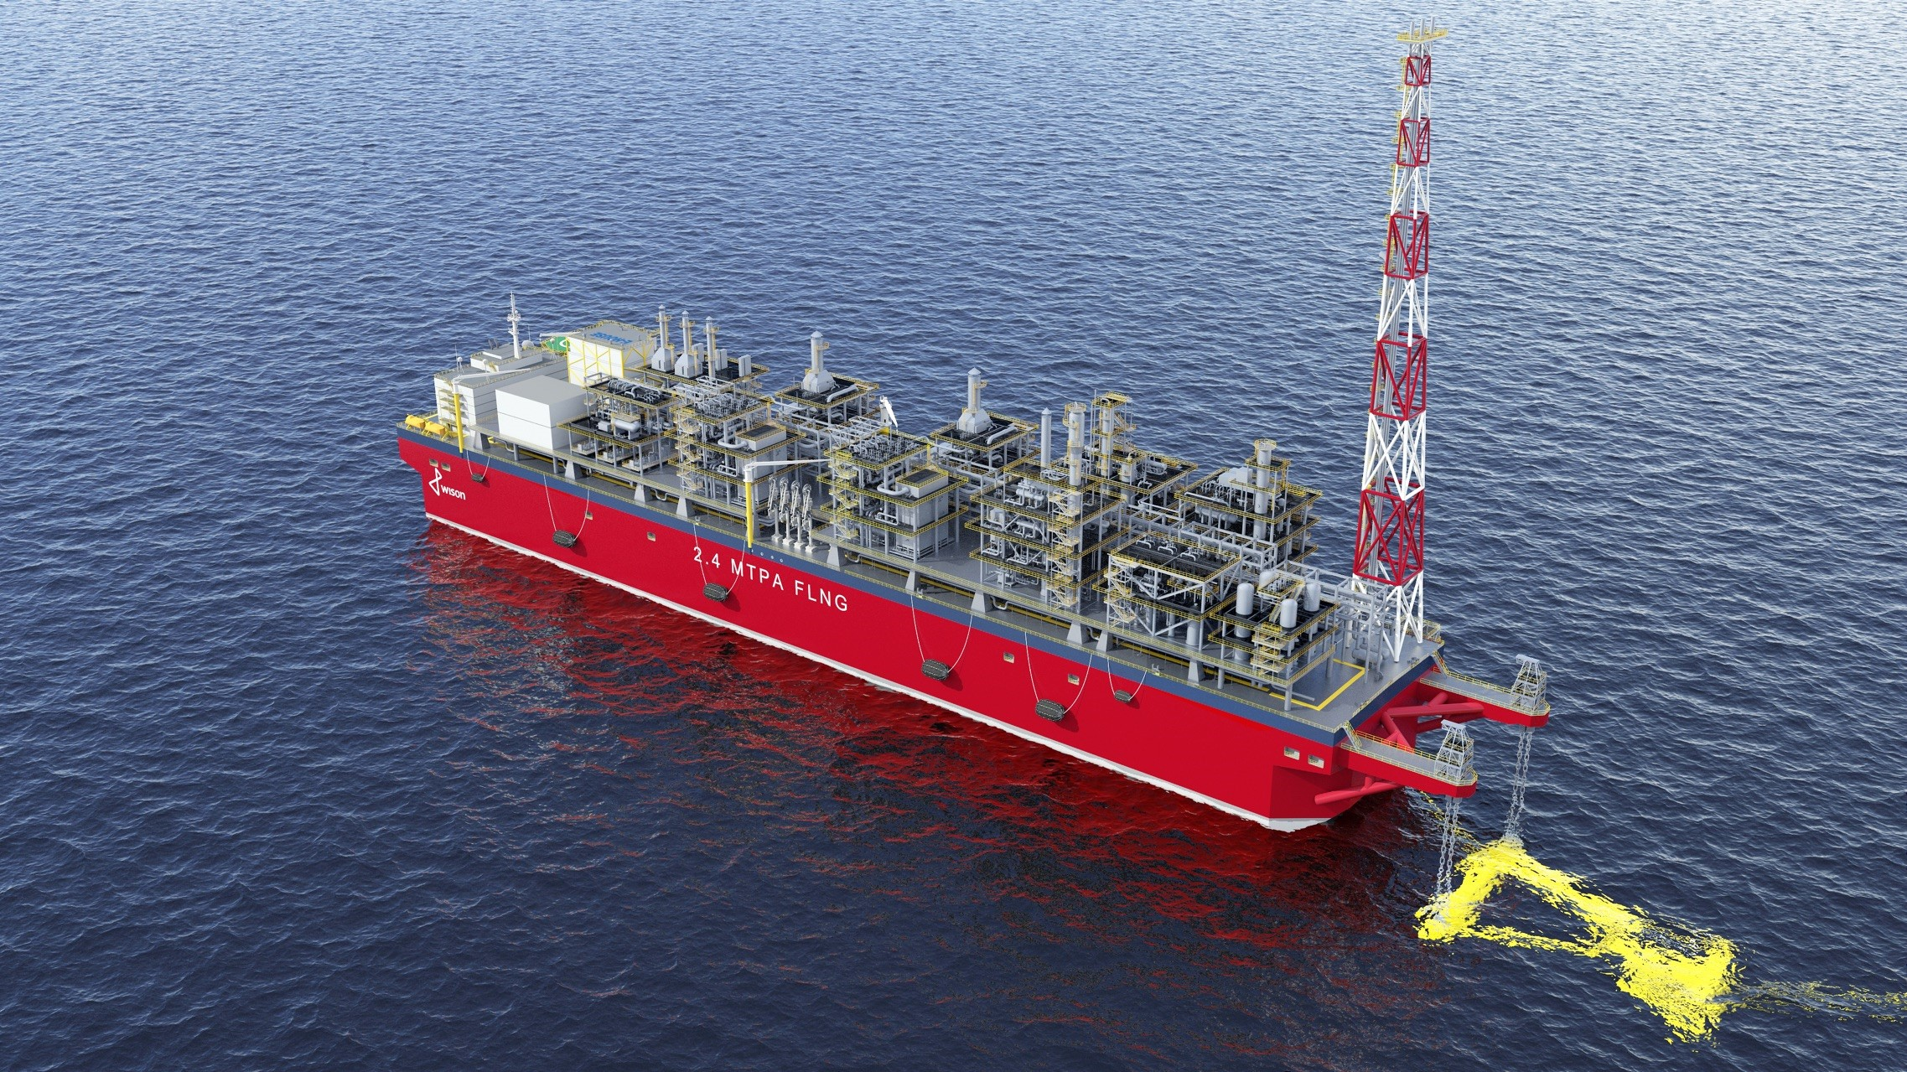

liebherr-rl series-wison-1.jpg  
Wison has started the construction of a floating liquefied natural gas (FLNG) unit ordered by Italian oil and gas company Eni. Liebherr supplies 5 cranes of the RL series and will support in the general process of the FLNG.



liebherr-rl series-wison-2.jpg  
The RL series stands out for its weight-optimised and compact design and can be used on floating offshore installations, especially in the wind power industry and in the oil and gas sector for maintenance and supply work.

Contact

Constanze Jantsch

Marketing Manager – Offshore Cranes

Tel: +49 381 / 600650 - 22

Email: constanze.jantsch@liebherr.com

Published by

Liebherr-MCCtec Rostock GmbH

Rostock / Germany

www.liebherr.com