Press release

LTM 1750-9.1 in action in Cologne: balcony renovation at the Axa high-rise building

⸺

Piece by piece onto the roof: LTM 1750-9.1 installs tower cranes at a height of 147 metres

Lighter in tandem: LTM 1150-5.3 served as an auxiliary and assembly crane

Crane rental company Colonia satisfied with long-standing partnership

Once a showcase project and, at the planning stage, even Europe’s tallest residential building – the Axa high-rise on the banks of the Rhine in Cologne was completed in 1973 and still provides accommodation for around 1,000 people on 43 of its 45 floors. As the building’s exposed aggregate concrete balconies have been dilapidated for some time, they are now being removed and replaced. An LTM 1750-9.1 and, as an auxiliary crane, an LTM 1150-5.3 were brought in to prepare the work site.

Ehingen (Donau), (Germany), 5 October 2023 – Today, the 147-metre high-rise is a listed building. This has made the renovation of its balconies quite a challenge, as noticeable changes to the building’s appearance are not permitted. To install the new, more weather-resistant balconies made of glass and aluminium, two tower cranes were mounted on the building’s roof at the end of June. An LTM 1750-9.1 played a key role in this project – with its 52-metre telescopic boom as well as a 15-metre mast extension and a 91-metre luffing jib, the mobile construction crane was tasked with lifting various parts of the two Liebherr tower cranes high into the air. “We used the entire ballast of 204 tonnes as well as all available equipment for the mobile crane for this operation,” reports Christian Kühne, project manager at the crane company Colonia. The large crane was supported by an LTM 1150-5.3, which was used as an auxiliary and assembly crane on the ground.

The LTM 1750-9.1 mobile crane is ideal for these lifts onto the 147-metre-high roof in the heart of Cologne. The 9-axle crane has a maximum pulley head height of 154 metres and can carry the complete telescopic boom on public roads. Thanks to the Y-guying system, considerable load increases can be achieved by combining the crane’s high lifting capacities with the variable jib system. As an all-terrain crane, the LTM 1750-9.1 was designed with particularly short set-up times and maximum mobility in mind. Extensive comfort and safety equipment, such as load charts for various wind speeds, round off the concept of the LTM 1750-9.1.

Decades of customer satisfaction

The cranes were used in tandem for one week on the banks of the Rhine in Cologne. The 750-tonne crane was set up in under two days. “With a maximum hook height of 152 metres, a building height of 147 metres and a load capacity of 13.4 tonnes, the constellation for this operation was already impressive,” says Kühne. “Especially for special jobs like this, we can rely on Liebherr’s excellent quality and service.” The crane rental company Colonia has been a customer of Liebherr-Werk Ehingen GmbH for decades and currently has 26 Liebherr cranes in its fleet. Four new additions – an LTM 1650-8.1, an LTM 1150-5.3, an LTM 1130-5.1 and an LTM 1110-5.1 – will join Colonia’s fleet in the near future.

**About Liebherr-Werk Ehingen GmbH**

Liebherr-Werk Ehingen GmbH is a leading manufacturer of mobile and crawler cranes. Its range of mobile cranes extends from 2-axle 35 tonne cranes to heavy duty cranes with a lifting capacity of 1200 tonnes and a 9-axle chassis. Its lattice boom cranes on mobile or crawler travel gear deliver lifting capacities of up to 3000 tonnes. With universal boom systems and extensive additional equipment, they can be seen in action on construction sites throughout the world. The Ehingen site has a workforce of 4,300. An extensive, global service network guarantees the high availability of Liebherr mobile and crawler cranes. In 2022, the Liebherr plant in Ehingen recorded a turnover of 2.37 billion euros.

**About the Liebherr Group**

The Liebherr Group is a family-run technology company with a widely diversified product range. The company is one of the largest manufacturers of construction machines in the world. However, it also supplies high quality, user-focused products and services in many other sectors. The group currently comprises more than 140 companies based in every continent of the world. In 2022, it had a workforce of over 50,000 and recorded a consolidated total turnover of more than 12.5 billion euros. The company was founded in 1949 in Kirchdorf an der Iller in southern Germany. Since then, its aim has been to win customers by supplying high quality solutions and to contribute to technological progress.

Ein Bild, das draußen, Himmel, Baum, Hochhaus enthält.
Images

liebherr-axa-colonia-LTM1750-9.1-01.jpg  
Working in tandem on the Axa high-rise: an LTM 1750-9.1, supported by an LTM 1150-5.3, installs a tower crane at a height of 147 metres.

Ein Bild, das draußen, Himmel, Hochhaus, Metropolregion enthält.

liebherr-axa-colonia-LTM1750-9.1-02.jpg   
Impressive constellation for the LTM 1150-5.3: a maximum hook height of 152 metres, a lifting height of 147 metres and a lifting capacity of 13.4 tonnes.

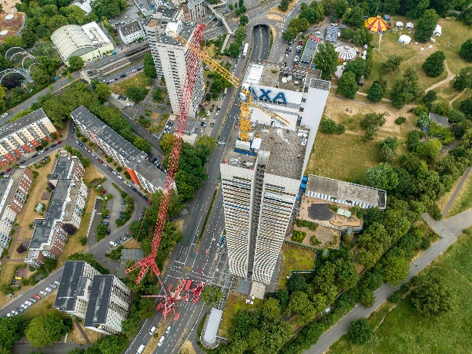

liebherr-axa-colonia-LTM1750-9.1-03.jpg  
The individual components of the tower crane were lifted onto the roof of the Axa high-rise building.

Contact

Berenike Nordmann  
Marketing and Communication  
Phone: +49 7391 / 502 - 0  
Email: berenike.nordmann@liebherr.com

Published by

Liebherr-Werk Ehingen GmbH  
Ehingen (Donau) / Germany  
www.liebherr.com