Press release

Next-generation LICCON3 control: RIGA MAINZ receives one of the very first LTM 1110-5.2 cranes

⸺

The first standard LTM 1110-5.2 cranes have been delivered

New control, cab and crane design

Long-standing partnership with RIGA MAINZ

**Liebherr is delivering the first ten LTM 1110-5.2 cranes equipped with the new LICCON3 crane control to customers in Europe. All prototype tests are now complete and the series production stage has been reached. Liebherr will incorporate the crane operators' experience of working with the new crane type under real-world operating conditions into its series production process. The crane and heavy haulage contractor RIGA MAINZ has taken delivery of one of the first LTM 1110-5.2 machines.**

Ehingen (Donau) (Germany), 11 October 2023 – In spring 2022, Liebherr unveiled the new LTM 1110-5.2, which features the LICCON3 crane control, redesigned cabs and new paintwork, at a customer event in Ehingen. The new crane was presented to customers worldwide at the Bauma trade fair in October. After intensive testing of several prototypes, Liebherr is now delivering the first 10 units to customers. They are equipped with an additional data logger that allows monitoring of the crane's job profile as well as any problems that may arise. Liebherr has therefore deliberately chosen customers in the cold north and hot south of Europe.

RIGA MAINZ Managing Director Kai Langer visited the Liebherr manufacturing plant in Ehingen in person for the official handover of the new LTM 1110-5.2: "Our aspiration is to set new benchmarks for the industry again and again. Therefore, it's important for us to be involved in new technologies such as LICCON3 right from the start in order to give important feedback to our partners in Liebherr's development department based on our practical experience." Liebherr has also worked closely with RIGA MAINZ in the past to obtain feedback from the field. For example, in the early years of the LICCON crane control, load interpolations for intermediate lengths were discussed with Kai's father, Uwe Langer, and then tested following their implementation.

David Traud, a crane driver at RIGA who was trained on the new crane at the Liebherr factory, is enthusiastic about the new control system: "I'm looking forward to being one of the first to drive the new crane. Everything is new and much more modern. I think the individual setting options are great. Nevertheless, you quickly get to grips with it, as the operation is basically the same as with the current LICCON2."

**Fourth-generation family business**

Kai Langer took over the role of Commercial Director in July. He succeeds Karl Reitz, who will enter his well-deserved retirement at the end of this year. Having decided to temporarily leave the company 10 years ago and prove himself in the market, Kai Langer has now returned to RIGA MAINZ after a career outside the company.

Back in May, he and Uwe Langer decided the time was right for him to return to the company to prepare it for the transition to the fourth generation. In his new role as Commercial Director, Kai Langer will assume responsibility for the areas of Finance, Human Resources, IT, Marketing and Business Development – and thus contribute significantly to the development and implementation of the corporate strategy.

Riga Mainz employs over 110 people and operates around 40 cranes with lifting capacities ranging from 30 to 700 tonnes. Its fleet also includes various heavy transport units such as 48-axle SPMTs and patented lifting and shifting systems that can easily move 4,000 tonnes.

**About Liebherr-Werk Ehingen GmbH**

Liebherr-Werk Ehingen GmbH is a leading manufacturer of mobile and crawler cranes. Its range of mobile cranes extends from 2-axle 35 tonne cranes to heavy duty cranes with a lifting capacity of 1200 tonnes and a 9-axle chassis. Its lattice boom cranes on mobile or crawler travel gear deliver lifting capacities of up to 3000 tonnes. With universal boom systems and extensive additional equipment, they can be seen in action on construction sites throughout the world. The Ehingen site has a workforce of 4,300. An extensive, global service network guarantees the high availability of Liebherr mobile and crawler cranes. In 2022, the Liebherr plant in Ehingen recorded a turnover of 2.37 billion euros.

**About the Liebherr Group**

The Liebherr Group is a family-run technology company with a widely diversified product range. The company is one of the largest manufacturers of construction machines in the world. However, it also supplies high quality, user-focused products and services in many other sectors. The group currently comprises more than 140 companies based in every continent of the world. In 2022, it had a workforce of over 50,000 and recorded a consolidated total turnover of more than 12.5 billion euros. The company was founded in 1949 in Kirchdorf an der Iller in southern Germany. Since then, its aim has been to win customers by supplying high quality solutions and to contribute to technological progress.

**Images**

Ein Bild, das Himmel, draußen, Rad, Fahrzeug enthält.

liebherr-ltm1110-5.2-riga-mainz.jpg  
Riga Mainz receives one of the first LTM 1110-5.2 cranes (from left to right): Kai Langer (RIGA MAINZ), Joachim Sommer (Liebherr-Werk Ehingen GmbH)

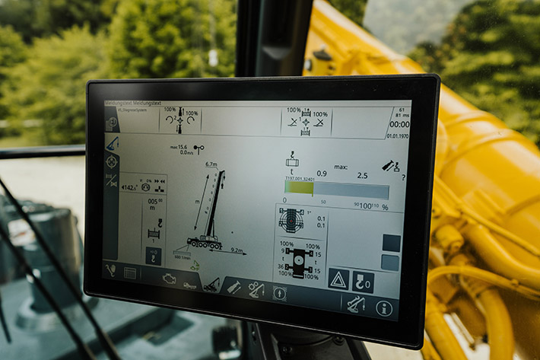

liebherr-ltm1110-5-2-touch-display.jpg  
Touchscreen functionality – the large display in the superstructure cab makes operation even easier and more comfortable.

**Contact**

Wolfgang Beringer  
Marketing and Communication  
Phone: +49 7391/502 - 3663  
Email: wolfgang.beringer@liebherr.com

**Published by**

Liebherr-Werk Ehingen GmbH  
Ehingen (Donau) / Germany  
www.liebherr.com